Peru 2022
Community, Culture, and Care:
Interprofessional Population Health Immersion
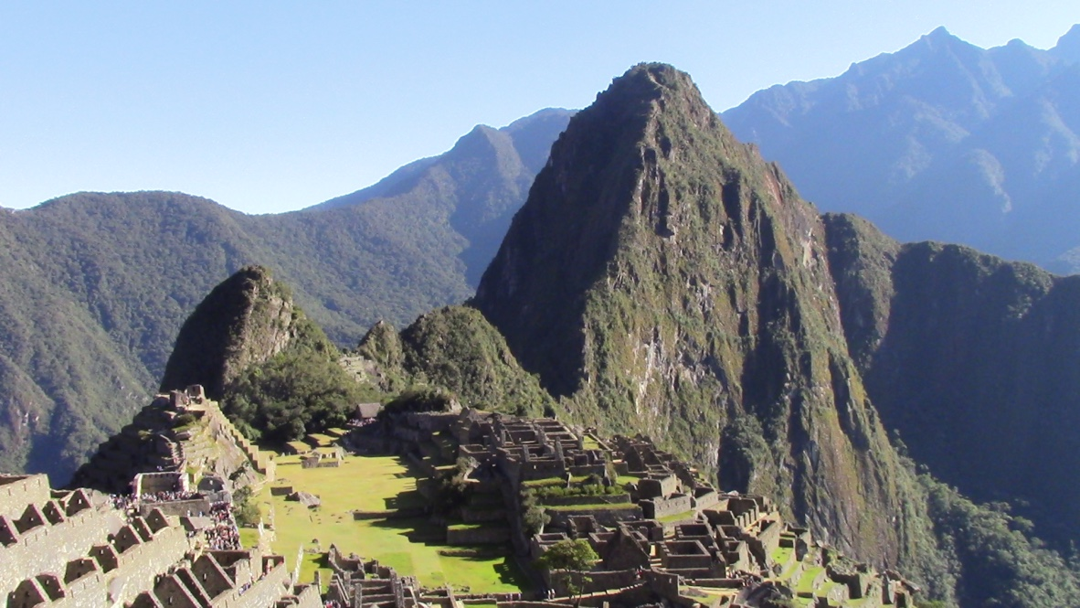
Come learn about community, culture, and care in Peru! Examine how people collaborate to ensure the health and education of their communities - and the role culture plays.
- Experience the role of culture differences in population health
- Create healthy, equitable, and symbiotic relationships between Xavier and people/professionals in Peru, leading to collaborative student learning experiences beyond the immersion experience
- Reflect on the impact of this experience with regard to student career and work decisions in the U.S.
When | May 14-28, 2022
Where | Lima, Cusco, Andahuaylillas, Sacred Valley (Machu Picchu)
Price Range | @ $5200 (Includes one course)
Courses | HESA 390: Foundations of Healthcare Ethics and Law (oral communication flag; ER/S focus elective)  EDCH 320/520: Multicultural Literature (humanities elective diversity flag)
Includes | - ALL meals and ALL lodging  - ALL in-country transportation (bus, train, flights)  - ALL in-country activities (museums, site visits, Machu Picchu)  - Course tuition
Excludes | Round trip flight to Lima, Peru
Contact | Dr. Browne or Dr. Bender-Slack (brownef@xavier.edu) (benderslackd@xavier.edu)

