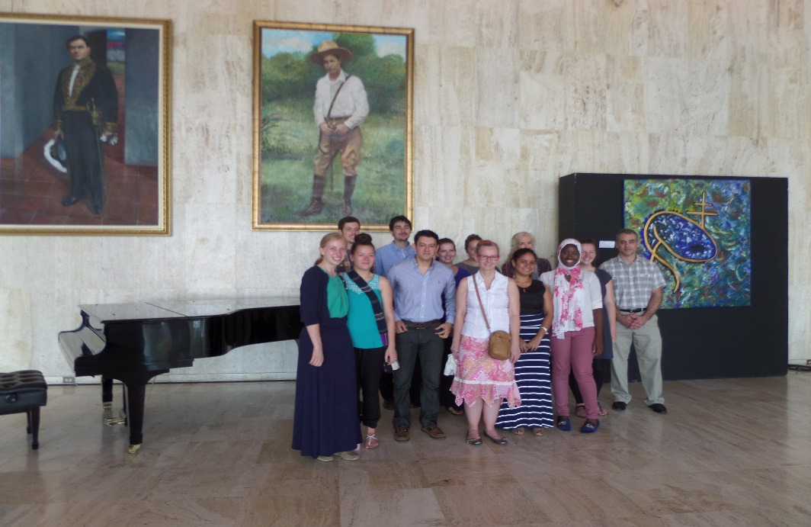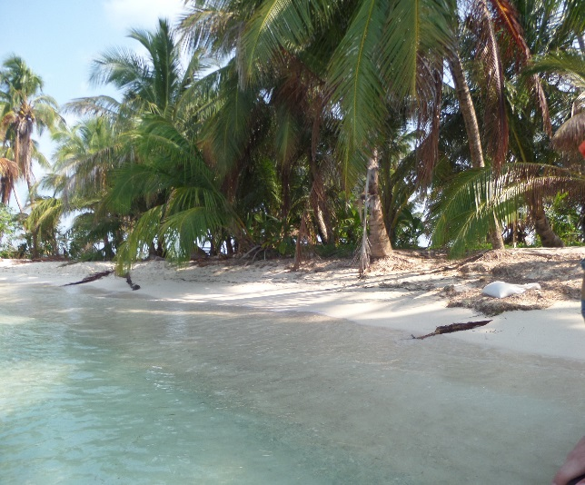 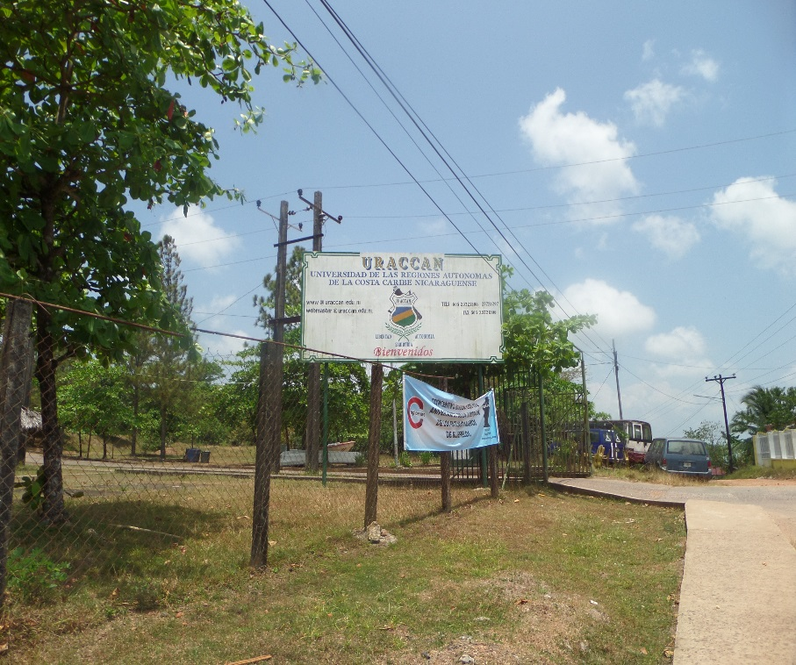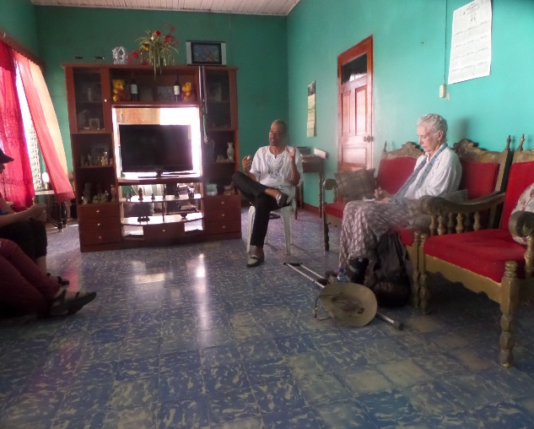

As the end of our time in Nicaragua approaches, we have been able to reflect back on all that we have done during our semester here. Whether it be the precious times with our families, the amazing people we have encountered, or the beautiful, historic sites that we have visited, each piece of this trip has been woven together to make a life-changing experience for us all.

In the past few weeks, we were able to explore more of the country, including the Atlantic Coast, which has a rich, unique history of its own. There we met some incredible people, whom we will talk more about later.

We have all enjoyed our time here in Nicaragua and all of the lessons we have learned while being in solidarity and working with others in the various service sites that have been talked about in the newsletters throughout our time here. We have learned *bastante* (or in other words, a great deal!) here in Nicaragua, and cannot wait to share our experiences with everyone back home.

## Update

The group at Doña Adilia’s son Erick Lacayo’s art exhibit in the Ruben Dario Theater.

¡No es “adiós”, es “hasta luego!”

Xavier University Solidarity Semester

Inside this issue:

Update 1

Excursions 2

Speakers and Service 3

Featured Professors 4

Featured Families 5

Volume 1, Issue 4

April 26, 2016

The group at a talk with Johnny Hodgson, from whom we learned about the history of the Coast.

Our visit to the URACCAN, one of the universities in the Coast.

A picture from our trip to The Keys while on the Coast.

Bluefields was one of the largest cities used by the British protectorate and is the capital of the South Autonomous Region of the Caribbean Coast in Nicaragua. During our visit there, we visited two universities, BICU and the URACCAN. URACCAN is dedicated to promoting a respectful co-existence between different cultures to empower the people. They focus on inter-cultural education to increase equality and recognition of indigenous cultures. They offer a variety of engineering and educational programs for college students in the area.

The BICU stands for Bluefields Indian & Caribbean University. It is the first university founded in the Atlantic Coast. The BICU is a communitarian and intercultural university focused on forming professionals and technical workers to promote the process of autonomy and contribute to the sustainable economic development of the autonomic regions. It has eight campuses along the Coast and offers over sixty professional and technical programs to students attending their university.

### **Bluefields**

While in Pearl Lagoon, which was the first leg of our trip to the Atlantic Coast, we boarded the *panga,* which is similar to a speed boat, in order to visit two of the local indigenous communities- the Garifuna and the Miskito. First, we talked with one of the leaders of the school in the Garifuna community, who spoke of the fight the people are having to face to hold onto their native language in a mainly Spanish and English-speaking region. He told us of the members of a Garifuna tribe in Honduras that had come to help revitalize the tribe´s roots, allowing them to hold onto their culture and heritage.

Then, we met with one of the community leaders of the Miskito, who echoed the sentiments of the Garifuna in their work to preserve the traditions and language of their people. He spoke of the importance of unity, peace and religion within this region and how these are the main principles that the Miskito strive to live by. He did, however, talk of how the Miskito people are succeeding in keeping their language alive by teaching it in the schools, as well as in their homes and within the community.

**Indigenous Communities**

**The Atlantic Coast (Pearl Lagoon, Bluefields, and More!)**

The Atlantic Coast, also called the Caribbean Coast, of Nicaragua has a very unique history that is distinguishable from the background of those on the Pacific Coast. The Atlantic Coast has a strong indigenous influence, which is made evident by the various Indigenous communities such as the Rama, the Miskito and the Garifuna tribes that still reside on the coast. In addition, there is a strong afro-descendant presence that has shaped the culture of the Atlantic Coast. This area had been under British control from the mid-1600´s until the mid-1800´s, which can be seen in the Creole English that is currently spoken on the Coast.. Now, the Coast is separated into two Autonomous Regions: the North Atlantic Autonomous Region (RAAN) and the South Atlantic Autonomous Region (RAAS).

Page 2

Meet the Group

Excursions

Page 2

[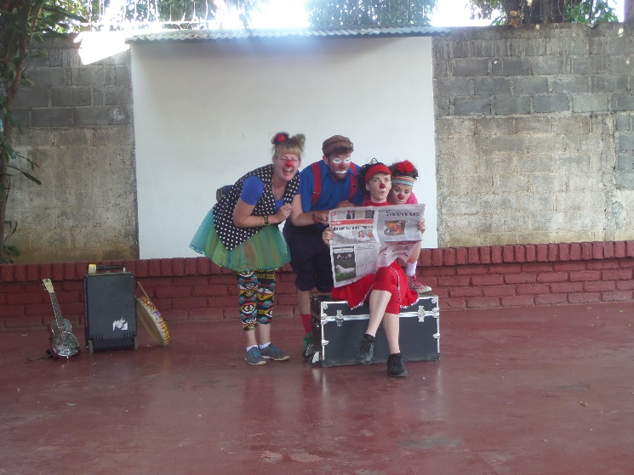](http://www.google.com.ni/url?sa=i&rct=j&q=&esrc=s&source=images&cd=&cad=rja&uact=8&ved=0ahUKEwjUkdmpld_LAhWmmoMKHV5vDN0QjRwIBw&url=http://web.stanford.edu/group/arts/nicaragua/student/linder/&psig=AFQjCNGlALVzAys5e0rTpDoVPtfag8MBVw&ust=1459109667736683)

The last service site (see previous newsletters for others) where participants volunteered is La Mascota Children’s Hospital. It is a public hospital in Managua focused on treating children from all overNicaragua for free with the help of private donations and government funds. Students Aichetou Waiga, Megan Hanes, and Allie Miller spent time reading, painting and laughing with the patients andfamilies there. Their supervisor Violeta Marin as well as other staff helped guide their time and enrich their experience as well. La Mascota, also, provides transportation and housing for families traveling from a far and offers life changing care for families of children up to fifteen years of age. Allie, Aichetou and Megan served as volunteers in the children’s oncology and hematology unit. During their month and a half there, they played with patients, connected with families and learned the importance of “Game Therapy”.

Featured Service Site: La Mascota



**Payasos Sin Fronteras (Clowns Without Borders)**

Present in twelve countries, Payasos Sin Fronteras is a Spanish Humanitarian organization that performs for free for children affected by poverty and war. It was founded in Barcelona in July of 1993. They are dedicated to bettering the emotional situations of children that are affected by the consequences of armed conflicts, wars, or natural catastrophes. Professional artists volunteer their time to perform comical shows to strengthen resiliency, provides hope and helps heal the emotional damage done to the children. The Xavier group first encountered PSF at Casa Ben Linder the last Thursday and thoroughly enjoyed their show. The group of performers is here in Nicaragua for fourteen days and afterward, the individuals will return to their careers at home or decide to sign up again to be part of a performers’ group sent to another country.

Page 3

Speakers and Service

Page 4

Featured Professors and Classes

Featured Professor

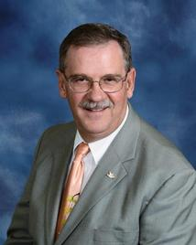

Dr. Gable

Dr. Mike Gable is the professor of the group`s Liberation Theology course. He has worked many years in ministry, including in Honduras, and has also taught in Xavier’s Theology department. In addition, he is the head of the archdiocese’s mission’s office in Cincinnati.

Dr. Gable provided the group with a new outlook on Theology, as well as informative resources that helped to guide the group’s learning experience while in Nicaragua. He has been leading the class from Xavier and helping the group make connections between the in-class information and the various religious practices seen in Nicaragua.

### Featured Class

Dr. Gable has been teaching the guided-learning class about Liberation Theology, which focuses on being in solidarity with, and fighting against, the injustices of those who are affected by poverty. He has encouraged the group to not only focus on what was being learned in the class, but also on the real-life applications of the information that can be found within every one of the host families’ houses. In addition to the enriching reading material, the group also had various excursions and talks that added to the class, including visits to the Christian Base Communities and conversations with Father Joe Mulligan and Don Luciano Siqueira, who are two leaders in their respective churches. These experiences made the information from the class come to life and have a greater impact on the lives of every individual in the group.

Featured Families: Doña Ana’s and Doña Patricia’s

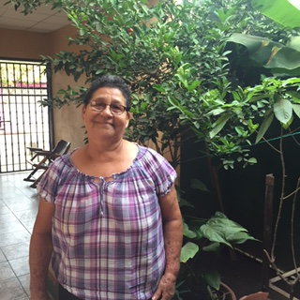

Doña Ana Soto:

Doña Ana has been with the program since 2011 and she is the host mother of Allie. She loves to attend church or pass her evenings watching *telenovelas* with her family. She always has a smile to give and fills the house with laughter. Her two granddaughters, Alicia and Dillcia and her husband, Don Jose live in the home as well.

Doña Ana cherishes time with her family and just celebrated her sixty eighth birthday with almost all of her six children, nine grandchildren, and her two great grandchildren. To her, family is the most important thing in life and her fervent love for God is an inspiration to all. Doña Ana and her family have welcomed Allie with warm smiles and open arms into the family and she couldn’t imagine a better host family.

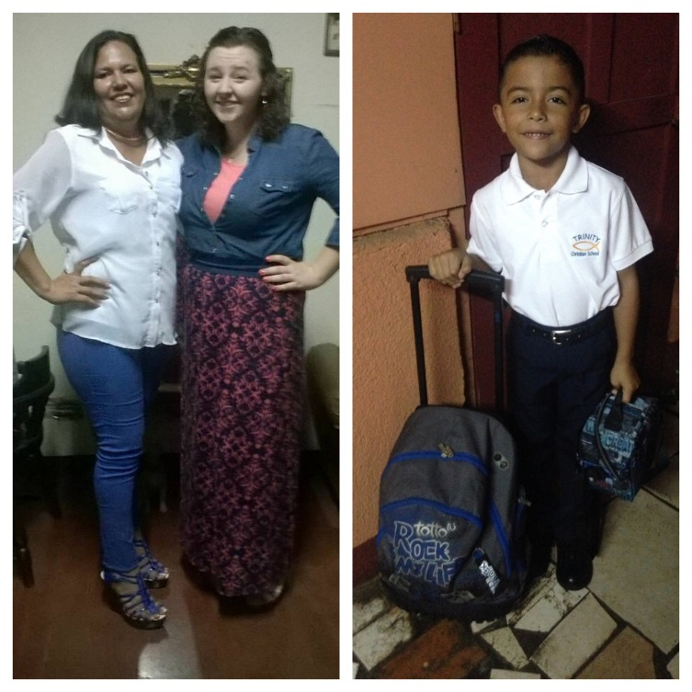

Doña Patricia Hernández:

Doña Patricia is new to the Xavier program this year and is the host mother of Morgan. She is known for her delicious cakes, fulfilling meals, and most importantly, her loving heart. She lives with her only son, Frank, who is seven years old. Currently, she works at a restaurant with her brother, Pedro, and also occasionally makes lunch for the group, which always leaves everyone fully satisfied.

Doña Patricia absolutely loves cooking and baking, and could not imagine doing anything else. She also adores her son, who is a complete blessing for her. She has opened up her home to Morgan, as well as the rest of the group, and made the time Morgan has spent away from her home in the U.S. much easier. Morgan loves not only her host mom but also her little brother, and she has cherished every moment that she has spent with them.

Want to learn more? Join us on Friday, April 29th at 3:30 p.m. in the Kennedy Auditorium for a full presentation of the Nicaraguan Solidarity Semester.

For more information about the program, contact Dr. Walker Gollar at [gollar@xavier.edu](mailto:gollar@xavier.edu)

.

For comments or questions concerning this newsletter, please contact Irene Hodgson at [hodgson@xavier.edu](mailto:hodgson@xavier.edu)

For more information or to apply to this program, please contact Iso Tidjani at [tidjanii@xavier.edu](mailto:tidjanii@xavier.edu)

Page 5