Above is pictured some of the group helping to celebrate Megan’s birthday.  - April 2016  ¡Hasta managua!  Update:  Our departure date from beautiful Managua feels very close, although there is still so much more to be learned!  Since our last update, we have had the chance to explore still more facets of life and culture here in Nicaragua. We returned to Granada for a more in depth visit, and we also stayed on the famed island of Ometepe. Along with these visits, we have taken part in internal exploration through the varying talks that we have been a part of, as well as the continued discussions in our classes.  The deeper we find ourselves exploring the culture of Nicaragua, the more there is to find. It seems that our learning has just begun, as we start to really dig in to life with our host families, and in our community, and piece together all that we have experienced thus far.  We hope you enjoy this third update on our semester living and learning in Nicaragua! |  | Volume 1, issue 3  In this issue:  Page 1  - holy week  - Family week  Page 2  - excursions  Page 3  - service  - speakers  Page 4  - featured class and professor  Page 5  - featured families  -  Nicaragua  Xavier University Solidarity Semester

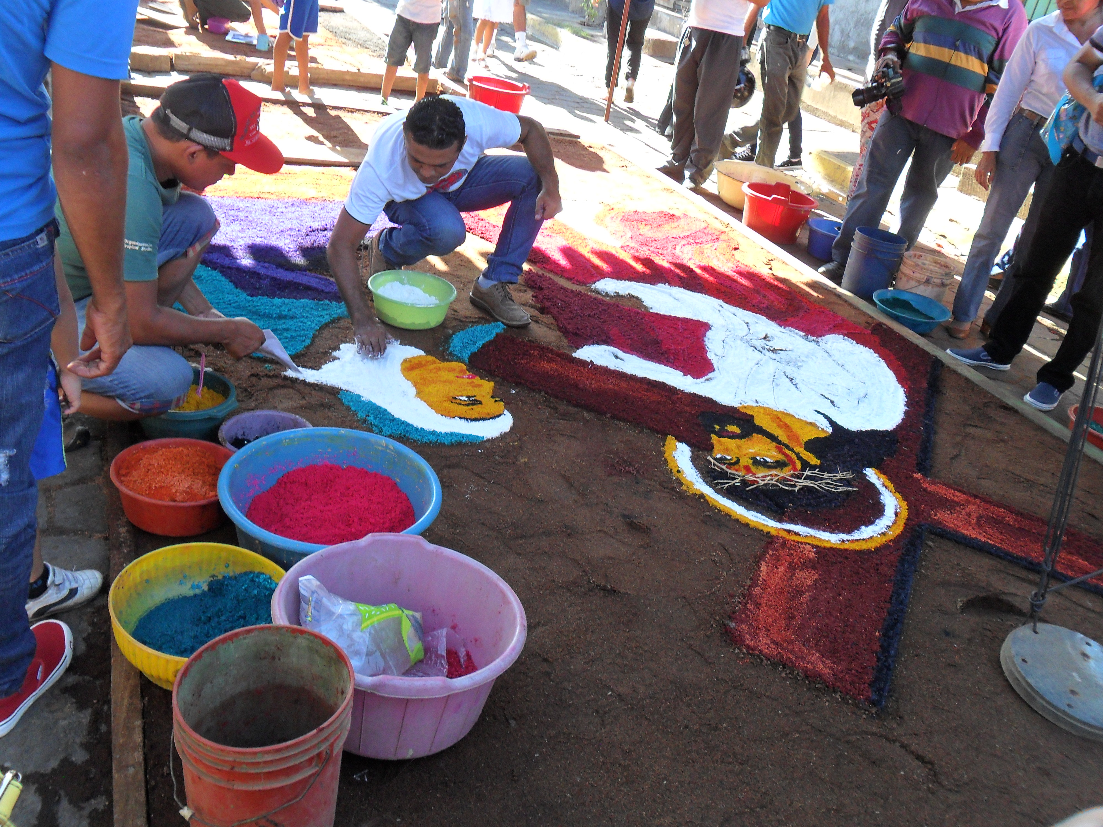
Holy Week

Holy Week, or Semana Santa as it is known here in Nicaragua was an experience unlike any other. The week preceding Easter Sunday, just about all of Nicaragua goes on holiday, in preparation for the joy of the resurrection on Easter. During this week, there are masses and processions galore. Although there are many different religious denominations in Nicaragua, there is an especially strong Catholic population. During this time in our barrio, each evening after mass, there would be an event which usually involved a procession. People walked through the streets, praying or singing, often following a stature of Jesus or Mary or some other saintly person whom the participants aim to emulate. On Holy Friday, an annual procession is held in downtown Managua where people walk for hours to the cathedral, following behind a statue of Christ. The roads are shut down on this day, as masses of people walk through the capital city, in the streets. Also on this day, some of us revisited the city of León where artists created huge alfombras (literally “rugs”) made of sand in the streets. All of them were in some way depicting the life and works of Jesus, and many focused on His passion and death. One of these works of art in progress is pictured here.
Easter Sunday in our barrio was an amazing experience with members of our community. Every year on this day, a procession is held before mass, with the men following a statue of Jesus and the women following one of Mary. The two groups process through the barrio, and when they meet, everybody dances and rejoices, and the whole congregation then processes together to the church. Religion is certainly not a quiet matter in our experience here in Managua. During the mass, there was singing, dancing, clapping, and even fireworks were released outside, for the “Gloria”! It was difficult to keep from smiling in mass this day. Often, Catholic mass is pictured as a solemn experience, but this is certainly not the case on Easter Sunday in our barrio. This experience was a lovely reminder of the joy that can and should be associated with religion.
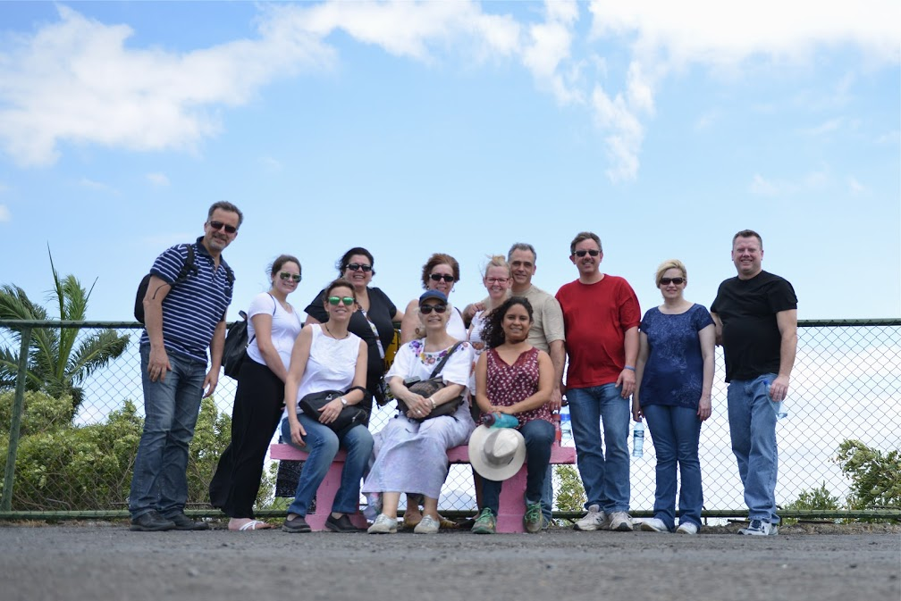
Visitors’ Week

From March 4 through March 15, some of our parents, friends, and relatives came to visit us here in Managua. Throughout visitors’ week we were able to show our visitors some of the wonderful places we have been able to experience along with an opportunity to meet our families and friends. Most of the visitors were able to go to service with their loved one at Pajarito Azul or Olla de Soya, although visitors did not have the opportunity to visit La Mascota, because we had just recently moved students to that service site when the visitors arrived. Visitors were able to see their students at work as teachers as well as cooks at Olla de Soya, and those visiting Pajarito Azul had the opportunity to participate in our Wednesday dance parties, which are always a ton of fun! Not only were our visitors able to experience our regular service sites that we go to three times per week, but they were also able to visit and participate in the service site we attend with students from the University of Central America. The visitors loved having the chance to see their students in action and be a witness to all we have learned throughout our time here in this beautiful country.
Above is a picture of our visitors on their city tour of Managua.
In the very beginning of our trip, we were introduced to Managua through a tour of the most important sites in the city. During this week of visitors, they were also taken on a city tour of Managua, where they were able to learn about Nicaraguan history and better understand today´s Nicaraguan society. Our relatives and friends visited the market in Masaya as well, where they bought some of the clothing and artwork created by Nicaraguans. Last but not least, visitors were able to join us for a talk at the Ben Linder House where we heard from two Honduran refugees living here in Nicaragua in search of safety from the violence and oppression in Honduras.
Granada
This trip was our second visit to Granada. After visiting some historic landmarks in the city, we took a boat out to the isletas, small volcanic islands in Lake Nicaragua. On our ride, we saw many different types of fish in the water, as well as many interesting looking birds flying by. One type of bird that we saw was one of our group members´ favorite birds. Also from the boat, we had a wonderful view of Volcano Mombacho, which we hiked earlier in the semester. On our visit to one of the isletas, we had the opportunity to swim in the water, and many of us had our first coconuts, cut straight from the tree. There is an abundance of natural resources in this area, but also clear economic differences among the people that live there. During our day visiting the isletas, we were shocked to see the vast differences in housing. Some islands were covered in small houses where the people use small boats to travel, and wash their clothes in the lake. In stark contrast, other nearby patches of land were filled with mansion-style housing where the inhabitants were lacking nothing. A common theme in our various excursions throughout Nicaragua is a mix of beautiful, abundant land, and very unbalanced economic situations accompanying it. Despite the often scarce economic means of these people, one thing that we have come to find is that monetary poverty is a much different thing than being poor.
Above is a view of Granada from atop the cathedral, with Lake Nicaragua in the distance.

Ometepe

Not too long ago, our group had the opportunity to visit the island of Ometepe. This island in the middle of Lake Nicaragua has two volcanoes, beautiful beaches, abundant forests, and very diverse wildlife and culture. It is no wonder that this location was nominated to be one of the new Wonders of the World.
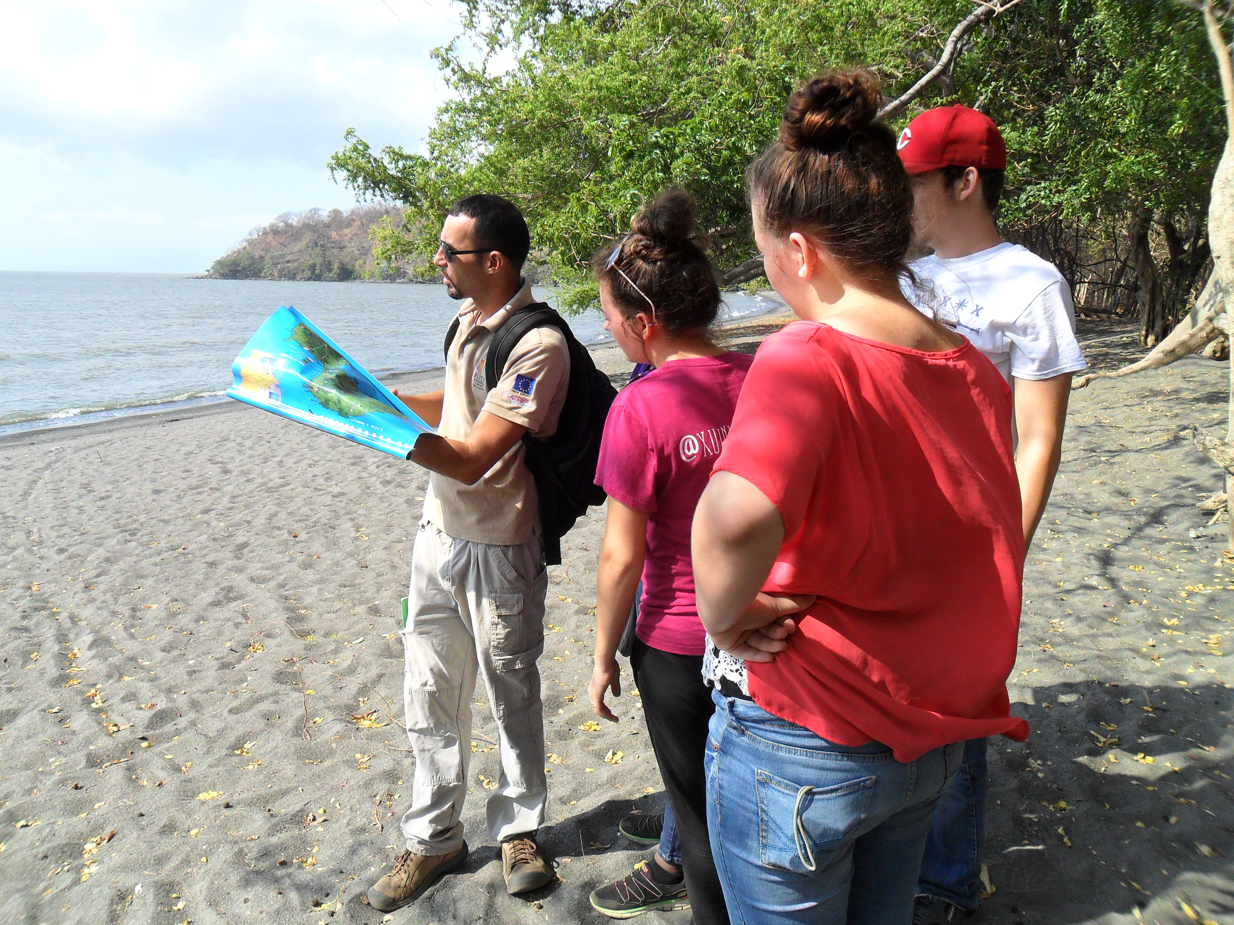
On our visit to this remarkable island, we had the opportunity to meet with an expert on the biodiversity of this unique location. We walked through a part of the park reserve and learned about many of the plants and animals living in the region. There are two species of monkeys on the island, several types of water birds, and a variety of insects and plants. On our walk, we saw monkeys, iguanas, lizards, and vultures. There are also some species on the island that are found nowhere else in the world, and the lake surrounding Ometepe is one of the few places in the world wherein live freshwater sharks. Also on our visit to this remarkable island, we learned about the history of the people of Ometepe. We saw petroglyphs with pre-colonial art, and we visited a museum with hundreds of pre and post Columbian artifacts. We saw varying types of bowls, whistles, arrowheads, jewelry and burial containers which exemplified the evolution of artisanship and trading in this region over time. This island is a prime example of the many differences in both geography and culture in Nicaragua. Although it is a small country in comparison to our own, there is no shortage of cultural diversity.
Learning about the biodiversity of the island on our walk with tour guide, Wilmore.

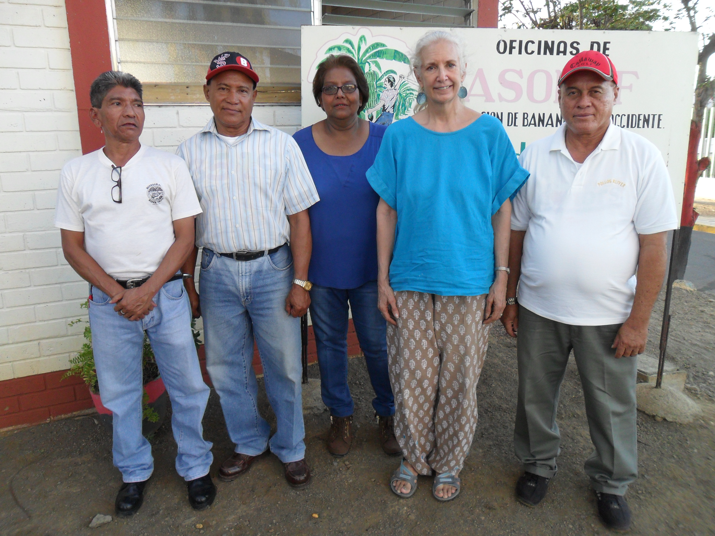
Speakers
One major focus of our semester studies here in Nicaragua has been issues of social justice. This is why we visited with members of the association of bananeros. In the 1970’s, farms were opened in Nicaragua by large, transnational companies. They came here to make use of the abundant land and labor available to produce many different crops. The bananeros, or banana workers, worked in some of the banana farms in Nicaragua, where many fatal chemicals were used. At the time of their work on the farm, these people did not know the chemicals used to treat the plants were lethal, although the company (Standard Fruit Company) they worked for was aware of this. Now, these people are very sick, and many are dying from their exposure to these chemicals. Unable to work, they now spend their energy fighting to receive justice from the companies who have wronged them.
Some leaders of the Association of Bananeros pictured with Dr. Hodgson.
In the meeting with the bananeros, the importance of solidarity is something which became very real. We have learned through experiences like this one that living for and with others is not something we should be planning to do one day when the occasion arises; it is something we need to do all the time. Every day, God is calling us to care for our neighbors, and to live in solidarity with them. This is one lesson that has permeated our experience and our thoughts this semester, and we encourage you to reflect on this as well, and think about how we can all live in solidarity with others.

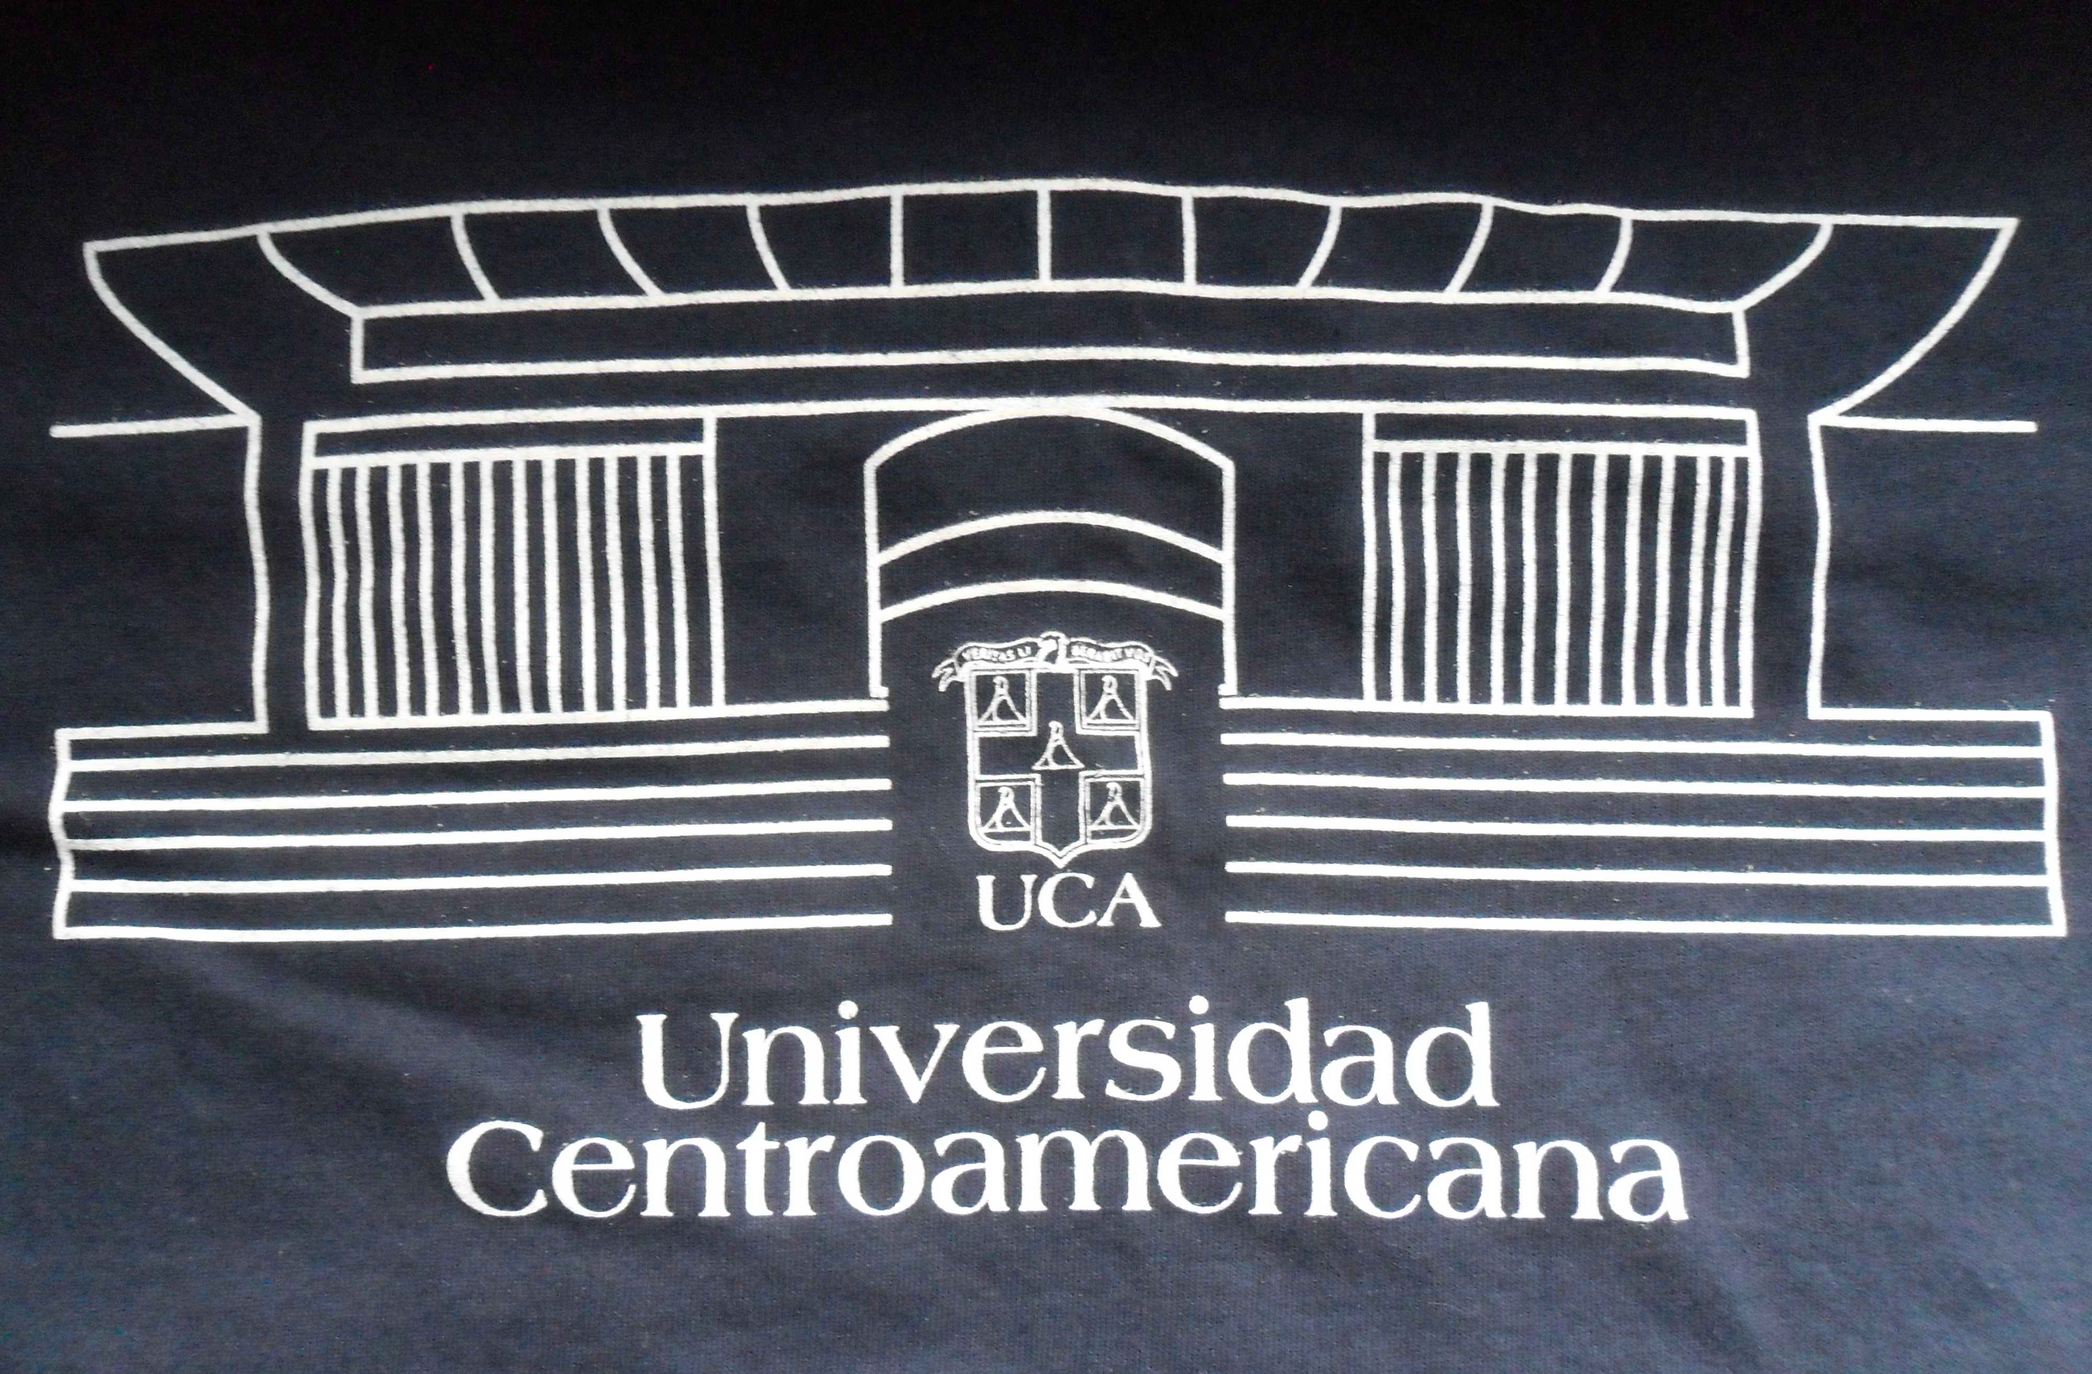
Service
During our time here in Nicaragua we have had the opportunity to join in service with some of the students from the University of Central America (UCA). Half of our group works with a group of girls living in a place called Remar Niñas (Rowing Girls) and the remainder of our group works with young boys in Arca de Noé (Noah’s Ark). Remar Niñas is the house where the young girls live, while Arca de Noé houses the young boys, who range from very small children to adolescents. Due to unfavorable circumstances with family situations, these children have been removed from their homes and live together in this complex, where they have made many friends. On Thursday afternoons we help the boys and girls complete their homework and afterwards, we play games with them, with jumping rope and soccer being some frequent choices. The children always look forward to our arrival on Thursday afternoons. They have taught us a great deal about what it means to be a child again, and we are very lucky to have had the chance to get to know all of these wonderful children through the course of this semester.

Featured Class: Academic Service Learning
On Mondays our group gets together for night class from 7pm until 9 pm. Normally, our first half of the class is focused on a reading we were assigned the week before that pertains in some way to our current experiences in Nicaragua. For example, we read an article entitled “Why Do Americans Act Like That?” This article pointed out many of the stereotypes people think of when they hear the word “American”. This article helped us to realize the effect of stereotypes on many different groups of people and to understand that most stereotypes are not even based on truth. According to Jesuit values, reflection should be a key aspect of our lives. Without taking the time to reflect, we risk the chance of meaningful events throughout each day slipping through the cracks. For this reason, our Monday night class also acts as an opportunity for each of us to reflect over the past week and talk about uncomfortable moments we may have had, as well as some of the joyful moments we experienced. Reflection is a time for us all to get things off of our chests and express how we are feeling. Oftentimes, we find ourselves missing home or in a frustrating situation and being able to talk about these things with our friends is very comforting.

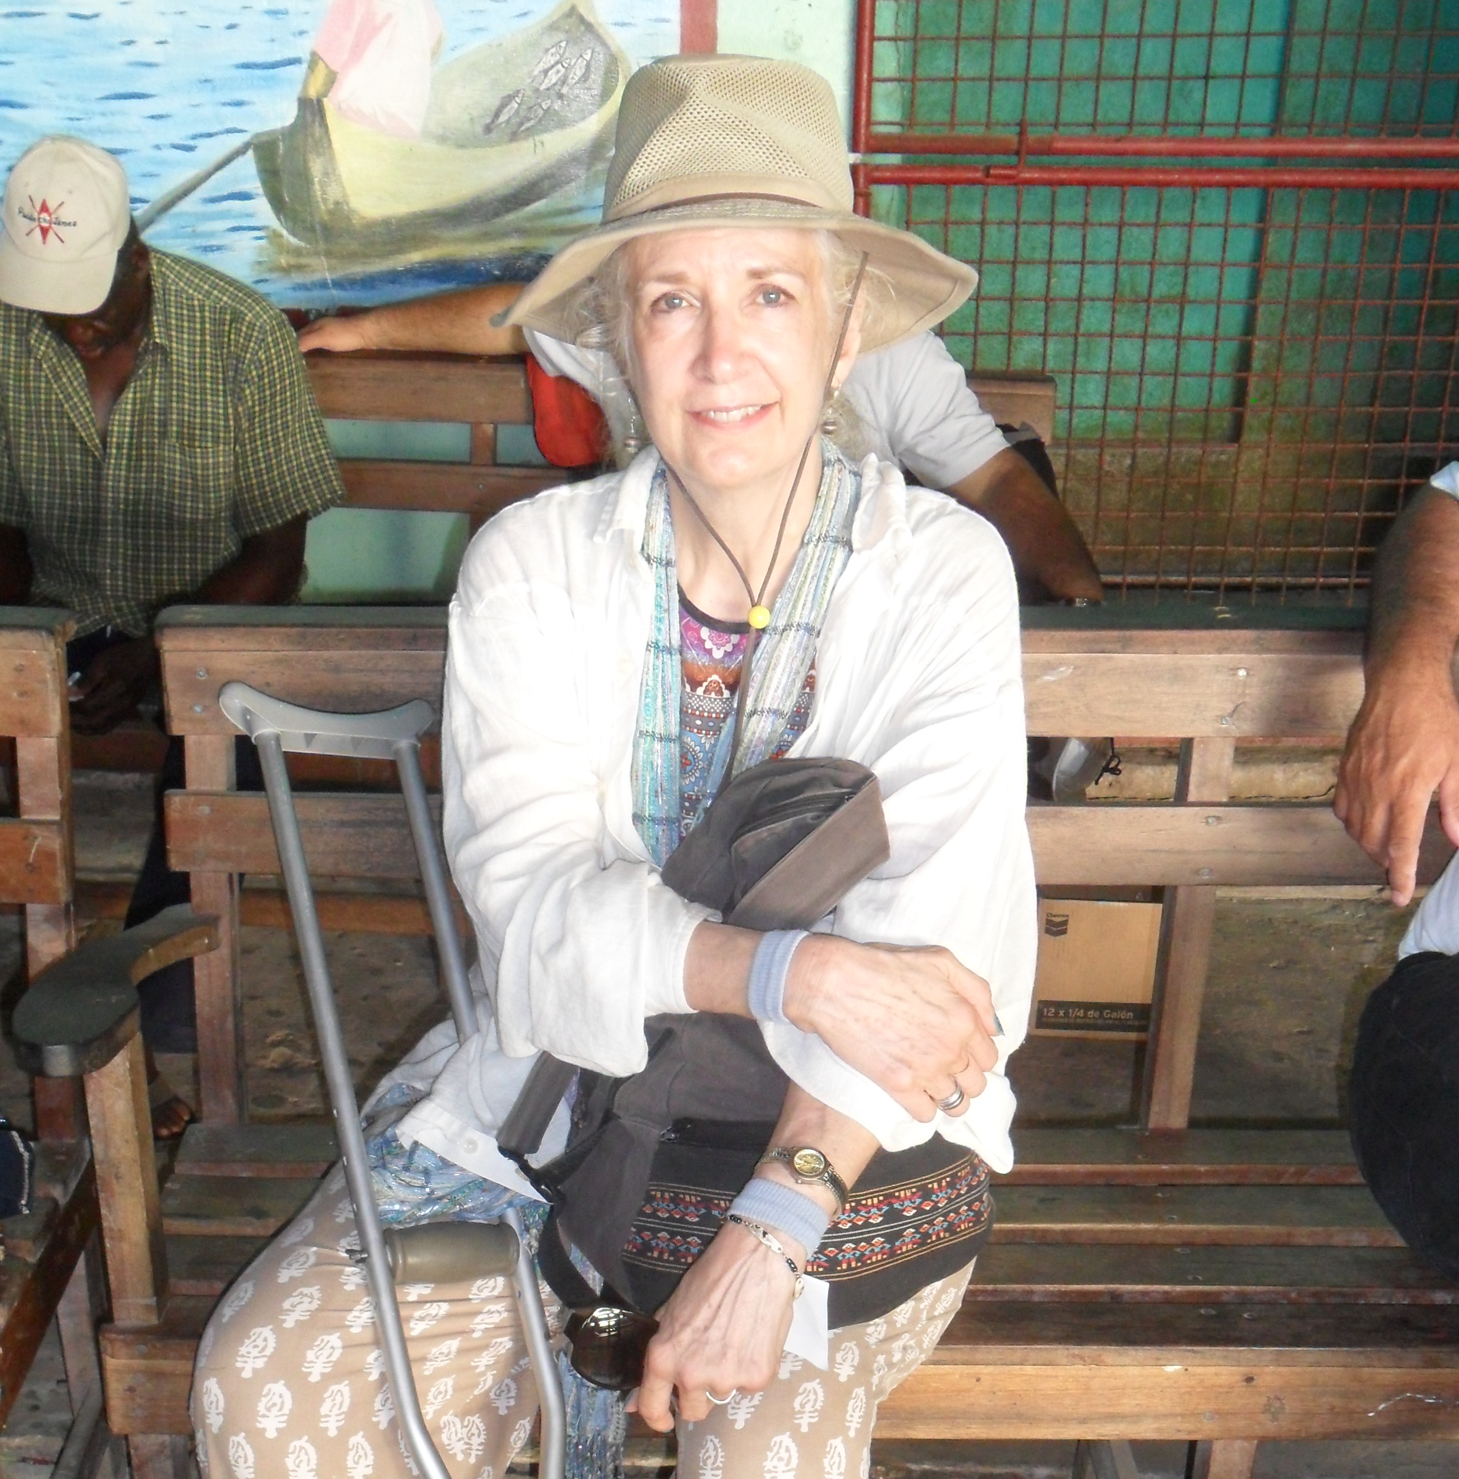
Featured Professor: Dr. Irene Hodgson
Our featured professor for this issue is our professor and trip leader, Dr. Irene Hodgson. As a Xavier professor for 30 years, ´Dr. H´ has been the faculty trip leader for solidarity semesters with Xavier University since 1999, and was the director of the academic service learning semesters from 2006 until 2012. A native Texan, she received her master’s degree from NYU, and her doctorate from Purdue University. She now does an excellent job guiding the minds of her students, both on campus and abroad. This semester, she is the professor for Academic Service Learning (featured above), and Culture and Society Classes. When she is on campus, you can find her teaching a variety of Spanish classes—including the only translation class currently offered at Xavier—and heading up the Latin American Studies Minor. She has done much work in translation, with one of her most recent published translations being of the writings of Oscar Romero, the archbishop of San Salvador, and later, martyr. Dr. Hodgson is a woman of tenacity, and often serves as the glue that connects many pieces of our semester together. Her dedication to her work is an inspiration to us all, and we are very grateful to have such a knowledgeable professor leading us this semester.

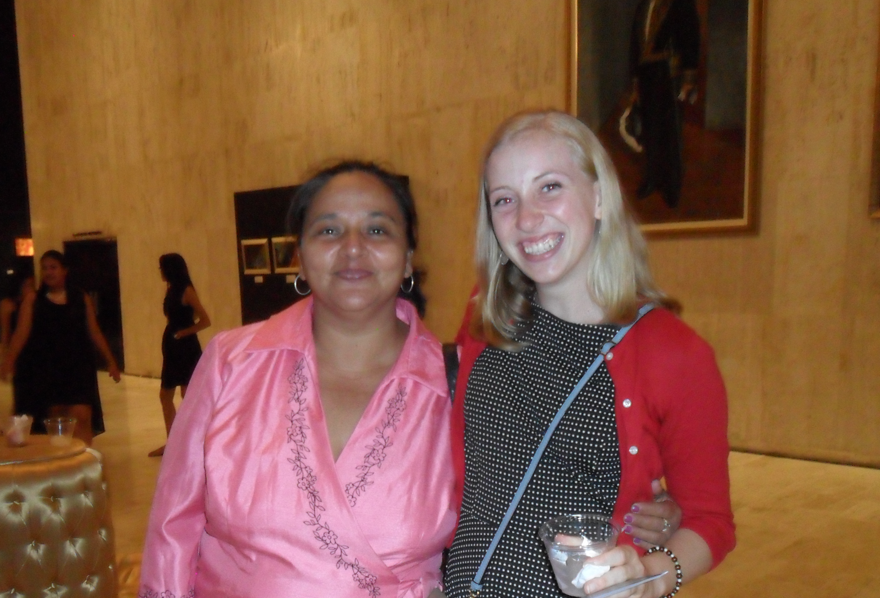
Featured Family: Doña Elba Tapia
Laura has spent the last few months living in the happy home of Doña Elba. Doña Elba and her family have lived in their Managua home for more than 30 years, and have been helping with the Xavier program since 1997. They are known around the barrio for selling pizza—among other things— and often times many members of the group can be found in their kitchen, buying and even helping to make the delicious pizza for lunch. With almost a dozen family members living here, one cat (Figaro), and the family business too, things are always buzzing in this house! Despite all of this, Doña Elba somehow manages to make sure everyone is well cared for, and very well fed. It has been a joy for Laura to be counted as one of this wonderful family.

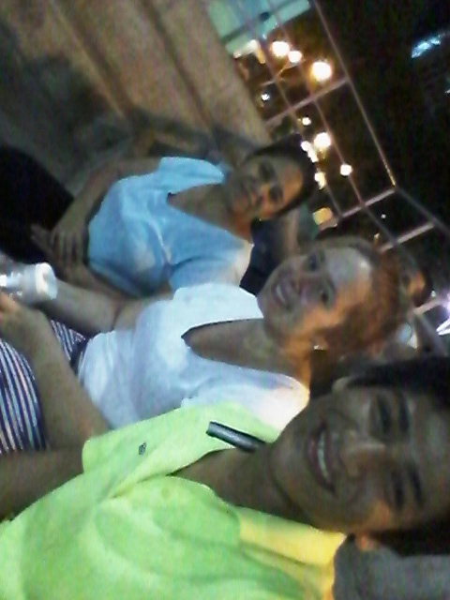
Featured Family: Doña Maritza Sotelo
For this newsletter, our other featured family is Reyna´s family. Reyna lives with her host mom Doña Maritza, her host sister Heydi, and her host brother Osman. Doña Maritza teaches a group of 50 young children within the barrio (neighborhood). Heydi and Osman both help around the house, and Osman is currently a student at the University of Central America. Reyna´s family also has two cats, Meow and Meow Chiquito. During her time here, Reyna has had the chance to really get to know her family members and improve her Spanish skills with the help of her host brother. Doña Maritza and her family have shown immense amounts of love and compassion to Reyna and she could not be more grateful for this experience.
Want to learn more about our semester abroad? Come to our presentation!
Friday April 29th, 2016 at 3:30pm
CLC Kennedy Auditorium
The presentation will last about an hour and a half, with a question/ answer session included. We hope to see you there!

For comments or questions concerning this newsletter, please contact Irene Hodgson at hodgson@xavier.edu

For more information or to apply to this program, please contact C. Walker Gollar at gollar@xavier.edu

