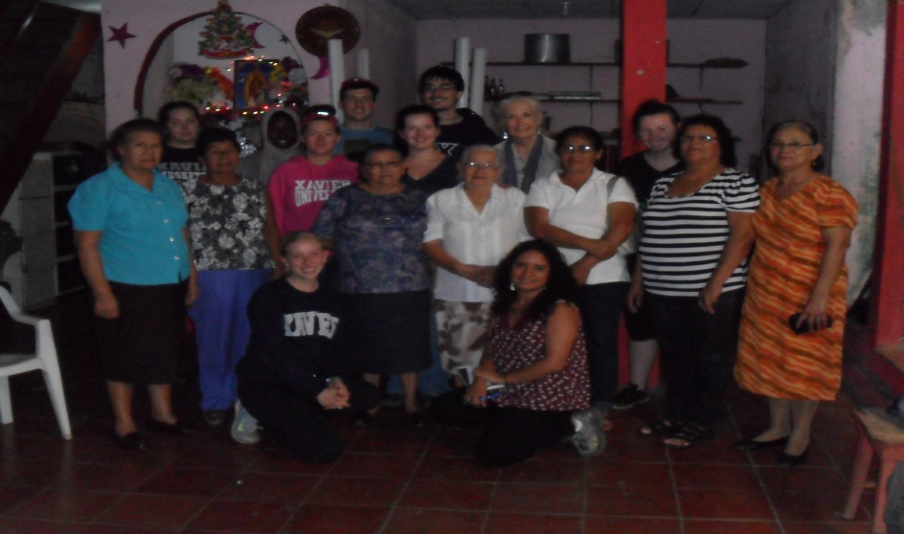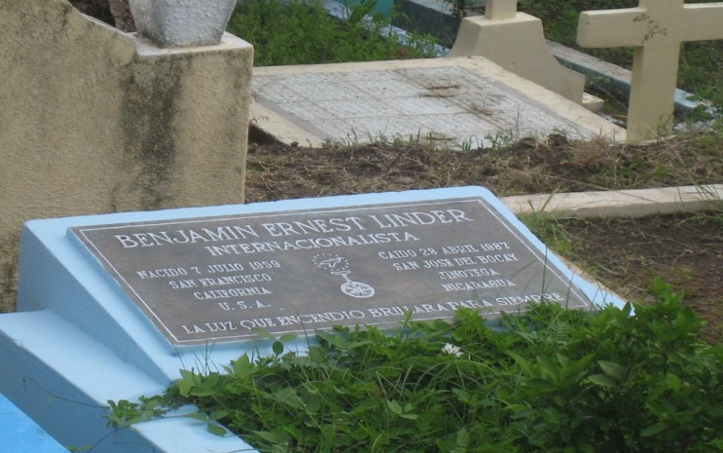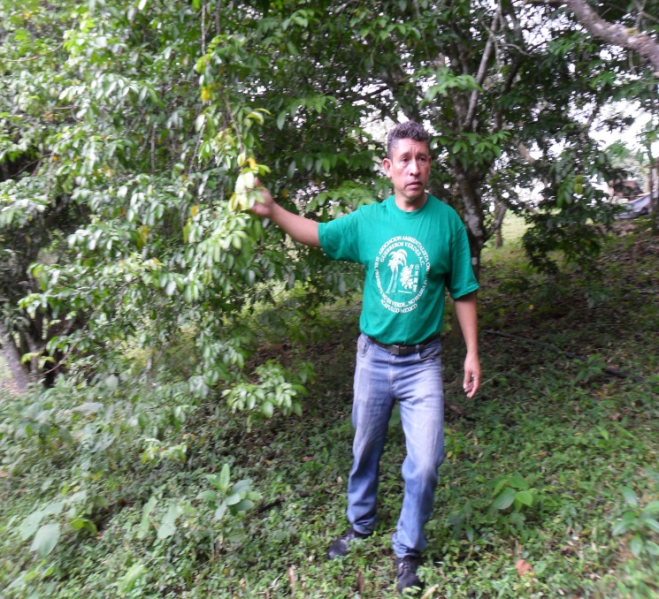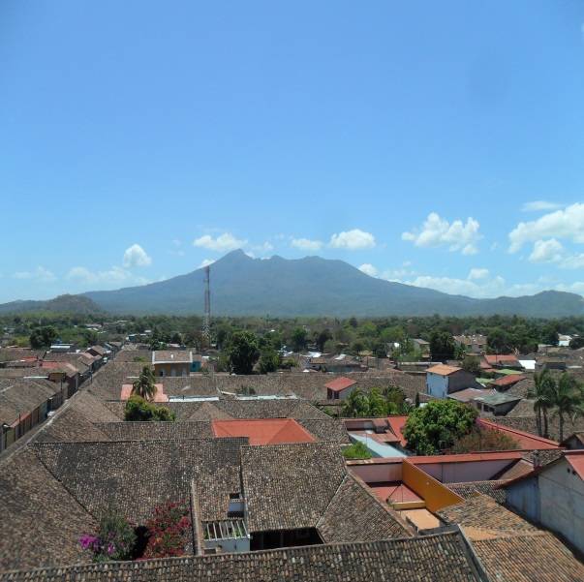

Mothers of the Heroes and Martyrs in Matagalpa with the group

TUANI! We have been in Managua for several weeks now and are becoming more familiar with the *barrio* (neighborhood), classes, service, food, heat, and families.

In the past few weeks we have embarked on several excursions, including visiting the cities of San Ramón, Granada, and Matagalpa; going to concerts (by Carlos and Luis Enrique Mejia Godoy); and explored more local areas in Managua (National Theatre and museums).

We are also now at three different service sites: Olla de Soya, Pajarito Azul, and La Mascota. Our classes are becoming more involved, and our academics have most certainly been enhanced by our time here.

We continue to be busy every day, but we love the fact that we can be involved in so many things here in Nicaragua. We hope this second newsletter gives you a little more insight into the time we have spent here since the last newsletter!

*Also, The title of this second newsletter comes from a song written by Carlos Mejia Godoy; we highly suggest you listen to his song (and the many others by him and his brother as well!)

 Nicaragua, Nicaragüita 

## Update

# Xavier University Solidarity Semester

Inside this issue:

Update 1

Excursions 2

Speakers and Service 3

Featured Professors 4

Fernando Cardenal 5

Featured Families 6

Volume 1, Issue 2

March 26, 2016

### **Matagalpa**

Granada is one of the most well-known cities in Nicaragua. Located near Lake Nicaragua, it once served as one of the major interoceanic trade routes of the 19th-20th century. Granada also served as the headquarters of the Conservative party during the Nicaraguan Civil War in the mid-1800s. During this time, William Walker – a loyal Confederate filibuster from Tennessee – came to help the Conservative party against the Liberal opposition. Once he gained the trust of the Conservatives, he betrayed them in order to establish his own regime and to annex Nicaragua to the U.S. as a slave state. Fortunately, his plans for annexation were thwarted by a joint effort of Central American forces to expel him from the region. Scorch marks from when he burned half the city of Granada during his conquest are still present along some buildings within the city.

Granada is also home to an annual International Poetry Festival. The group was fortunate enough to attend this cultural exhibition of some of the greatest living poets from all over the world. The first night was capped by a performance by Carlos Mejia Godoy, a famous Nicaraguan singer/songwriter most widely known for his music concerning the Nicaraguan Revolution of 1979. Stay posted for our next newsletter which will contain information of our upcoming return to this historic city.

After visiting San Ramon, we had the opportunity to head to Matagalpa but not before quickly stopping at the *Castillo de Cacao* (Castle of Cacao) to buy some delicious chocolate made from cacao beans. In Matagalpa, we met with the *Madres de Heroes y Martires* (The Mothers of the Heroes and Martyrs), a group of women whose children died as a result of being involved in the Revolution and Contra War. After listening to their stories, we visited the grave of Ben Linder (see more about Ben Linder on the next page). We also met with Sister Rebecca Trujillo, who helped to open the first (and only) park in all of Nicaragua accessible to children with handicaps.

## **Granada**

## **San Ramón**

During our excursion to Matagalpa, we had the opportunity to tour an organic coffee farm and to spend a night with the rural community. The coffee farm we visited is owned by a man named Martin Vicente Padilla, a leader in the small town of San Ramón (about 600 residents). Before giving us a tour of his property, Martin Vicente presented the history of the land which included his personal struggle to protect it from local gentry. Martin Vicente told us of stories of the legal, psychological, and physical abuse he and his family received over the rich resources (including potable water) of his property. Fortunately the fixed court hearings, nightly gunshots (for intimidation purposes), and police brutality ended nine years ago when the Department of Matagalpa ratified Martin Vicente’s land title. Now he uses his land to grow organic produce – fertilized with his special blend of compost that promotes the nutrition of the soil – not only as a business but also to protest against the negative health effects associated with the use of petrochemical fertilizers and pesticides in commercial agriculture.

Afterwards, we had an amazing opportunity to spend the night with some members of the San Ramón community. The living conditions in San Ramón are very humble (dirt floors, no indoor plumbing, three-room houses), but this was hardly noticeable due to the warm hospitality that the members of the community gave to us. Our rural stay in San Ramón is one of the most memorable experiences that we have had thus far, as proof, feel free to ask the group about our stories there when we return (they will not disappoint).

Page 2

Meet the Group

Excursions

Page 2

[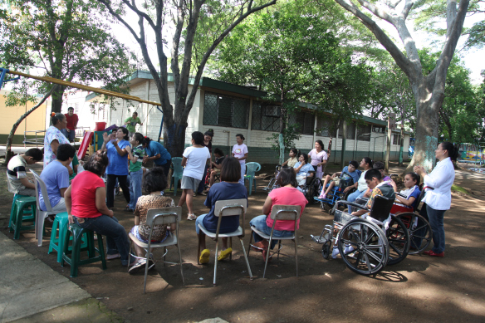](https://hogarpajaritoazul.files.wordpress.com/2011/10/img_4688.jpg)[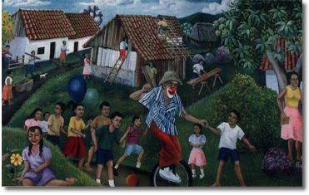](http://www.google.com.ni/url?sa=i&rct=j&q=&esrc=s&source=images&cd=&cad=rja&uact=8&ved=0ahUKEwjUkdmpld_LAhWmmoMKHV5vDN0QjRwIBw&url=http://web.stanford.edu/group/arts/nicaragua/student/linder/&psig=AFQjCNGlALVzAys5e0rTpDoVPtfag8MBVw&ust=1459109667736683)

*Pajarito Azul* (Little Blue Bird) is the service site for Laura, Reyna, and Felipe. It is an orphanage specifically for persons with disabilities. Pajarito Azul has three dorms, each housing either the men, women, or, in the case of the *Osito* (Little Bear) room, children. Although many residents at Pajarito Azul have been abandoned, there are some families that come and visit their children. These families would like to keep their children within their own homes, but lack the resources to take care of them since many residents have complicated medical conditions.

A typical day at Pajarito Azul includes playing games, taking walks, and having snack time. However, on certain Wednesdays, the residents come out to the yard for a dance party. Although many view the situation of the residents of Pajarito Azul as sorrowful because some cannot walk or feed themselves, a closer analysis reveals that every member of the Pajarito community is incredibly joyful. We have learned valuable lessons in accompaniment (the “with” in for and with others), giving and receiving love, and how to persevere in joy through life’s challenges from the residents at Pajarito Azul. The employees at Pajarito Azul – the educators and the two post-grad volunteers (one, Evelin, from Germany and the other, Jeremy, from the Jesuit Volunteer Corps.) – reinforce these lessons through their service rooted in compassion and love.

## Featured Service Site: Pajarito Azul

Founded in 1988, The House of Ben Linder is a place in Managua that serves as a meeting place in Nicaragua, offering support, reflection, and a chance to learn about different things that are affecting the people in Nicaragua. Every Thursday we have the opportunity to attend *las charlas* (the talks) at The House of Ben Linder. So far, we have listened to talks on a variety of topics including justice in Central America, the Christian Base Communities, and Father Fernando Cardenal (see more about Fernando Cardenal on page 5).

Casa Ben Linder is named after a young engineer from Portland, Oregon—Ben Linder—who worked on hydroelectric projects in El Cua in northern Nicaragua. Ben was known for his work in engineering, but he was also often seen riding his unicycle in El Cua, bringing joy to everyone around him. In 1987, he was shot point-blank by the contras, a group of U.S.-trained assassins funded by the Ronald Reagan administration.

### **Casa Ben Linder (House of Ben Linder)**

Page 3

Speakers and Service

Page 4

Featured Professors

### Featured Professors

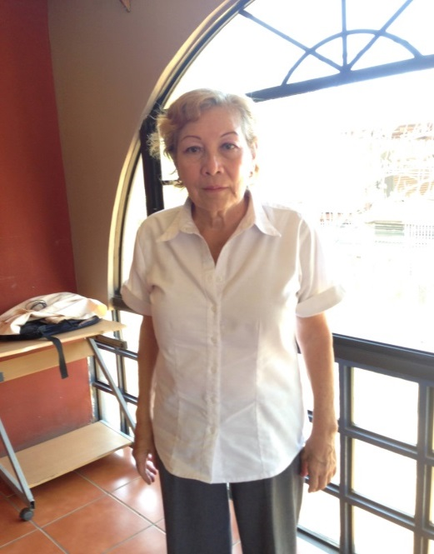

### Professor Myrna

Myrna Zerón is one of the Spanish professors in Nicaragua. She has been teaching as part of the Xavier Nicaragua Solidarity Semester for about ten years. She teaches a very discussion-based class, which really helps with conversational skills. She lives in Jinotepe, Nicaragua with her daughter, Marcela, her dog and fifteen rabbits. (She is currently trying to sell thirteen of them.) She also enjoys making her own clothes for her and her family.

In addition to being part of the Xavier program, she also teaches Spanish for Goshen University. She also is very involved in her Evangelical church as well. She does not really have a favorite kind of food, but she loves when food is grilled. Her favorite color is purple, and her favorite animal is a dog.

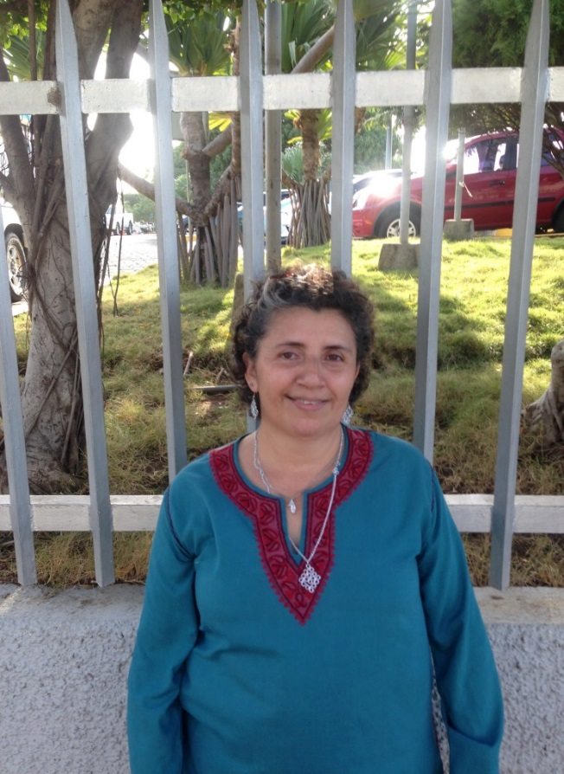

### Professor Mercedes

Profesora Mercedes Aburto is one of the Spanish professors, and she is a very tranquil, kind-hearted woman. Before starting this year (her first with the Xavier program), she had worked with students from Japan and the U.S. in intensive Spanish programs in a Nicaraguan school called Oxford.

Profesora Mercedes is originally from Jinotepe, the capital city of a southern department of Nicaragua called Carazo. Currently she lives in Ciudad Sandino (in Managua) with her two children, Francis and Edwin, and her mom who is disabled.

Although the group is constantly immersed in the Spanish language, our Spanish class (Monday, Tuesday, and Friday) really allows us to fine-tune our speaking skills. With no more than three people in a class, each one of us receives close attention which promotes more accelerated learning. In addition to the small, conversation-oriented style, our Spanish classes augment our knowledge of current events in Nicaragua through our assignments. For example, each of us has to present an article from a local newspaper at the beginning of each class which not only exposes us to new grammar and vocabulary but also in more depth to Nicaraguan society.

### Spanish Class

### Fernando Cardenal, S.J. - A man of faith and joy

We would be remiss if we did not pay tribute to the great Jesuit, Fernando Cardenal, widely renowned for being one of the most inspiring figures of Nicaraguan liberation. Father Cardenal passed away on February 20 after complications with surgery. Father Cardenal was instrumental in his role speaking to the U.S. Congress to denounce the tyrannical dictatorship of the Somoza family. He was also a member of the Group of Twelve, a clandestine junta in Costa Rica that gave leverage to the FSLN (Sandinista Front for National Liberation) against the dictator by seeking support from other countries. His involvement in the Nicaraguan Revolution led to his expulsion from the Jesuits; however, the Vatican later accepted his objection of conscience and readmitted him into his order. In the 500 years of the Jesuits, he is the only person to have ever been readmitted.

After the Revolution, his commitment to the oppressed and marginalized continued in his implementation of the National Literacy Campaign which lowered the illiteracy rate of Nicaragua from 50% to 12% in one year. He also served as the Minister, or as some would say *ángel guardián* (guardian angel), of Education for Nicaragua*.* Father Cardenal later directed an educational program called *Fe y Alegría* (Faith and Joy), which works toward providing quality education to impoverished children. He has been an integral part of the Solidarity Semester in years past and has even visited Xavier in order to share his inspiring stories of courage, love, and commitment to the poor. He is dearly missed by Nicaraguans and others from around the world. *Que descanse en paz* (May he rest in peace).



Fernando Cardenal. Presente, presente, presente!

Page 5

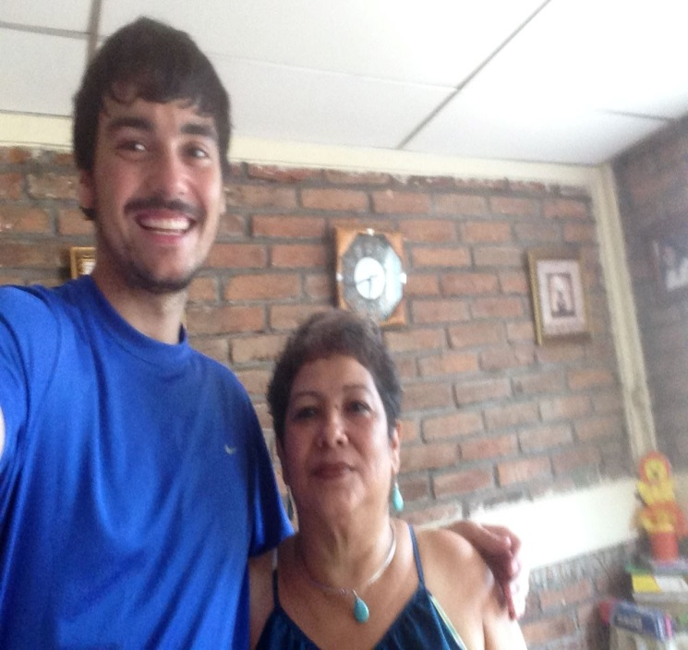

For comments or questions concerning this newsletter, please contact Irene Hodgson at [hodgson@xavier.edu](mailto:hodgson@xavier.edu)

For more information or to apply to this program, please contact Iso Tidjani at [tidjanii@xavier.edu](mailto:tidjanii@xavier.edu)

### Featured Families: Doña Urania’s and Doña Ivania’s

Doña Ivania:

Phil has had the fortune of being placed with Doña Ivania as his host mother. Doña Ivania is a very sweet, welcoming, and intelligent woman whose cooking never ceases to amaze him. Doña Ivania lives with her son, Ivan, and his girlfriend, Norma. Occasionally, her oldest daughter, Tamara, will stop by with her children (Eddy-Leon and Melissa) to visit. Her other daughter, Natalia, works in a tourist hotel in the department of Rivas. Natalia can speak English very well and also comes to stay with Doña Ivania during her days off. In addition to opening her house to students of the Xavier Solidarity Semester, Doña Ivania also rents out rooms to students from the University of Central America (UCA). Currently, Donaldo – a fellow Economics major, but from the UCA – is living with Doña Ivania and her family during the weekdays. In addition to singing and dancing, Doña Ivania enjoys sewing; in fact, many members of the community come to her for their clothing repair needs. As mentioned before, Doña Ivania is a very loving woman, and Phil could not have asked for a better host-mom with whom to share this experience.

Doña Urania:

Our first featured family in this issue is Megan’s host family. She lives with Doña Urania and Don Jorge, along with five of their children: Jorge Ernesto, Maria Fernanda, Chris, Nahomy, and Luciana. Jorge Ernesto’s girlfriend, Marjory, lives with them as well. Doña Urania is a very busy woman as she cooks and cleans for everyone in the house (on top of doing like a hundred other things!) Don Jorge sells and rents property on Ometepe Island with his father, Don Horacio, and Jorge Ernesto and Marjory both work for the government.

The size of Megan’s family in Nicaragua is much different than in the United States. In Nicaragua, she lives with eight other people (sometimes nine or ten--they have a lot of visitors), but in Michigan, she lives only with her mother and grandfather (and two dogs). It has been very different for her, but her Nicaraguan family makes her feel right at home, and she has appreciated the opportunity to have relationships with every member of her family. Megan’s host family loves her presence in the house, and Megan cannot imagine living with anyone else!

Page 6