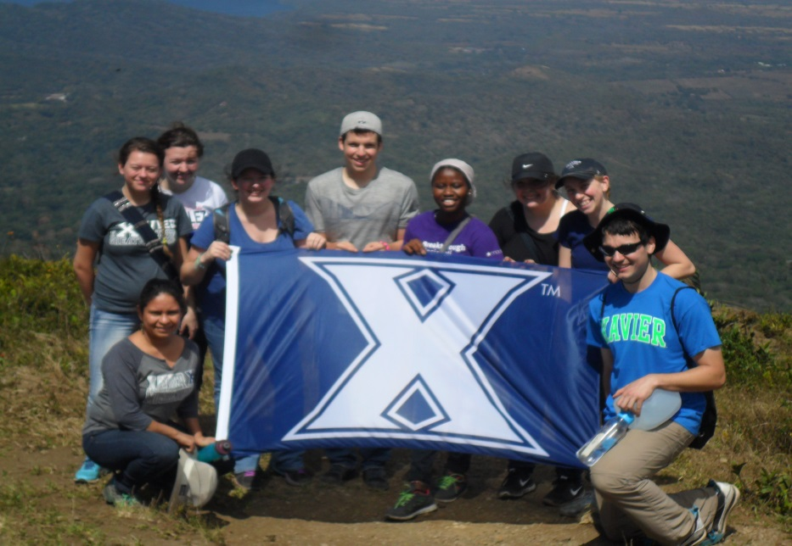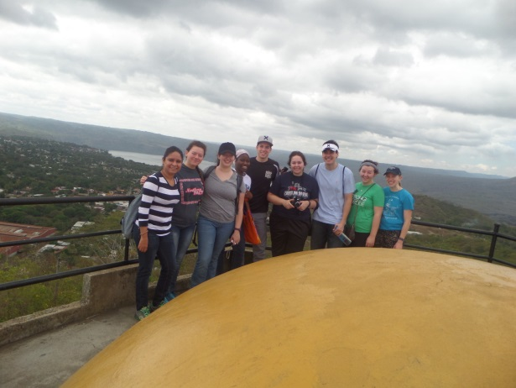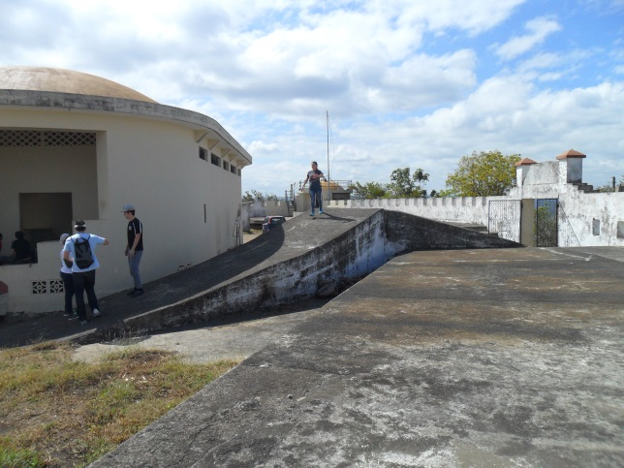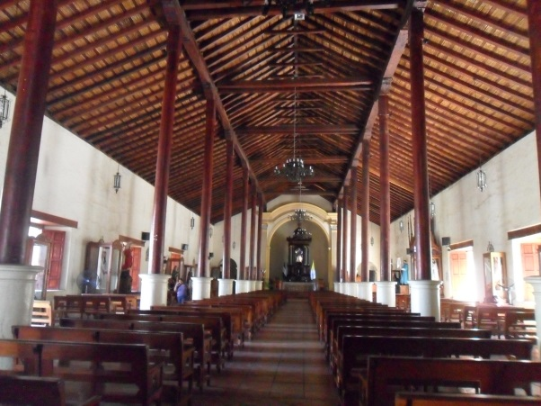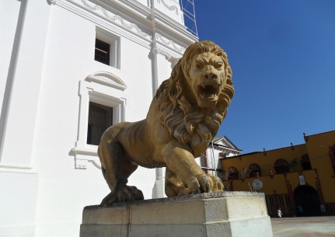

HOLA! We arrived safely in Managua and we were quickly greeted by the Nicaraguan heat, a new language, and the welcoming smiles of the Castro family. We are writing this newsletter to give the Xavier community a glimpse into what we have been doing so far. In the three short weeks we have been here we have already gone on several excursions, started working at our service sites, and becoming acquainted with our new families.

So far we have visited Coyotepe, climbed the Mombacho volcano, toured historical sites in Managua, and visited the old and new cities of León.

In addition to all the excursions, we have also been hard at work at two of our four service sites: Olla de la Soya and Pajarito Azul, both situated in Managua. Our classes also began soon after our arrival. As you can see, we have been quite busy! So we hope this newsletter can give you a taste of everything we have been doing.

## Update

# Xavier University Solidarity Semester

Inside this issue:

Update 1

Meet the group 2

Excursions 3

Academics 4

Featured 5

Welcome to Nicaragua!

Volume 1, Issue 1

February 26, 2016

Picture taken on top of one of the towers in Coyotope

**Kenia and Martin Castro**

Kenia and Martin are both from Nicaragua and are tremendously involved with the Program.

**Irene Hodgson**

Professor at Xavier University and Faculty Coordinator of the Solidarity Semester in Nicaragua

Nica Family: Doña Francisca

**Aichetou Waiga**

Major: Biology

Minor: Spanish

Hometown: Nouakchott, Mauritania

Year: Junior

Age: 21

Nica Family: Doña Nieves, Don Erasmo, Marián

**Morgan Clinton**

Major: Early Childhood Education

Hometown:

Year: Sophomore

Age: 19

Nica Family: Doña Patricia, Frank

**Phil Cooley**

Major: Economics, Sustainability

Hometown: Grand Rapids, Michigan

Year: Junior

Age: 21

Nica Family: Doña Ivania, Ivan, Natalia, Lulú (Dog)

**Laura Wolter**

Major: Undecided

Hometown: Cincinnati, OH

Year: Sophomore

Age: 20

Nica Family: Doña Elba, Don Mario, Hazel, Erenia, Elbita, Mario, Irene, Campanita (Dog), Figaro (Cat)

**Reyna Grundy**

Major: International Studies and Political Science

Minor: Political Thought

Year: Sophomore

Age: 20

Nica Family: Doña Maritza, Don Rubén, Osman, Heidi, Melissa, Miau (Cat)

**Eduardo Patron**

Majors: International Studies and Political Science

Minor: Philosophy

Hometown: Merida, Mexico

Year: Sophomore

Age: 20

Nica Family: Doña Coco, Alisson, Natalie, Tania, Osman, Nazareth, Belen, Junior (Dog)

**Alexandrea Miller**

Major: Biology

Minor: Spanish

Hometown: Dekalb, Illinois

Year: Sophomore

Age: 20

Nica Family: Doña Ana, Don José

**Megan Hanes**

Major: Psychology

Hometown: Detroit, Michigan

Year: Junior

Age: 20

Nica Family: Doña Urania, Don Jorge, Jorge Jr., Chris, María Fernanda, Naomi, Luciana

Page 2

Meet the Group

## **León**

One of our very first excursions was to an old hilltop fort called Coyotepe, which also doubled as a prison and torture center in recent history in Nicaragua. The prison sits atop a hill with a 360 degree view in which you can see the cities of Granada, Masaya, and Managua. As we toured the facility we learned what the gruesome situations were like in the different cells and rooms. We were also told of the horrendous methods of torture that were used on prisoners of war and political prisoners.

After touring Coyotepe, we had lunch in Masaya and walked around an artisans’ market where some of us made our first purchases in Nicaragua. We also got the opportunity to visit the cathedral in Masaya.

### **Coyotepe/ Masaya**

During our third week in Nicaragua, we visited the historical cities of León and León Viejo. We visited a museum in León Viejo commemorating the *conquista* and how the indigenous people of Nicaragua were oppressed and exploited. We toured León with a woman named Azucena who had lived through the recent struggle in Nicaragua, the Revolution that overthrew the oppressive Somoza dictatorship. She is a native of the city of León, which played a massive role in the Revolution as its liberation marked the beginning of the end of the war. Since it was the 100th anniversary of the death of Ruben Dario, we also visited his house. Rubén Darío is known as the poet laureate of Nicaragua.

Managua is where we are staying and we have been familiarizing ourselves with it since the moment we landed. We have visited the Museum of the Revolution, where we learned about the first Nicaraguan Revolution and some of its important figures such as Sandino, Carlos Fonseca and Daniel Ortega among others. We also visited the Museum of *las* *Huellas de Acahualinca*, an archaeological site showcasing footprints found in Nicaragua from about 4000 years ago. Every Thursday, we travel to Casa de Ben Linder where we have the opportunity to hear talks about everything ranging from fair trade to the investigation of the case of the six murdered Jesuits in El Salvador. It is not all serious and that is why we have also attended an opera concert at the Ruben Darío National Theater commemorating the birth of Cuban National Hero, Jose Martí.

## **Managua**

Excursions

Page 3

Page 4

Academics

### Classes

Everything in Nicaragua has been new and surprising. The changes in language, diet, and culture have given us unique opportunities to mature as more well-rounded individuals. Indeed, we have had many opportunities to grow as men and women for and with others, and the main catalyst of this development has been our education. The classes we have been taking [1] are directly linked to the service that we do. At our service sites, we are confronted by the challenging situations of those whom we serve and then to class where we learn how to best use our resources to help others now, and in the future. This combination of academic education and service learning has already challenged us as we wrestle with the realities of socioeconomic injustice in the context of our backgrounds. This struggle has reaffirmed, and in some cases reshaped, our career aspirations and ideologies. Our assignments are difficult not only because our days are long; hot; and unpredictable, but rather because they cause us to critically think about how to use our time and talents to achieve justice. This new way of learning is new and challenging, but also incredibly rewarding and satisfying.

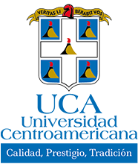

Central Amerian Cutlure and Society

Spanish (Various levels)

Nicaraguan Folk Dance

History of Nicaragua

Academic Service Learning

Liberation Theology

### Featured Professor: Antonio Monte



Professor Monte is our History teacher at the University of Central America (UCA). Professor Monte is originally from Argentina. He also lived in Costa Rica, but has been a Nicaraguan resident for over 15 years. So far, we have learned about the history of the Natives in Nicaragua and their struggle to maintain their identities amidst the hardships they have faced through the Spanish conquistadores, the history of the political parties and the dictatorial Somoza regime. At the end of each lesson, Professor Monte leads a discussion that ties past problems to modern-day issues so that we are able to learn what roles we all play in them and what we can do to participate more actively.

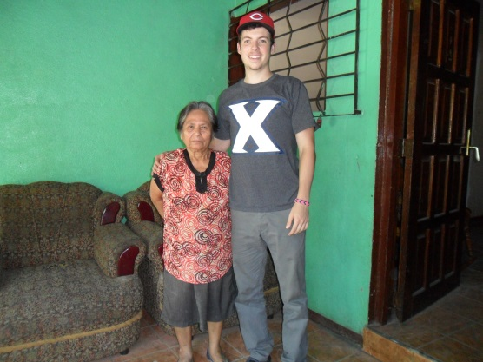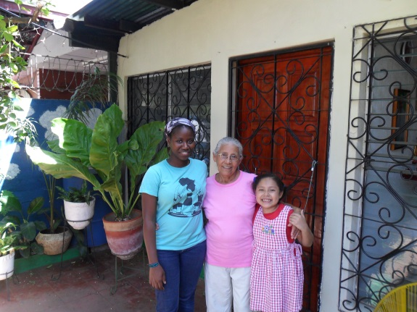

For more information or to apply to this program, please contact Iso Tidjani at tidjanii@xavier.edu

Doña Nieves is Aichetou’s host mother. She has been with the program for about 20 years and continues to be a vital part of it. Doña Nieves has been living in the barrio since a little before the Revolution. She is extremely involved within the Catholic Church and the neighborhood, leading a Bible Study Group and hosting gatherings in her home. “Doña Nieves is a great mother. She is constantly making sure that I got enough sleep and enough food in my tummy. I can just tell she cares about me and it’s only been a month!”, Aichetou said. Doña Nieves lives with her grand-daughter Marian (8) and her husband Don Erasmo. She has a sewing business in her house and the house is often welcoming someone in the neighborhood who needs their pants or skirt fixed. In addition to her job, she cooks and takes care of everyone in the house. She diligently wakes up at 5:00 am every day and does not rest until she gets to bed at around 10:30 pm. She wakes up the next morning and does it all over again with a smile on her face. Doña Nieves is an incredible person and anyone would be lucky to have her as a host mother!

Our first featured family is Eduardo’s host family. He lives with Doña Coco (featured on the left) and her family. She is a very busy woman as she is a mother of seven children, grandmother of 16 grandchildren and is even a great grandmother to 11! Doña Coco is a woman who is full of love and looks to see how she can spoil us rotten. It took Eduardo no time at all to feel right at home in Doña Coco’s house.

Doña Coco also played a part during Nicaragua’s revolution. Her home was a “safe house” where people would go to find a place to stay clandestinely as they carried on the fight against the oppressive Somoza regime. Apart from her role in the revolution, Doña Coco is also one of the founders of a Christian base community in the neighborhood. In addition, Dona Coco has been a host mother for Xavier students for over 20 years.

### Featured Families: Doña Coco and Doña Nieves Nieves

One of the service sites we have begun working at recently is Olla de la Soya San Rafael. Olla de la Soya is an organization that provides nutritional supplements for children that are underweight in the nearby area and also serves as a preschool in the mornings. The children there are between the ages of two and five years old and the nutritional supplements are all soy-based to hold them over better until their next meal.

Our work at Olla consists of interacting with the kids, helping the two teachers give lessons and also helping the volunteers in the kitchen with whatever they need. The volunteers at Olla are mostly mothers of children who are in the program and carry out their work with tremendous love and pride.

## Featured Service Site: Olla de la Soya

Page 5