An Invocation of Our Ignatian Gifts

Today, together, we call to the divine, offering humility and faith, asking for strength and guidance.

We give thanks for every talent and voice contributing to the great work of our university.

Together we look forward to new horizons, choosing to leave safe harbors to pursue the greater
good. This is magis, a space of courage, of perseverance, of beneficence .

Together we pause on new shores, reveling in the life-giving comfort through which we heal and
celebrate our best selves. This is cura propria, a space of peace, of gratitude, of renewal.

Together we champion learning, the extraordinary project to which we have been called at this
university—a project that is inspiring, transformational, and challenging. We seek and build and value new knowledge, both inside and outside our walls. We train together to pursue truth for good reasons and to just ends. This is cura studiorum, a space of creativity, of curiosity, of patience.

Together we honor our breadth of commitments to tend this institution, our garden. We nurture all
the components over which we have been called to steward, from the largest trees to the smallest buds. We bask in the aroma of each new blossom. This is cura apostolica, a space of collaboration, of humility, of benevolence.

And finally, together we celebrate, at the center of this garden, our support for the whole person.
We offer love and advocacy for each multifaceted individual, constructing rich environments that bolster new lives. This is cura personalis, a space of joy, of generosity, of fulfillment.

For these gifts we give thanks. Amen.

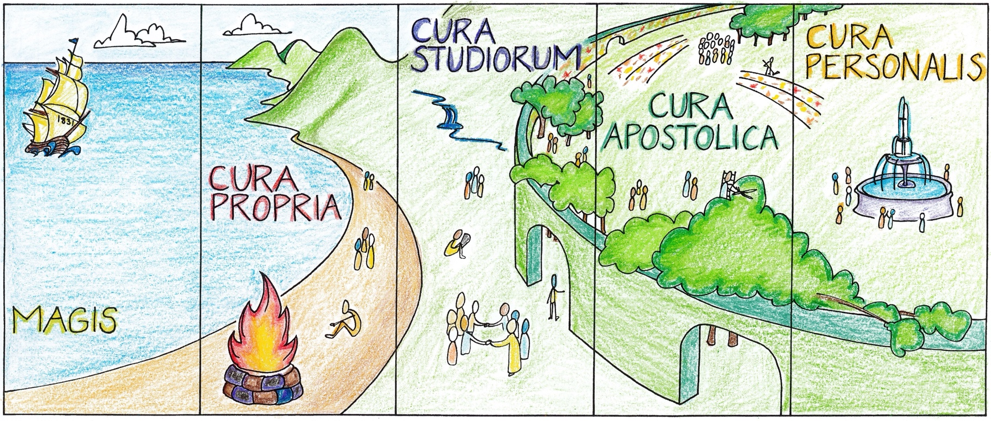
S. Yandell

The Gifts of Ignatian Heritage Banners, Spring 2023

Like Xavier’s first five Ignatian banners, this tapestry honors five new Gifts of the Ignatian Heritage and offers viewers a visual mnemonic. Read left to right, the tableau attaches each gift to a moment along a narrative landscape in order to make the list more memorable. The collective image, like the imagined space, is meant to be immersive and contemplative.

The landscape begins where the last banners left off, just as the sun rises over the fruit groves of Mission. The life-giving warmth of Mission thus anchors both sets of images.

The first new banner depicts a multi-sailed ship bearing 1831, Xavier’s founding date. The clipper ship represents not simply Xavier University’s fortitude, but also magis, our call to seek the greater good in all situations. Our Strategic Plan asks us to be adventurers: to explore, leave safe harbors, and embrace the challenge of new horizons. The ship also is meant to reinforce magis not as an act of “taking on more” but relying on one’s own buoyancy, trusting in the support of the surrounding seas, and directing with confidence one’s helm toward truth.

The second banner invites viewers to rest on calm shores. Cura propria offers rejuvenation through our commitment to self-care. Warmed by a beachside fire, individuals are nourished both alone and with others as they eat, sleep, play, talk, and think.

The beach offers access to the third banner, where multiple large garden gates open to the university. Cura studiorum champions learning both inside and outside the garden’s walls. To support the pursuit, creation, and exploration of knowledge, the university makes available a breadth of resources, including people, texts, objects, and experiences.

In the fourth banner, viewers find themselves amidst a multitude of people, witnessing the vast efforts required to tend the garden: cura apostolica. Whether as individuals, pairs, or teams, our large, supportive community works together in its commitment to care for the institution. This includes planting seeds, watering plants, trimming trees, and encouraging blossoms.

The fifth banner opens onto the center of the garden: cura personalis. Here a large fountain signifies the life-giving heart of the university. As water feeds the lush, open glade, individuals find themselves nourished on all sides and in all aspects of their multifaceted personhood.

Banners three through five borrow from a particularly significant metaphor in medieval poetry, that of the enclosed garden and the life-giving fountain at its center. Le Guillaume de Lorris’s Roman de La Rose, the Lais of Marie de France, and Geoffrey Chaucer’s Parliament of Fowls all invoke these images to varied degrees and point not simply to nourishment, but to deepest fulfillment.

The design of the banners is meant to allow all individuals to find themselves represented and to offer multiple connections to the work of Xavier University.

Stephen Yandell, Department of English

