Lead with Ignatian Gifts

*Decision Making Examen: Walk the path of Leadership with Ignatian Communal Discernment*

Use this guide w/ photo on the back to think through a decision mentally.

Take this guide to the Labyrinth on campus and physically walk through a decision.

1. Begin the Process in a state of Ignatian indifference

* Approach the Labyrinth with an impartial mindset. Stand with a pause at the start of the Labyrinth with REFLECTION. Use this pause to get some perspective of the challenge that lies ahead of you and ask yourself the reflection questions (on back).

1. outline the pro’s and con’s of the decision

* Start walking the path, considering the pro’s and then the con’s of your decision. Weigh your issues and concerns in light of the mission’s values and vision.

1. Be a contributor and an active listener in brainstorming a solution

* Reach the top of the loop and look back to where you entered. Welcome in the opinions and contributions of others in your process.

1. Presume good intentions on the part of others

* Although the path of the Labyrinth seems to go in one direction, notice that there are many alternatives to get through the maze. Use this thought to realize the different viewpoints on your issue and try to see it through other people’s eyes.

1. notice God’s presence and will

* Start to walk your path again balancing your agitation or disharmony (Ignatian Desolation) with feelings of peace and inspiration (Ignatian Consolation). Notice that the pavers of the path do not match each side in number. Yet still there is a balance in the entirety of the whole. Mirror this balance with your decision process.

1. deliberate until there is a shared contentment and decision

* Stand in the center circle and feel the gratitude of God’s light. Leave with a decision and exit. Or walk in reverse on the path for further deliberation until you can leave with a resolution that you feel you can bring to the group that will unite all.

1. Enter the maze feeling the invitation to be open to God’s spirit and take action with the intent to contribute good as you engage in Ignatian Communal DISCERNMENT.

Michelle Dietz

Assistant Director

Xavier University Auxiliary Services

xavier.edu/auxiliary-services I (513) 745-2935



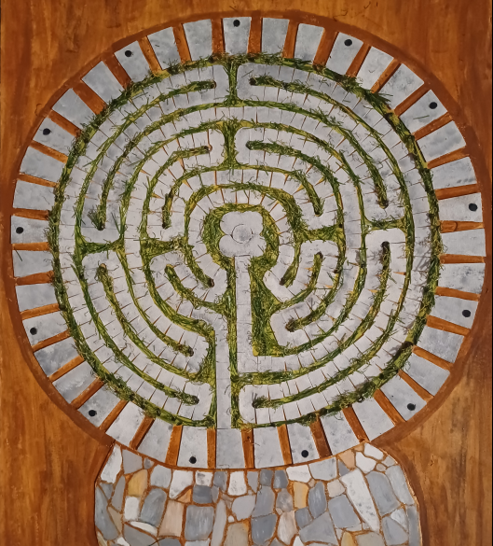

**Consolation**

**Desolation**

**CON’s**

**PRO’s**

**GRATITUDE**

**WELCOME**

**other views**

**DECISION**

**Shared**

**Contentment**

**Pause**

**REFLECT**

**Enter with Ignatian Indifference**

**BALANCE**

As we reflect on departmental decisions we will walk the path of Leadership with Xavier Ignatian Communal Discernment. As we Reflect into the decision we will ask ourselves:

1. How will the decision I am about to make recognize and respect the inherent dignity of every person in the Xavier Community?
2. Is our decision perspective broad and inclusive enough to encompass identities that are not currently represented at the table?