**Institutional Research’s Information Support Cycle as Gifts of Ignatian Heritage**

*Craig This, Director, Office of Institutional Research*

*April 12, 2024*

Participating in both Assuring the Future Mission and Identity of Xavier (AFMIX) and Xavier’s Seminars on Ignatian Leadership during the same term has placed a demand on time (3 hours each week with 1 ½ hours for each respective program). The focus on AFMIX I have found to be one of personal self-reflection and growth, a much more intimate discussion of who I am as an individual and my personal faith and beliefs. Whereas the focus of the Ignatian Leadership has been on the practical side of leadership development and traits. While there has been some repitition of topics, I have found that rather helpful as I am non-Catholic and have been at Xavier University just four years. The first exposure, in AFMIX, to Ignatian and Jesuit values and beliefs provided an introduction and, more times than not, left me dazed and confused—so much information in such a short period of time. Thankfully, the second exposure, in Ignatian Leadership Seminar, allowed me to build on what I had heard and read in AFMIX and the “second time through” provided me with greater insight and context of things I had not seen the first time around. So, it was with Dr. Stephen Yandell’s overview of the Ignatian values (2023, 2024).

**Ignatian Values**

Dr. Yandell presented the Ignatian Values, which Xavier University refers to as [“Gifts of Ignatian Heritage”](https://www.xavier.edu/president/mission):

* REFLECTION invites us to pause and consider the world around us and our place within it.
* DISCERNMENT invites us to be open to God's spirit as we consider our feelings and rational thought in order to make decisions and take action that will contribute good to our lives and the world around us.
* SOLIDARITY and KINSHIP invites us to walk alongside and learn from our companions, both local and afar, as we journey through life.
* SERVICE ROOTED IN JUSTICE AND LOVE invites us to invest our lives into the well-being of our neighbors, particularly those who suffer injustice.
* CURA PERSONALIS invites us to care for others recognizing the uniqueness and wholeness of each person.
* MAGIS invites us to ask, “Where is the more universal good?” when making decisions; it relates to the Jesuit motto, For the Greater Glory of God.

In our second exposure to these values, I realized that I had seen them in our work as institutional research practitioners. The Ignatian values mirror those of the “Information Support Cycle” (Figure 1) found in McLaughlin and Howard (2004) *People, Processes and Decision-Making* (pp 11-14).

**Figure 1**

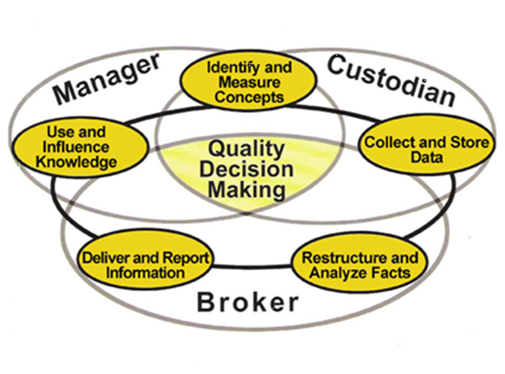

**Reflection**

Reflection, which invites us to pause and consider the world around us, is the first stage in the information cycle, which is known as “Identifying and Measuring Concepts.” When our office is presented a research request, a research project from a university stakeholder, we pause and consider the world around us. As McLaughlin and Howard write, “Identifying and Measuring Concepts” calls upon institutional researchers to

Develop a conceptual model of the situation. Describe its major components. Include measurements which explain the feasibility of alternatives, desirability of outcomes, and availability of resources. Identify the key individuals and groups of individuals who have a stake in the process. Define the essential elements required to make the decision. (11-12)

This is reflection, the first gift of Ignatian Heritage and the beginning of the information cycle. We take the request, pause, and identify the key individuals and groups who have a stake in the process while identifying the essential elements to make a decision as well as understand the world around us—the program, the department, Xavier University, and the world of higher education.

**Discernment**

Discernment, which is the second stage of the information cycle “collecting and storing of data”, invites us to be open to God's spirit as we consider our feelings and rational thought in order to make decisions and take action that will contribute good to our lives and the world around us. As was described by Fr. Nathan Wendt, discernment isn’t about deciding between good and bad, but between better and best, which is what we are trying to do at this stage (Wendt, 2024). We are trying to get the stakeholder the best data for his or her request so that he or she can make the best decision. As McLaughlin and Howard write:

Obtain data from various relevant sources. Include qualitative as well as quantitative facts. Store data so that they are secure and accessible to authorized users. Use technology where appropriate. Standardize the codes used and develop a collection of definitions and documentation. Edit and audit for correctness. Document the procedure, the situation, and the process of data capture and storage. (12)

This is discernment—we are focused on what is best. If the goal, from a Jesuit perspective, is what is the more, the greater good, and if the goal, from an institutional research perspective, is quality decisi0n-making then the decision should not be between what is good and what is bad. Rather, it should be between what is better and what is best. That is how we will achieve quality decision-making and that is how we will achieve the greater good.

**Solidarity and Kinship**

Solidarity and Kinship, which parallels the third stage of restructuring and analyzing facts, invites us to walk alongside and learn from our companions, both local and afar, as we journey through life. Once we have the data, then, yes, we need to walk alongside and learn from the stakeholder. We cannot and should not as the saying goes “when all else fails manipulate data,” we can as McLaughlin and Howard state, “summarize and focus the data on the stituation . . .[and] describe the limitations in the methodology.” As institutional reseachers, we have have a [code of ethics](https://www.airweb.org/ir-data-professional-overview/statement-of-ethical-principles) that we abide by and follow, which leads into the next gift of Ignatian Heritage.

**Service Rooted In Justice and Love**

Service Rooted in Justice and Love invites us to invest our lives into the well-being of our neighbors, particularly those who suffer injustice. This corresponds to the fourth stage of the information cycle, which is to deliver the data—in essence we are serving others. Again, as McLaughlin and Howard write,

Apply the information to the situation. This includes using appropriate delivery technology to make the restructured facts available for further restructuring. Interpret instances where there may be differences or gaps between the collection of the data and the current need to make decisions. Identify systemic sources of bias. Focus reporting on the specific alternatives and support interpretations of causality and desirability of outcomes. (12)

This, then, is service rooted justice and love. Not only do we “apply the information to the situation” but we are to indicate where there are gaps and identify biases. The work of institutional research is to help units, programs, and departments overcome injustice whether it be low graduation rates of Pell Grant students or the lack of representation of women in the STEM fields to name just two.

**Cura Personalis**

Cura Personalis invites us to care for others recognizing the uniqueness and wholeness of each person. The fifth stage of the information cycle, “Use and Influence Knowledge,” states we return to

Use facts to clarify the situation, to make a decision, or to advocate a belief or value. Identify the way the new knowledge expands the previous understanding. Determine the changes in the environment and what is assumed about the situation. Consider the importance of new information relative to the issues incorporated in the previous conceptual model. (Howard and McLaughlin, 2004, pp. 12-13)

When McLaughlin and Howard state “use facts to clarify the situation,” “identify . . . new knowledge,” and “consider the importance of new information” is that not recognizing the uniqueness and wholeness of each person?

**Magis**

The final Ignatian gift, towards which all this is driving, is Magis. Magis invites us to ask, “Where is the more universal good?” when making decisions; it relates to the Jesuit motto, For the Greater Glory of God.

This the center of this information cycle—making quality decision making. Quality decision making is answering the question “where is the more universal good?” Just as all the steps in the information cycle lead to and revolve around quality decision-making, so, too, do the gifts of Ignatian heritage lead to and evolve around Magis—the universl good.

But, we should recognize that both Magis and quality decision-making while an end goal are by no means a stopping point. The gifts of Ignatian heritage and quality decision-making should not stop because our Ignatian values call us into continous reflection and discernment. The institutional research information cycle is just that—a cycle. And, once we have made revolution, we ask ourselves “what is the more univeral good?” We see this cycle elsewhere in Jesuit learning and at Xavier University whether it be the [labyrinth at Xavier](https://www.xavier.edu/now/2023/musketeer-meditation-xavier-new-labyrinth) University or the the Ignatian Pedagogical Paradigm (Figure 2) provided by Dr. Diane Ceo-DiFrancesco (2024).

**Figure 2**

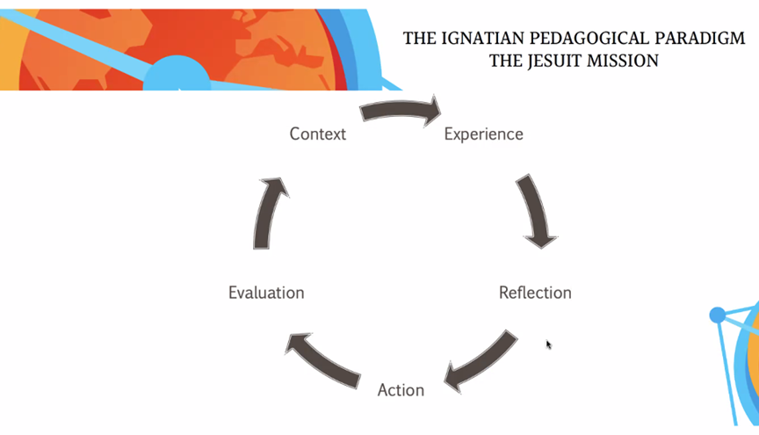

Other faith traditions have a similar on-going process of reflection and discernment. John Wesley had as a premise for his Methodist movement the “[moving on to perfection](https://www.umc.org/en/content/what-did-john-wesley-mean-by-moving-on-to-perfection)” The Buddhist’s have their Eightfold Path to [Enlightenment](https://tricycle.org/beginners/buddhism/what-is-enlightenment/). On a secular level, there is American football coach Vince Lombardi’s famous quote to the Green Bay Packers: “Gentleman – we’re going to relentlessly chase perfection - knowing full well we won’t catch it because nothing is perfect. But, we are going to relentlessly chase it because in the process we will catch excellence.”

*Ad Majorem Dei Gloriam*

**Works Cited**

Ceo-DeFrancesco, D. (2024). *Transformation and Justice through Jesuit Education.* AFMIX Presentation, March 27, 2024.

McLaughlin, G. & Howard, R. (2004). People, Processes, and Managing Data, 2nd ed. Tallahassee, FL: Association of Institutional Research, 2004.

Wendt, N. (2024). *What is Discernment? and How Do I Really Know It Is God? Consolation and Desolation.* AFMIX Presentation, February 7, 2024.

Yandell, S. (2023). *Xavier's Jesuit Values, Vision, and Mission.* AFMIX Presentation, November 14, 2023.

Yandell, S. (2024). *Xavier's Jesuit Values, Vision, and Mission.* Xavier’s Seminars on Ignatian Leadership, February 7, 2024.

Office of Institutional Research Reading List for the Gifts of Ignatian Heritage

A Work in Progress

Inspired by Gary Massa’s reading list from his presentation, I have begun compiling a list of books to read in conjunction with the Gifts of Ignatian Heritage

REFLECTION

*How to Train a Wild Elephant: And Other Adventures in Mindfulness* by Jan Chozen Bays

*The Miracle of Mindfulness: An Introduction to the Practice of Meditation* by Thich Nhat Hanh

*The Three Questions* by Jon J. Muth

DISCERNMENT

*The Blueprint: 6 Practical Steps to Lift Your Leadership to New Heights* by Douglas R. Conant

*The Inner Game of Tennis: The Classic Guide to the Mental Side of Peak Performance* by W. Timothy Gallwey

*Wisdom of the Bullfrog: Leadership Lessons from a Life of Service* by William H. McRaven

*Upstream: The Quest to Solve Problems Before They Happen* by Dan Heath

*The Way of Nagomi: How to Find Peace & Harmony in Your Life* byKen Mogi

*Your Next Five Moves: Master the Art of Business Strategy* by Patrick Bet-David

SOLIDARITY and KINSHIP

*Agents of Grace: How to Bridge Divides and Love as Jesus Loved* by Daniel Darling

*The Boys in the Boat* by Daniel J. Brown

*I'm Still Here: Black Dignity in a World Made for Whiteness* by Austin Channing Brown

*WOLFPACK: How to Come Together, Unleash Our Power, and Change the Game* by

Abby Wambach

SERVICE ROOTED IN JUSTICE AND LOVE

*Braving the Wilderness: The Quest for True Belonging and the Courage to Stand Alone* by Brené Brown

*David and Goliath: Underdogs, Misfits, and the Art of Battling Giants* by Malcolm Gladwell

*Demystifying Disability: What to Know, What to Say, and How to Be an Ally* by

Emily Ladau

*The Universal Christ: How a Forgotten Reality Can Change Everything We See, Hope For and Believe* by Richard Rohr

CURA PERSONALIS

*The Boy, the Mole, the Fox and the Horse* by Charlie Mackesy

*The Gifts of Imperfection* by Brené Brown

*No Mud, No Lotus: The Art of Transforming Suffering* by Thich Nhat Hanh

*The Perfection Trap: Embracing the Power of Good Enough* by Thomas Curran

*Trusting God in Hard Times: Lessons From the Life of Elijah* by Bill Crowder

MAGIS

*Let Us Dream: The Path to a Better Future* by Pope Francis