Circle the top 6 attributes that you believe are
most important in a leader
*THE most important
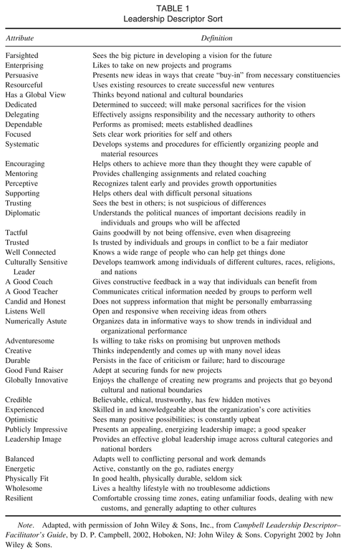
Year of birth___________
Gender______

