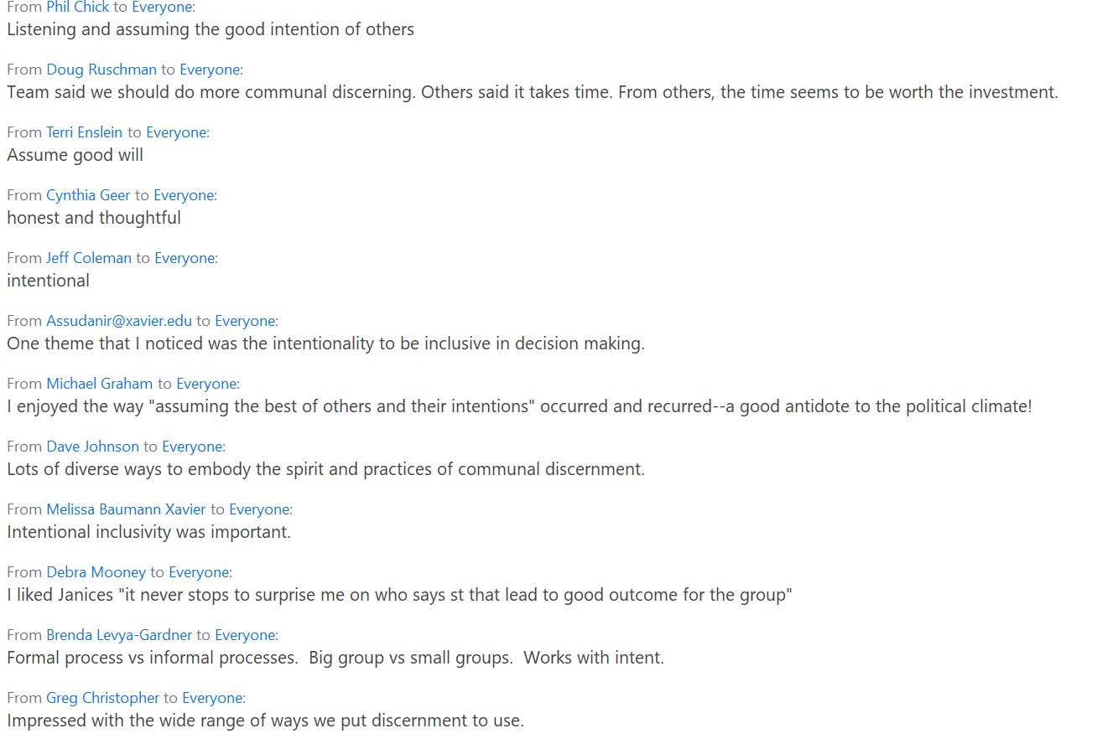

**Cabinet Chat Box Reactions and Learnings to the**compilation of examples leading with an Ignatian Communal mindset