AFMIX PARTICIPANTS - COHORT “XI”
Jessie Arnold  I earned my Bachelor’s and my Master’s at Western Kentucky University in Bowling Green, KY. My husband and I moved to Northern Kentucky in 2016 so he could pursue his Master’s at Xavier. Before becoming a Success Coach at Xavier, I worked at other higher education institutions in the Office of Admissions. I enjoy spending time with my family and friends, meal prepping for the week, and watching Survivor (yes, it is still on)! | 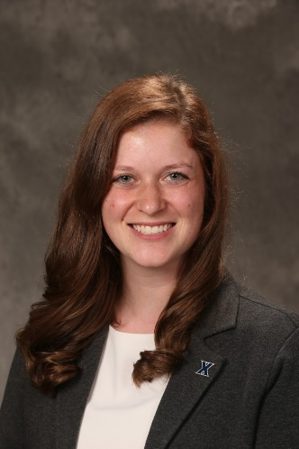
Andy Barry  I have just completed my 31st year at Xavier University and am now the Assistant Athletic Director for Business and Finance. Previously roles I have held are the Director of Business Operations, Director for Premium Seating and Ticketing, Licensing Director, Compliance Assistant and Athletic Ticket Manager.  I came to Xavier in 1988 after spending two years in the Cincinnati Reds' Ticket Office.  My bachelor's degree is from UC and MBA from Xavier.  I was involved with the LaSalle High School drama department for nine years. I am active with the Boy Scout troop at St. James in White Oak.  I live in Colerain Township with his wife, Jenny and has three grown children. | 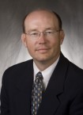
Kirby Bell
Hello! My name is Kirby Bell and I am the Kuhlman Hall Director. I am originally from Portland, OR and new to Cincinnati. I went to a Jesuit high school and university so I am very passionate about the Jesuit mission and so excited to see what this year has to bring!
Brenden Bergen  I'm a Content Producer in the Office of Marketing & Communications beginning my sixth year at Xavier. Prior to switching to my current role, I spent nearly five years in Xavier Athletics as a communication coordinator.  I was a history major at the University of Dayton ('09) and also completed a master's degree at DePaul University ('14). I've spent most of my professional career in higher education, including stops at Case Western Reserve, Wake Forest, DePaul and now Xavier.  In my spare time, I love to golf and watch the Reds. I live in Pleasant Ridge with my wife, Andrea, and our dog, Ruthie. | 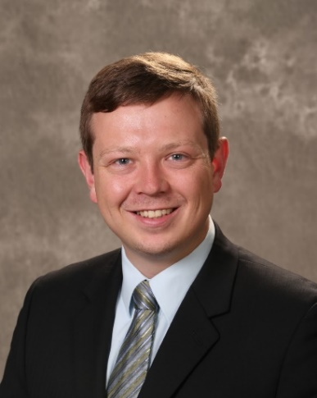
Jenny Broomall
My name is Jenny, I work in Alumni Relations. I have been with Xavier since February 2018. I am from Alexandria, KY where I live with my youngest son Sam and his two dogs, Cooper and Archie, total I have 5 children and a granddaughter Charlotte. I am also working on my BLA degree through APEX. I am also a weight watcher WW leader very part time, I love meeting new people!
Barb Bruns-Mueller
Prior to coming to Xavier to serve as an Academic Success Coach in the ABSN program, I worked as an Academic Coordinator for the West Chester/Liberty Boys and Girls Club, an adjunct English Instructor at Cincinnati State, and a high school English teacher for eighteen years. Outside of work, I am a mom to a 15-year-old son and 22-year-old daughter. I enjoy live music of almost any kind, as well as traveling and educational podcasts about medicine, history, and crime.

Clare Bunning
Hello! My name is Clare Bunning and I’m the HR Assistant in the Office of Human Resources. I’ve been a part of the Xavier community in different roles for the last 10 years. I’ve had the unique experience of navigating Xavier University as a basketball fan, prospective student, undergraduate student, graduate student, financial aid office student worker, bursar’s office employee, GOA instructor, and now human resources employee. I’m a Cincinnati Native. I live in Blue Ash, Ohio. In my spare time, I enjoy reading, spending time with friends and family, and traveling whenever I get the chance.
Jeff Coleman  I was born and raised in KY and attended NKU. I currently live in Union KY with my wife Brigitte. I was raised Pentecostal but my current religious affiliation is Southern Baptist.  I joined Xavier in 2012 as the AVP of Audit and Risk Mgmt. and have held a number of positions at Xavier including interim CFO and interim Police Chief (twice). My current position is VP of Risk Mgmt with direct responsibility for Campus Police, Audit, Compliance and Insurance.  Prior to joining Xavier I had over 25 years of progressive experience in audit, security and law enforcement in both corporate roles and most recently with the FBI. | 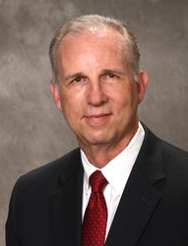
Rosalyn Collins  Rosalyn Collins is one of the brightest stars in higher education in Greater Cincinnati. She has served as Assistant or Associate Director in several offices at the University of Kentucky, Miami University, University of Cincinnati and now Xavier. In all of her professional roles as an Assistant Director, she has reimagined, rebranded, and our founded new centers and offices. She also has a Master’s degree in Student Affairs in Higher Education with a concentration in Diversity, Equity, & Culture. She specializes in diversity and social justice education and has created programs and robust curriculum on topics of equity and inclusion. | 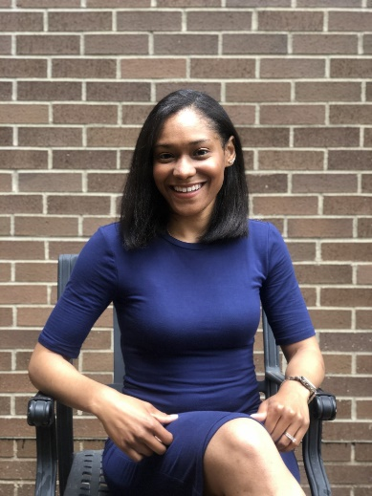
Chloe Connelly  My name is Chloe Connelly and I’m an analyst in the Office of Institutional Research. I’ve been at Xavier for a little over a year and a half. I love reading, traveling, and listening to podcasts. I was born in Oregon and have lived all over the U.S. I currently live in Northside with my husband (as of this summer!) and our dog, Odin. | 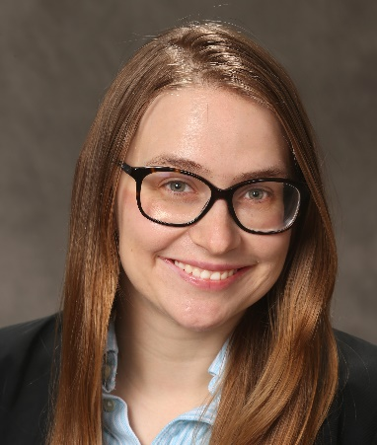
Jillian Dolciato  Hi! I’m Jillian! I’m the Assistant Director of Aquatics and Risk Management for Recreational Sports. I’m heading into my third professional year at Xavier. For my first two years I served as the Club Sport Coordinator. In addition to being a staff member, I’m also a proud Xavier alum; I graduated in 2013 with a math degree. Prior to returning to Xavier in 2017, I worked for Florida Southern College and served as the Orlando Alumni Chapter President. This year, I am most looking forward to moving into the HUB, being part of AFMIX, and spending time with my new dog Ellie! | 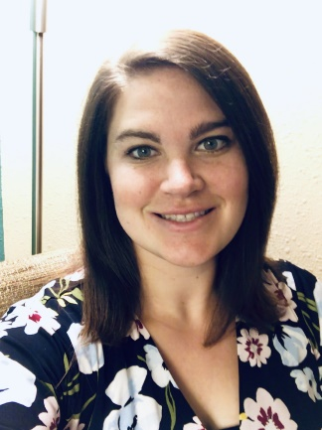
McKinley Estime  Hi! My name is McKinley Estime and I am coming to you all from Canisius College in Buffalo. I fell in love with Jesuit Education there and chose Xavier to continue learning and exploring the Jesuit values. I am new to the Cincinnati area! Can't wait to get to know you all! | 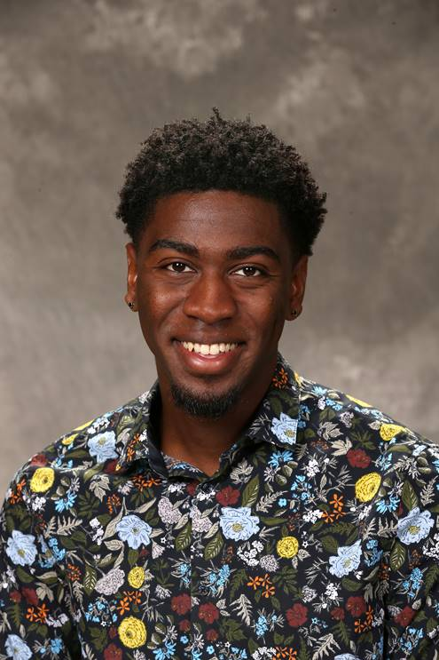
Kathleen Flanagan  I am originally from Massachusetts, and have lived in Cincinnati since 2011. I work in Tech Services at McDonald Library, in Collection Management (periodicals and electronic resources). I have worked in libraries most of my career, in a variety of roles, and also have worked as a copy editor. I have been at Xavier for about three months, and was drawn to work here because of its sense of mission and its emphasis on educating the whole person, including spiritual development. In my free time I enjoy hiking, birdwatching, playing traditional Irish music with friends, singing in my church choir, road trips, and (lots of) reading. | 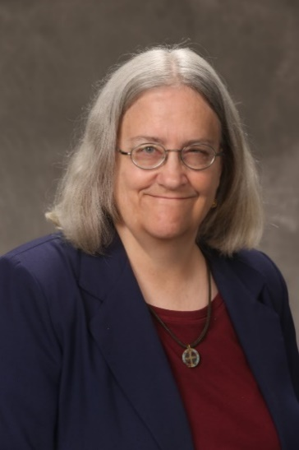
Morgan Gill
Morgan Gill is just starting her journey here at Xavier. She currently works in the Department of Residence Life and is the Hall Director for Brockman Hall. She is so excited to be here and to learn more about Xavier and Jesuit education.
Joel Houlette  My name is Joel Houlette and I get to be the Husman Hall Director, as I have since July of 2018, in the Office of Residence Life here at Xavier. I am originally from Louisville, KY, and have attended the University of Louisville and Indiana University for my schooling. I have worked in housing and residence life since graduating from UofL, and most recently worked at IUPUI as a graduate hall director. I am looking forward to exploring and affirming the mission and identity of Xavier with you all, and to getting to know you all better as well shortly! | 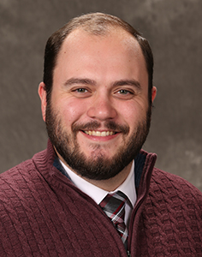
Ashley Holthaus  Hi everyone! My name is Ashley Holthaus and I use she/her pronouns. I am new to Xavier this year and am lucky to work as the Apartments Director for the Office of Residence Life. I am coming from California Institute of the Arts where I worked for the past two years as a Residence Life Coordinator, though I am from OHIO! I am excited to get to know everyone and learn together! | 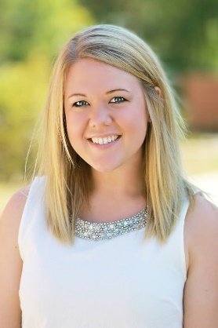
Ellen Hurst
Road to Xavier: Miami University (Economics; B.S.); Miami University (Economics; M.A.);
Research Interests: Housing Economics; Economics of Education; Poverty;
Teaching Interests: Micro Principles; Macro Principles; International Trade and Business Environment
Life Interests: My family; Running; Yoga; Gardening;
Judy Janzen  Judy Janzen is the Administrative Assistant to the program director for the Health Services Administration undergraduate program. She completed her Bachelor’s degree in Liberal Arts, graduating with cum laude honors, and Master’s in Education, in Administration at Xavier. She holds Project Management and Lean certifications and a degree in business administration. In her role, she acts as program coordinator, managing the workflow for student records and reporting, performs academic advising, and has been recognized for her outstanding work with student retention and persistence efforts. | 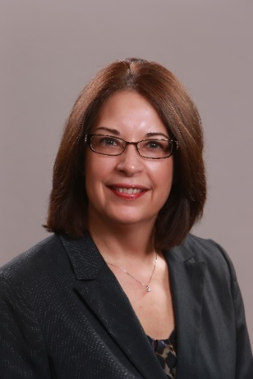
Megan Kickbush  Megan Kickbush is the new Head of Access Services at McDonald Library. She has been married for just over 4 years to her husband, Mike. They are active in their church, The King's Chapel, in West Chester, a Reformed Baptist Church. Megan and Mike are somewhat recent transplants from South Carolina, though Megan grew up in the Midwest. She enjoys knitting, reading, buying yarn, baking, and board games. | 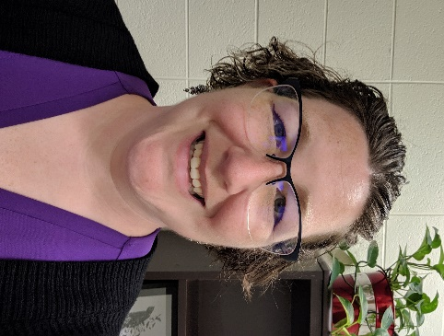
Jennifer Lewis  I worked in government and civil service -- in public policy and environmental economics -- before discerning my path to the rabbinate. I was born in New Jersey, grew up in Galveston, Texas, and lived in Northern California as an adult before beginning rabbinical school at HUC-JIR in Jerusalem and Cincinnati. I met my husband, Len, who recently retired from P&G, during rabbinical school. Before joining the staff of Xavier's Center for Faith and Justice, I worked as a community-based rabbi and chaplain, occasionally serving out-of-town pulpits, engaged in interfaith dialogue, and enjoyed volunteering at our daughter's elementary school. | 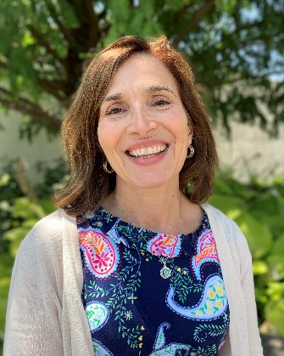
Pam Mack  Hi, I'm Pam Mack. I am an Administrative Assistant in University Relations/Annual Fund. I have been working at Xavier for a little over 3 years. I am a 1991 Alum of Xavier as well. I love that I get to work here at Xavier where I have many fond memories and have always felt a close connection.  I have been married to my husband Rich for 26 years (he is also a 1991 alum) and we have two children. My son Drew is a senior and is in the Army Reserves and ROTC here at Xavier majoring in Psychology and Economics. My daughter Clare will be a freshman at UC this year. She is still exploring a major presently. We also have a golden doodle named Willow. | 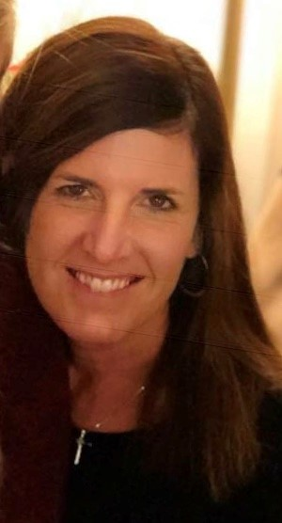
Bill Moran  Bill Moran serves the University as the Director of Auxiliary Services (aka ConneX). ConneX is responsible for overseeing many business operations on campus including food services, bookstores, parking, mailing, banking, and ALL Card services. Bill just entered his 22nd year of service. Bill is also a proud Xavier graduate, Class of 1993.  When not working, Bill enjoys spending time with his wife Karen and kids Ava and Liam. | 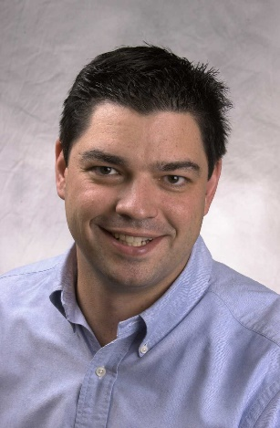
Anna Mosier
I was born and raised in Cincinnati, so I am so happy to be back working at Xavier for the last year. When I'm not working, I'm baking and hanging out with my cat, Ted!
Jodi Osborn
I have been an administrative assistant for over 20 years in some realm of academia both private and public at the elementary, secondary and post-secondary level.
I am the mother of four children ages 22, 19, 18 and 16. Needless to say, I am busy but when I have free time I like to spend it reading, making jewelry, watching movies and stand-up comedy.
Cara Pickett
Cara began as the Administrative Director at the Center for Teaching Excellence in July 2019. She’s worked in various higher ed and non-profit roles in Cincinnati and Chicago, including faculty development, grants management, and most recently, fellowship advising at UC. She has a Ph.D. in Music History from Yale University and an undergraduate degree from Lawrence University in Piano Performance. Cara grew up in the Cincinnati area and moved back 5 years ago. She lives in Northside with her family and still tries to play piano when her 7- and 3-year-old don’t demand her attention.
Nathan Ray  Nate was born and raised in Richmond, Indiana. Upon graduation from Richmond High School in 2010 he enlisted in the Marines from 2010-2014, a majority of which was spent serving in South East Asia. After separating from service he returned home and attended Indiana University where he earned an undergraduate degree in psychology. Nate now works in the Student Veterans Center here at Xavier as the center’s recruiter and admissions counselor, he works with any military connected students who are interested in attending Xavier. | 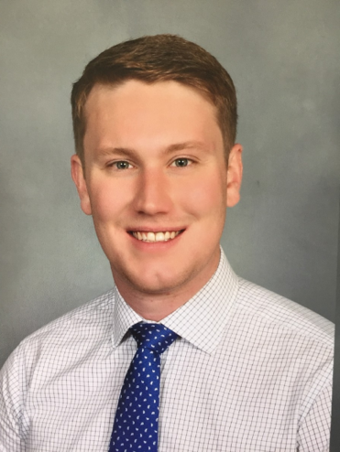
Mason Rick  Mason graduated from Xavier with his Bachelor’s Degree in International Business in 2009. That same year he commissioned as a Second Lieutenant out of Xavier’s Army ROTC program. Mason served as a Field Artillery Officer and during his time in the Army was stationed in Washington, Oklahoma, Hawaii, and Afghanistan. In 2013, Mason moved back to Cincinnati and started working at Xavier. Mason is the Assistant Bursar and is scheduled to graduate with his MBA in December 2019. Mason is married to his amazing wife, Liz (also a two-time Xavier graduate) and has two beautiful daughters, Nora (Xavier class of 2038) and Greta (Xavier class of 2040)! | 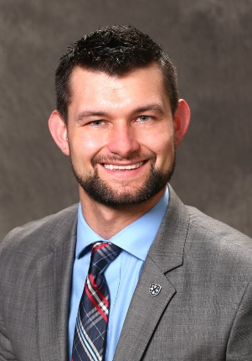
Christopher Roschke  I am a young professional in the field of higher education. Educationally speaking I come from a strong liberal arts background, and am constantly striving to grow intellectually and spiritually. I was originally trained and licensed to be a public sector social studies teacher in grades 7-12. While attending graduate school here at Xavier University I decided to make a transition into higher education and began working in enrollment management at UC. I spent 4.5 years with UC, before arriving back at Xavier University as an Assistant Registrar in the Office of the Registrar. | 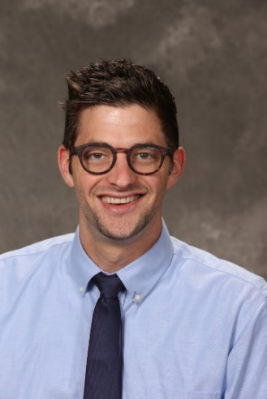
Lesley Roth  Greetings! I am excited to join the AFMIX cohort and look forward to meeting all of you. This is my third year serving as Director of the Montessori Institute. I have been a part of the Xavier Montessori program for a number years, holding several positions at the lab school including Lead Teacher and Principal. I enjoy the opportunity of being in the company of the university’s youngest students by day and teaching our adult learners in the evenings.  When I’m not on campus, I’m usually doting on our first grandchild, reading a good book, or at a yoga class. | 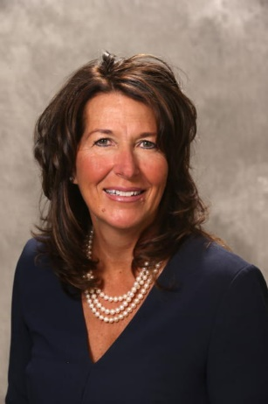
Colleen Ryan Mayrand  I am originally from Poughquag New York, but am coming to Xavier after working the past six years at Wheeling Jesuit University in Wheeling, WV. I am new to Xavier and Cincinnati and will be working in the Center for Faith and Justice. My husband is an alumni of Xavier and I am very excited to be part of this community I have always heard so much about! | 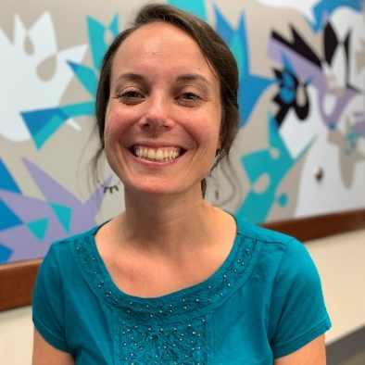
Amber Schutte  I grew up in Cincinnati and graduated from Xavier with a degree in Biology. As a student, I participated in a service learning semester in Kathmandu, Nepal. I spent the year after graduation as an AmeriCorps volunteer and worked as a community outreach educator at the Providence Children’s Museum in Rhode Island. I also taught science at schools in Kentucky, Alabama, and Germany. I moved back to Cincinnati eight years ago and stayed home with my daughter and son until returning back to work as a part-time Admin in 2017. I have been in my current position as an Administrative Assistant in the College of Arts & Sciences since October 2018. | 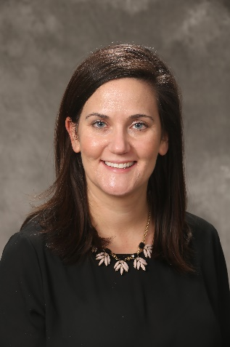
Matescia Stroud
My name is Matescia Stroud. I have been with Xavier for one year as the ABSN Financial Aid counselor. I have 13 yrs. of financial aid experience and love working with students and their families. In addition to working in higher education my prior experience includes working for the IRS, credit services and school systems. Outside of work, I am a wife and mother of three, two girls & one boy and grandmother of four. I enjoy reading and traveling. I consider myself a lifelong learner and look forward to the opportunity to grow through this experience.

Jenn Thornton  Jenn is the Biweekly and Student Payroll Specialist at Xavier since October 2018.  Jenn is originally from Rochester, NY and came to Cincinnati to get her Bachelor of Science degree in Psychology from Xavier University, she graduated in 1991.  Jenn enjoys watching her teenagers in their sports, and other activities. Jenn volunteers with the Leukemia Lymphoma Society and with her husband's American Legion and at her son's school for various events. Jenn enjoys musicals and hanging out with friends. | 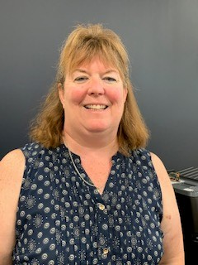
Jay Treft  I was raised in a large Catholic family here in Cincinnati and am a graduate of both UC and Xavier. I obtained my masters here at Xavier while working as a graduate assistant within the College of Business. I've worked in project management for about 20 years within different industries, the last 1.5 years in the Project Management Office here at Xavier. I am married (separated) with one son, Jesse. I'm currently caregiver for my elderly mother who has been diagnosed with dementia. I enjoy fitness activities, volleyball, swimming, bowling, following the Reds, Bengals, Xavier basketball, Kings Island / roller coasters, and travel ... | 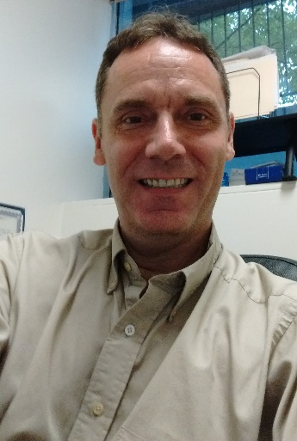
Katy Tucker  Hi Everyone! My name is Katy Tucker, and I am the Acquisitions Librarian here at Xavier. I joined the University in June, and I am excited to be participating in this year’s cohort. I moved to Cincinnati in 2017 from Lexington, Kentucky, and I grew up in Columbia, South Carolina. In my free time, I enjoy reading, going to concerts, and spending time with my family, including my two dogs, Violet and Oliver. I am looking forward to learning more about Xavier’s mission and identity with you all! | 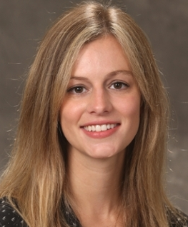
Talia Tuesta  My name is Talia Tuesta (she/her/hers). I am Xavier’s Title IX Program Director. I am working on my 3rd year here and excited to have a space to reflect on my journey thus far. The things that bring me joy are: my family; being outdoors; and learning. My strengths are: empathy; connectedness; and restorative. I believe we all have a responsibility to contribute to the world we want to create. | 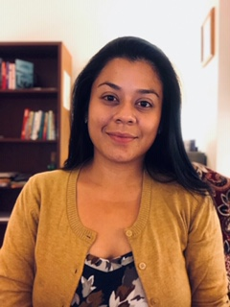
Heather Vibberts
I am now starting my fourth year with Xavier. Prior to Xavier I was in corporate America working for companies like Luxottica and Travelers. While at these companies I specialized in customer analytics and actuarial work. I am a graduate of the University of Cincinnati for Undergrad and University of Connecticut for my Masters. I am the mother of a 15 year old son, AJ and a 13 year old daughter Samantha. My husband, Eric, and I met at the University of Cincinnati. In my spare time I enjoy watching my kids sports and coaching soccer for CHCA High School.
Daniel Wooddell
I have been the Instructional Technologist at Xavier for over 6 years now. I assist the faculty with building their courses online in Canvas, as well as support them in using the other learning technologies that Xavier licenses and supports. I also provide in-person trainings, workshops, and one-on-one support for faculty in need throughout the year. Some of the things I enjoy are watching sports, playing video games with friends, and pretty much anything related to technology!
Matthew Zalman  Hello! My name is Matt Zalman and I am originally from Nebraska, born and raised. I started my work with students there and then moved to Appalachian State University to work with Learning Communities in the residence halls. From there, I came to Xavier! At home I get to spend my time with my awesome wife and continue my school work in Educational Leadership. In my free time, I love a good book, any type of movie, and and/or a good podcast to help me learn something new. | 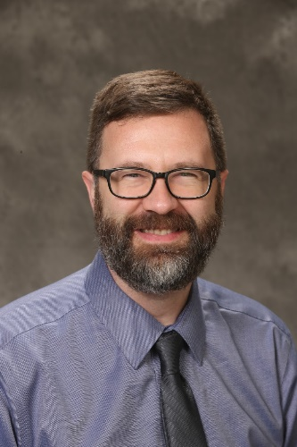
XAVIER’S AFMIX TEAM
Sheila Doran  Sheila Doran began teaching mathematics as an adjunct at Xavier in 1981 and is currently a Senior Teaching Professor in the Department of Mathematics. She was a participant of AFMIX I and has continued as a facilitator of AFMIXs II-X. Sheila enjoys swimming, hiking, quilting and spending time with her husband, two sons, daughter-in-law, and three grandchildren. | 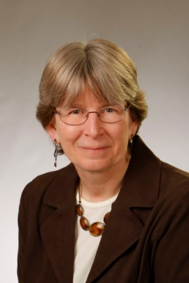
James Green  James is starting his fifth academic year at Xavier and currently works as the Head of User Experience and Assessment at University Library. He graduated from AFMIX IX and was a third semester small group facilitator for AFMIX X. James is also a member of the Xavier Veteran Employee Team (XVET) affinity group and has taught the CORE 103 military veterans GOA class since fall 2017. James is married with one daughter who is a sophomore at Lakota West High School. | 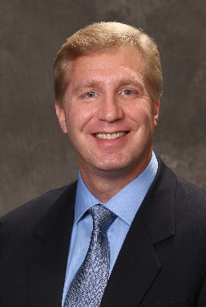
Supaporn Kradtap-Hartwell  Supaporn Kradtap Hartwell, Associate Professor of Chemistry, relocated to Indiana from Thailand with her family, joining Xavier University in 2011. Passionate about research and strongly believing in the power of education to improve quality of life, a career in teaching has been most suitable and mentally rewarding for her. When she isn’t busy preparing lessons, conducting chemistry experiments or keeping up with her two boys, Supaporn enjoys studying Japanese language and reading or writing Thai poetry. | 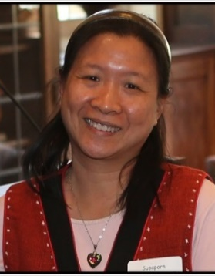
Douglas Riga  Doug started at Xavier in 2004 and works as a Senior Database Administrator in Application Services. He’s been actively involved in various Mission and Identity programs starting with his participation in AFMIX VI and has been co-facilitating AFMIX since AFMIX IX. He’s also served on the Benefits Committee and is currently serving on the Staff Advisory Committee. He is a U.S. Navy veteran that retired as a Lieutenant after serving for 22 years. He is married with 2 children and his son recently graduated from Xavier. In his free time, he enjoys reading, watching movies and playing games of all sorts (board, card, video games, etc.). | 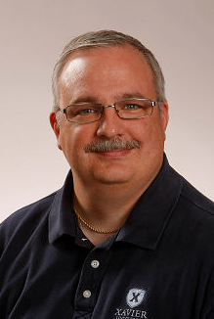
Joe Shadle  Joe began working at Xavier in 2006 and serves as the Director of the Center for Mission and Identity. He works with Xavier’s faculty, staff and advisory boards helping them integrate principles of Ignatian spirituality and Jesuit education into their positions within the University. Among his responsibilities are the coordination of Xavier’s participation in national mission-focused initiatives and the development of digital and print resources that support the University's educational mission. Joe is also an adjunct faculty member of Xavier's Williams College of Business teaching BUAD 604: Spirituality and Leadership. | 