Week 5
I ask that I may be able to look evil in the face—the magnitude of the “sin of the world”— and yet come to appreciate the loving mercy of God, more powerful than any evil, toward us all.
In my own words, what I ask is . . .

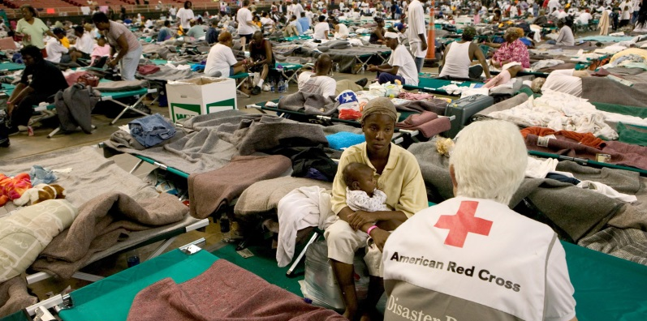

Take this, all of you, and drink from it: this is the cup of my blood, the blood of the new and everlasting covenant. It will be shed for you and for all so that sins may be forgiven. - Eucharistic Prayer
Reading
Brackley – 26. Worldly Prayer pp. 244-252 Now I can incorporate the prayer called “Examen” into the end of each day.
Creighton – 5. The Disorder of Sin: The Sin of the World pp. 32-39
Suggestions
This week is more about God’s love for us (for me!) than it is about our human failure. I ponder God’s mercy in Jesus on the cross: he overcame evil, not by retaliating with power that would have perpetuated it, but by enduring it, absorbing it, suffering it. Re-read and ponder Gillick’s last paragraph on p. 37: “The real freedom . . . but not negative.”
Scripture
Colossians 2:9-15; 1 John 2:1-2
~~~
Summation: Has it really dawned on me that God’s love and mercy is more wonderful and powerful than all the evil of the world (including mine)?
Journaling: Is there anything I want to hold on to?
Group Meeting: From my praying the Sp. Exs. this week, what do I want to bring to the group?

