Week 34
I ask the “Good and Holy Spirit” to guide me in choosing how I will live my life into the future—in Jesus.
In my own words, what I ask is . . .

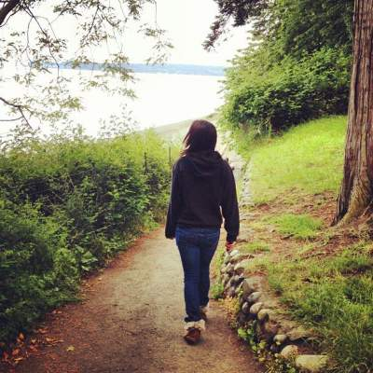
God is the one who began this good work in you, and I am certain that he won’t stop before it is complete on the day that Christ Jesus returns.
We must keep going in the direction that we are now headed.
-Philippians 1:6, 3:16
Reading
Brackley – 23. Learning to Love Like God pp. 212-222 This chapter can be read as a reprise on the Creighton chapter from last week.
Creighton – 34. Let Us Reflect on the Path before Us pp. 301-308

Suggestions

Re-read the prompt questions on the bottom half of p. 302 and top of 303 and/or those on pp. 304-305. Respond in writing (journaling) to some of them.

~~~~~
Summing up the week: Was I surprised by anything I read or prayed or felt or experienced?

Journaling: Have I learned anything from the readings, scripture, or my prayers that I want to hold on to?

Group Meeting: From my praying the Sp. Exs., what do I want to bring to the group?

