Week 28/29
I ask, through imaginative contemplation, to feel my way through Jesus’ suffering.
In my own words, what I ask is . . .

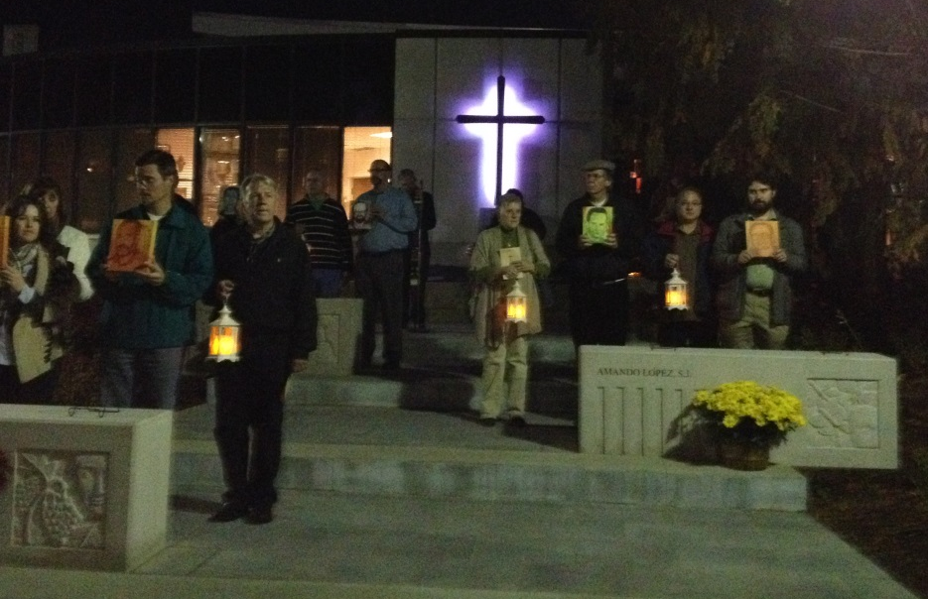
He suffered and endured great pain for us, . . . -Issiah 53:4
Reading
Brackley – 20. Blessed Are the Persecuted pp. 186-191 Defending what is right brings conflict, but we shouldn’t worry: “for it is not you who speak but the Spirit of your Father speaking through you.”
Creighton – 28. Jesus Surrenders to His Suffering 29. Jesus Dies for Us pp. 249-263
. Suggestions
Ponder: Jesus’ surrender to his suffering (as opposed to striking back in retaliation) defeats the power of evil and death.
“Our desire is to enter into the Gospel story and to be there with Jesus”: see p. 250, paragraph 1, for details.
Re-read p. 257, paragraph 2.
. Scripture
Matthew’s account of Jesus’ suffering—26:14-27:66 (see pp. 251-252); Luke’s 23:26-56; John’s 19:16-42
~~~~~
Summing up the week: Was I surprised by anything I read or prayed or felt or experienced?

Journaling: Have I learned anything from the readings, scripture, or my prayers that I want to hold on to?

Group Meeting: From my praying the Sp. Exs., what do I want to bring to the group?

