Week 27
I ask to experience Jesus’ love for me as I contemplate the Last Supper.
In my own words, what I ask is . . .

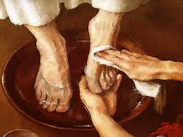

Do you understand what I have done?
You call me your teacher and Lord,
and you should, because that is who I am.
And if your Lord and teacher has washed your feet,
you should do the same for each other.
-John 13:12-14
Reading
Brackley – 19. The Solidarity of God pp. 179-185 Contemplating Jesus on the cross does not change our idea of Jesus; it changes our idea of God who here comes to us not in power and miracle but in the vulnerability of our humanity.

Creighton -- 27. Jesus Gives Us His Body and Blood pp. 241-247
Suggestions

Brackley’s ch. 19 is rich in material to ponder.

Put yoursself imaginatively into the Last Supper scene—both Jesus’ gift of himself in the meal of bread and wine and in his washing his friends’ feet—two sides of the same coin. Hear him say: Do this in memory of me.
Scripture

Matthew 26:17-30--Eucharist; John 13:1-17—Foot Washing
~~~~~
Summing up the week: Was I surprised by anything I read or prayed or felt or experienced?

Journaling: Have I learned anything from the readings, scripture, or my prayers that I want to hold on to?

Group Meeting: From my praying the Sp. Exs., what do I want to bring to the group?

