Week 23
I ask to know Jesus more intimately as the healer with understanding and love.
In my own words, what I ask is . . .

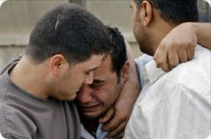
He healed our diseases and made us well.
-Matthew 8:17
Reading
Brackley – 16. Three Ways to Make a Decision pp. 143-156 These ways work for those who have arrived at sufficient internal freedom from compulsion or external law.

Creighton – 23. Jesus Heals pp. 209-214
Suggestions

Re-read the paragraph that starts at the bottom of p. 209 and concludes at the top of 210. Talk to Jesus about this understanding of who he is as healer.

Who throughout my day seems diseased or paralyzed or dysfunctional or blind or outcast by others? What external disorder or inner infection needs penetrating, embracing love?

Scripture
Luke 5:12-15; 5:17-26; 13:10-17; 18:35-43. Use one of these accounts to “contemplate” Jesus the healer; perhaps by putting yourself into the story as the one being healed.
~~~~~
Summing up the week: Was I surprised by anything I read or prayed or felt or experienced?

Journaling: Have I learned anything from the readings, scripture, or my prayers that I want to hold on to?

Group Meeting: What do I want to bring to the group?

