Week 22
I ask to live my life as a response to Jesus’ message.
In my own words, what I ask is . . .

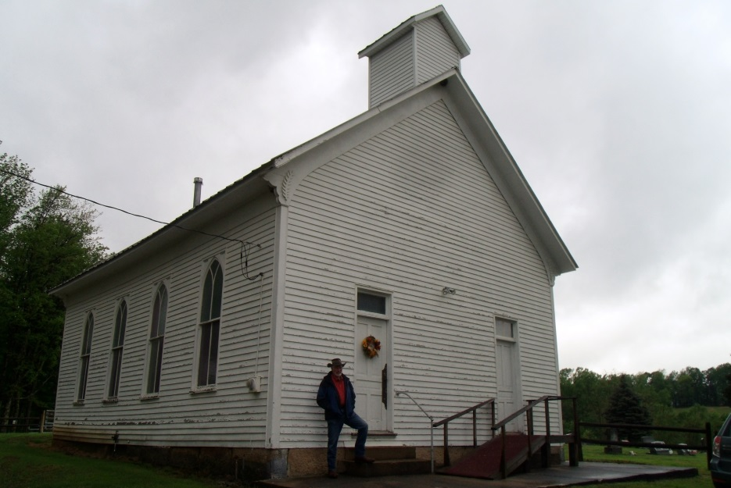
God blesses those people who depend only on him. They belong to the kingdom of heaven! -Matthew 5:3
Reading
Brackley – 15. More Rules for Discernment pp. 133-142
As the first set of Rules deals chiefly with the desolation that can hinder the reform of one’s life, so the second set deals chiefly with consolation and the deceptions that can accompany it.
Creighton – 22. Jesus Shares His Message pp. 201-207
Suggestions

Jesus must have heard his call as he read from Isaiah in his hometown synagogue (Luke 4:18-19—p. 201, par. 3). How do these words speak to me?

Take one of the Beatitudes (Matthew 5:1-16) that strikes you and ask the Spirit to enlighten you about how you are living it (surprise?) and how you can live it. What would it be like for you to live this way in all simplicity?
Scripture

John 15:1-7—The Vine and the Branches—. Again and again through the week, use this image to visualize how you are connected to Jesus.
~~~~

Summing up the week: Who is Jesus for me at this point in my life? Who am I for him?

Journaling: Have I learned anything from the readings, scripture, or my prayers that I want to hold on to?

Group Meeting: From my praying the Sp. Exs. (which might simply amount to living my life in a consciously reflective way) , what do I want to bring to the group?

