Pause: Thanksgiving Break

I ask for whatever grace the Spirit leads me to.

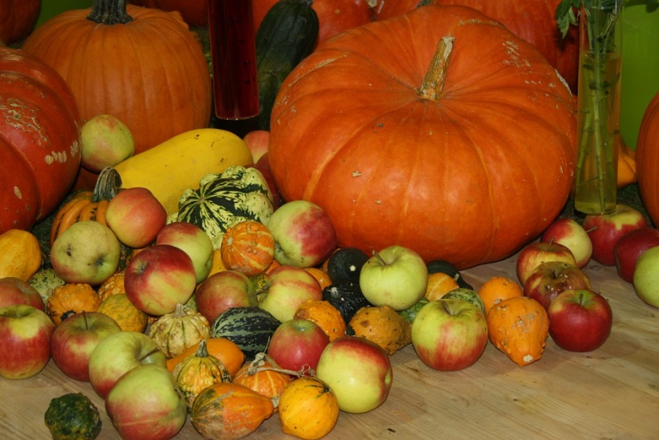

Reading
Brackley -- No new reading
Creighton – Ignatian “Repetition”
Suggestion

At various places in the book of the Exercises Ignatius has a reminder that it is not a lot of knowledge (“many things”) that is so important but rather plumbing the depth of a few things. We can do this by returning to what we have already known and experienced—especially where we have been moved by it in any way—and going “deeper.”
Scripture
Was there a scripture passage that especially touched me over the past weeks? I can go to it again.
~~~~~

Summing up the weeks: Where am I now? Who is God for me now? Who am I now?

Journaling: Have I learned anything from the readings, scripture, or my prayers that I want to hold on to?

Group Meeting: No meeting

