AFMIX Reflections
How it has impacted my work at Xavier University
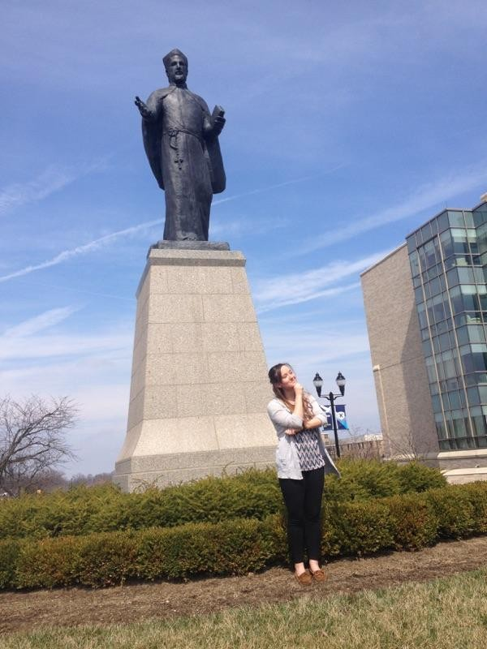
In the picture to the left is my Senior RA Sarah James. She is reflecting in front of St. Francis Xavier on a beautiful day. I have to be honest and say that this is not a normal occurrence for me or my staff but this picture sums up a lot of what I learned during my AFMIX experience. This picture represents the connection between my work with my RAs and our Jesuit faith. As I learned new skills and information during AFMIX I had the privilege to be able to go to my RA staff meetings and individual meetings and start to have more conversations about what Xavier University from a faith and service standpoint as well as just from an academic view. I was also able to utilize some of the techniques I was taught with the students. Sarah James (above) led us through the Examen during our first staff meeting. Reflection is constantly being incorporated in our meetings as well.
AFMIX has allowed to me to feel ownership over the positive tenants of Xavier’s Jesuit faith. Every day I never lose sight of the idea that we can find love in all things. There are moments when my RAs will get a little tired or frustrated with a student situation. In those moments I find myself reminding them to think, “Why are we here? Why do we have to live and work at all hours?” and then I try to help them realize that our work shares so many similarities to how St. Ignatius approached service. We are not above the students, we are with them. When they struggle and have problems, we are right there with them step by step. That clarity of purpose helps me to remind my staff why we do what we do.
I loved my job long before I attended AFMIX, but AFMIX has given my work new meaning. As a new employee, it has helped me connect to so many people around campus. As somebody who did not understand and was kind of scared of the Catholic faith, it opened my eyes and helped me connect to the faith in way I never thought possible. AFMIX is one of the programs that make Xavier special. This kind of experience cannot happen anywhere else. It has helped me in ways that these paragraphs can’t capture, and I thank the Center for Mission and Identity for the opportunity.
James Cosby
Residence Life

