Week 17
I ask for knowledge of the deceits of the “Enemy” and of effective counter measures to use against him—and I ask for knowledge of the true and good life in Jesus and grace to follow his way.
In my own words, what I ask is . . .

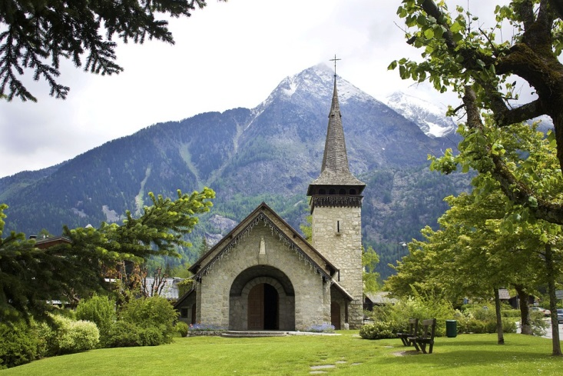

God bless those people who depend only on him. They belong to the kingdom of heaven.
-Matthew 5:3
Reading
Brackley – 10. The Two Standards [= Flags] pp. 78-89. The subject matter of the B. and C. chapters coincide this week. Creighton – 17. Two Ways of Desiring pp. 143-150
Suggestions
Ponder the two opposing strategies: The Evil One—riches to honors to arrogant pride and then to all other vices versus Jesus—poverty to rejection to true humility and then to all other virtues. [The universal applicability of this cycle has been challenged. For some people the bad pattern may rather be “lack of self-esteem—lack of appropriate self-assertion—failure to act.” We will re-visit the question in week 20: Brackley, Chapter 13.]
The so-called “triple colloquy”: The matter for this week is so important —and difficult—that Ignatius invites us to ask first Mary (the mother of Jesus), then Jesus himself, then God for the grace to live Jesus’ way. As Jesus in his baptism experienced God’s unconditional love (You are my beloved. With you I am well pleased, Mark 1:11), ask for God’s unconditional love. Such experience (You have given more joy to my heart than others ever knew for all their grain and wine—Ps 4) makes it possible to embrace Jesus’ way.
Scripture
Matthew 5:1-16; 1 Timothy 6:17-19; 1 Peter 5:1-11
Journaling: What do I want to hold on to from the week?
Group Meeting: From praying the Sp. Exs., what will I bring to group?

