Week 6/7
I ask to profoundly know my own sin so that I may experience the depth of God’s love for me personally.
I ask to recognize the patterns of my sinfulness, how sin happens in me, more deeply to understand God’s love and desires for me.
In my own words, what I ask is . . .

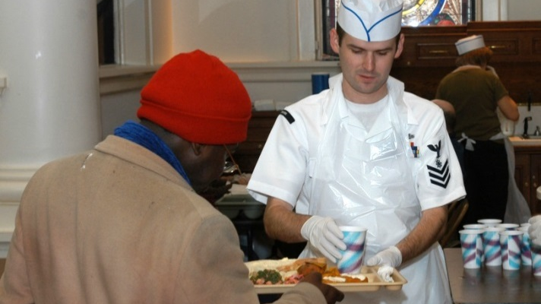

Christ died for us at a time when we were helpless and sinful. No one is really willing to die for an honest person, though someone might be willing to die for a truly good person. But God showed how much he loved us by having Christ die for us, even though we were sinful.
Romans 5: 6-8
Reading
Brackley – 2. Free to Love pp. 10-19 Read this chapter as a reprise on, or a “repetition” of-, the Creighton chapters 3 and 4 on the purpose of my life.
Creighton – 6. The Disorder of Sin: Personal Sin 7. Personal Patterns pp. 41-57
Suggestions
6. Face the questions that start at the bottom of p. 41 to 42 (The purpose for doing this is not to induce guilt and discouragement, but to experience gratitude for God’s loving forgiveness.)
Re-read this paragraph: Some of us . . . God will provide (p. 44). Re-read For the Journey: pp. 45-46. What does it say to me?
7. Re-read slowly Some Practical Help (pp. 52-55) or “For the Journey (pp. 55-56). When you recognize yourself in something, stop and ponder it. Talk to God about it or let the eyes of Jesus look at you about it.
Scripture
Luke 15: Read 1 of the 3 parables and see what touches you in it. Talk to God about that feeling.
~~~
Summation: Do I recognize God’s forgiveness for my sins?
Journaling: Write about anything from your readings, praying, and/or reflection on scripture that you want to hold on to.
Group Meeting: What do I want to bring to the group?

