CHILDHOOD EDUCATION
“Where is God in All of This?”
A Personal Reflection on “Cura Personalis” and “Calling”
through Xavier’s Mission Academy
Leslie Ann Prosak-Beres, Ph. D.
Mission Academy Participant

“The Jesuit ideal of giving serious attention to the profound questions about the meaning of life encourages an openness of mind and heart, and seeks to establish campus communities which support the intellectual growth of all of its members while providing them with opportunities for spiritual growth and development and a lifelong commitment to social growth.”¹

A Call to Excellence
When the opportunity arose for a formalized Mission Academy specifically for veteran faculty in the Academy, it provided me with a distinct purpose of renewal to discuss our mission, our Jesuit tenets and beliefs, and, our focus on serving our academic community on campus and beyond. It was this gathering of “pilgrims” who shared, discussed, and debated our existence as Jesuits over an academic year that supported my search for human excellence. It was the call to critical thinking and disciplined studies, a call to develop the whole person, head and heart, intellect and feelings.

The Mission Academy, then, was just the opportunity I was looking for and praying about as an individual and an academician. I love the opportunity I have been afforded to teach courses in literacy, both reading and children’s literature, over the past 25 years. I have thrived in offering my talents on academic committees. I have enjoyed researching and writing about those topics that have supported my interests in developing teacher candidates. As I reflected on all of these “gifts” I had been given, the urge to do more in the Jesuit tradition was haunting me, as I contemplated the focus of my remaining years at Xavier. It helped me personally to develop thoughts and desires to serve the world in a different, more inclusive way.

Our systematic study in the Mission Academy, incorporated methodology from a variety of sources, which better contributed to the intellectual, social, moral and religious formation or lack thereof, of the whole person. As documents on Jesuit education suggested, in the underlying principle of Tantum Quantum, that which may work better is adopted and assessed while that which is proven ineffective is discarded. Those who were part of the Academy sorted their foci and understanding of mission, with stress on uncovering and exploring the patterns, relationships, facts, questions, insights, conclusions, problems, solutions, and implications which a particular discipline brings to light about what it means to be a human being. This study in Ignatian Pedagogy was the process by which we, as companions in the Academy, accompanied each other in our pursuit of competence, conscience and compassionate commitment.

Since Jesuit Education strives to give learners ongoing development of their imagination, feelings, conscience and intellect, the Mission Academy encouraged us and helped us recognize new experiences as opportunities to further growth. It enabled us to see service to others in a new light as more self-fulfilling than personal success or prosperity. The opportunity to gather allowed the development of more complex learning skills beyond rote knowledge to that of application, analysis, synthesis and evaluation. Understanding the impact of Jesuit Education within the Ignatian Paradigm and cultural humility through service, suggested that we engage in an ongoing process of self-awareness and self-reflection in the process of becoming servant leaders in society.

How Characteristics of Jesuit Education impacted the Mission Academy
Since the inception of the first Jesuit school in 1548, the Jesuits have believed that a high quality education is the best path to leadership and service. It is the path to developing leaders with the potential for influencing and transforming society. This, then, became my focus during the Mission Academy as well as the focus for many of my other colleagues on the journey to excellence.
Fr. General Kolvenbach at his address at Georgetown (1989) suggested that, “the ultimate aim of Jesuit education is…that full growth of the person which leads to action – action, especially, that is suffused with the spirit and presence of Jesus Christ…, the Man/Woman for Others. ” ² Developing one’s strength in academic knowledge rooted in sound understanding of mission, gives birth to “well-rounded, intellectually competent, open to growth individuals… committed to doing justice, and in generous service to the people of God.”³ The in-depth study of Jesuit education became a carefully reasoned investigation through which I reformed my attitude towards other people and the world. This formed education strengthened my way of thinking by the way I approached how I lived in the world, seeking the greater good in terms of what can be done to enhance the quality of peoples’ lives. Understanding Jesuit education became a paradigm that spoke to the teaching-learning process and addressed the dynamic interrelationship of teacher and learner strengths on the journey of growth in knowledge and freedom to serve others at home. in the workplace, in the community, and ever-present human need.
My Mission, My Plan
In my opportunities, over the past two years, to travel nationally and internationally, attend and present at conferences related to my literacy expertise and Jesuit focus, I have come to realize my desire to do more as it relates to “cura personalis” and our university’s mission. Why, you might ask, did I want to do more? The “more” was life giving and encouraged me to go beyond the walls of Xavier; the “mission” encouraged the use of my talents to being human with and for others in an environment of care, respect and trust. My acronym for “mission” became: Many, Initiatives for, Service and, Solidarity, In, Other, Neighborhoods near and far.

The Opportunity
The opportunity began simply and quietly with a phone call on August 17, 2011. I was in the consultation area of Mercy Hospital in Lorain, Ohio. My Dad had suffered a stroke the day before, the day before classes started, the day before I realized that Guatemala was to become part of my life. I had been reflecting about service in a more global sense; I had just returned from delivering an academic paper in Lima, Peru. My emotions were high because of the trip and equally high over my Dad’s prognosis. Joe Berninger, a graduate of Xavier and Executive Director of Cooperative for Education, called me. He was a calming influence on a day that was fraught with uncertainty; he was interested in establishing a relationship with our Department of Childhood Education and Literacy. We spoke about two hours regarding potential educational opportunities for our students and for his cooperative. Our interests were mutual; our beliefs were common; our intentions were genuinely Jesuit. We ended our conversation in prayer for my Dad, for the Cooperative for Education and in thanksgiving for our meeting.

Why Guatemala? In a word: poverty. Guatemala’s Central and Western Highlands exhibit one of the most extreme combinations of systemic poverty, illiteracy, and inequality in the hemisphere. The indigenous populations that inhabit these regions suffer from malnutrition (rates of which rank among the worst in the world), poor health outcomes, racism, high rates of illiteracy, and low levels of educational attainment. Together, these factors virtually guarantee that the next generation will be no better off than the last. Due to a lack of opportunities, many indigenous migrate (often illegally) to the U.S. in search of better jobs. They face many perils along the way, including the break-up of the family unit, exploitation at the hands of unscrupulous human smugglers, and death. Cooperative for Education aims to help communities in the Western Highlands lift vulnerable young people—and their communities—out of poverty. By providing marginalized children in these regions with educational opportunities and access to technology, they can achieve success as individuals, as members of their local communities and as contributors to Guatemalan society.⁴

In the communities that CoEd serves, families subsist on $3–$6 a day. They live hand-to-mouth, with little access to education and no hope for a better future. Parents in these remote towns and villages want more for their children. That is where Cooperative for Education (CoEd) comes in. CoEd provides educational opportunities to impoverished Guatemalan schoolchildren that help them:
- Stay in school
- Learn valuable skills
- Gain access to better jobs, and
- Aspire to a better life, beyond poverty⁵
No more was said; I was convinced that I was being “called” to help with the initiative. Plans began and Guatemala became my “project” for the Mission Academy and my year of study with my personal mission and identity.

The Immersion and the Benefits
During the latter part of July and beginning of August, I will travel to Guatemala with Cooperative for Education to experience first-hand how I can bring this part of Latin America to my students of literacy at both the graduate and undergraduate levels and their teaching/learning experiences and expertise to Guatemala. What are the benefits of Ignatian Pedagogy as it aligns to the Mission of Xavier University for me, as mentor and for the students I teach?
- Ignatian Pedagogy promises to help teachers be better teachers. It enables teachers to enrich the content and structure of what they are teaching. It gives teachers additional means of encouraging learner initiative. It allows teachers to expect more of students, to call upon them to take greater responsibility for and be more active in their own learning. It helps teachers to motivate learners by providing the occasion and rationale for them to relate what is being studied to their own world experiences.
- Ignatian Pedagogy personalizes learning. It asks learners to reflect upon the meaning and significance of what they are studying. It attempts to motivate students by involving them as critical active participants in the teaching-learning process. It aims for more personal learning by bringing student and teacher experiences closer together. It invites integration of learning experiences in the classroom with those of home, workplace, community, and ever-present human need.
- Ignatian Pedagogy stresses the social dimension of both learning and teaching. It encourages close cooperation and mutual sharing of experiences and reflective dialogue among learners. It relates student learning and growth to personal interaction and human relationships.
- And, for me personally, Ignatian Pedagogy applied to my immersion trip to Guatemala and the planning for subsequent trips for pre-service teachers and graduate students of literacy with the Cooperative for Education (CoEd) will be a personal source of renewal to the tenets of our university’s mission in mind, heart and soul and to my gift of mentoring “persons of others.”
How does the Cooperative for Education in Guatemala provide an opportunity to experience Ignatian Pedagogy in Action for me and for Xavier Education Students of Literacy (in Reading and Children’s Literature)? I believe it embodies the five key teaching elements of Ignatian Pedagogy: Context, Experience, Reflection, Action, and Evaluation.⁶
- Context
What needs to be known about learners (their environment, background, community, and potential) to teach them well? “Cura personalis”--personal care and concern for the individual--is a hallmark of Jesuit education, and requires that teachers become as conversant as possible with the context or life experience of the learner.

Getting to know another culture and country and how literacy development can make a difference in the lives of its children is the focus of this study.

- Experience
Experience - What is the best way to engage learners as whole persons in the teaching and learning process?

An immersion trip engaged in the teaching of literacy and the learning of another language and culture.

- Reflection
Reflection - How may learners become more reflective so they more deeply understand what they have learned and appreciate its implications in the continuing search for truth?

Educators in training through memory, understanding, imagination, and feelings grasp the essential meaning and value of what is being studied and are able to apply it to wherever they have the opportunity to mentor others.

- Action
Action - How do we compel learners to move beyond knowledge to action?

While it may not immediately transform the world into a global community of justice, peace and love, the immersion trip to Guatemala as a capstone trip in either the Xavier undergraduate program in education or the graduate program in Literacy should at least be an educational step towards that goal even if it merely leads to new experiences, further reflections and consequent actions within the area of literacy…specifically reading and children’s literature.

- Evaluation
Evaluation -How do we assess learner’s growth in mind, heart, and spirit?

Ignatian Pedagogy aims at evaluation that includes but goes beyond academic mastery to the learner’s well-rounded growth as “persons for others.” It is hoped that observant teachers will perceive indications of growth or lack of growth both in and out of class discussions, and that their generosity in response to the common needs of others will be an influence in their lives much more frequently.

“Where is God in all of this?”
The Call
What is the plan for me through personal study, prayer and reflection because of this Mission Academy?
- Personal renewal of being a “person for others” as a member of the Xavier Community.
- Exploring and seeing God in all Things through other lenses or in a “different colored chalk.”
- Taking action on a felt call to working with the Cooperative for Education and the Berninger brothers.
- Learning about “Breaking the Cycle of Poverty through Education” in Guatemala and helping others to experience the same during their matriculation through a program of literacy education.
- Designing a curriculum rooted in Jesuit Pedagogy and Xavier University’s mission that aligns with already existing travel abroad programs in Education and across our three colleges.
The Plan
How will I attempt to respond to the Call? The following are the goals set for my response to the Mission Academy:
- Imersion in the study of the history of Guatemala.
- Imersion in the study of Latin America Spanish.
- Imersion in my trip to Guatemala, July 29 – August 8, 2012.

The Reflection
God instilled the “call” to seek a better understanding of mission and “cura personalis” in my life and the lives of those I am privileged to serve both here and in other parts of the world. I journeyed with colleagues in the Mission Academy to sort out the path of service and justice set before me and seek the MAGIS in what I do for my students and the university. The spirit of God enabled my heart to open to the goodness of the people of the world because I believe that the world is infused with the grandeur of God. I was called to understand His love for me here and now. The call was to transcend myself, to understand my ultimate meaning and therein to find God.

References
¹ The Mission of Jesuit Higher Education. www.ajcunet.edu/The-Mission-of-AJCU (accesed April 25, 2012).

² See Peter-Hans Kolvenbach, S.J., “Themes of Jesuit Higher Education,” an address at Georgetown University, June 7, 1989, http://www.xavier.edu/jesuitresource/jesuit-a-z/terms-k.cfm (accessed April 10, 2012).
³ See Peter-Hans Kolvenbach, S.J., “Ignatian Pedagogy Today,” an address delivered at the International Workshop on “Ignatian Pedagogy: A Practical Approach” Villa Cavaletti, April 29, 1993, http://www.seattleu.edu/uploadedfiles/core/jesuit_education/ignatian%20pedagogy.pdf (accessed April 10, 2012).
⁴ Cooperative for Education www.coeduc.org/ (accessed April 13, 2012).
⁵ Cited in Cooperative for Education, pp.2-5.
⁶ See “Ignatian Pedagogy: A Practical Approach,” 5-6, http://www.seattleu.edu/uploadedfiles/core/jesuit_education/ignatian%20pedagogy. pdf (accessed April 10, 2011).

Photos of Guatemala from the Cooperative for Education

Where the Cooperative for Education Serves
CoEd programs serve rural Guatemala, mainly in the country’s Central and Western Highlands. Program regions are inhabited primarily by indigenous Mayan Indians and plagued by systemic poverty, illiteracy, and inequality. The school systems in these communities are under-resourced and typically neglected by government support structures.
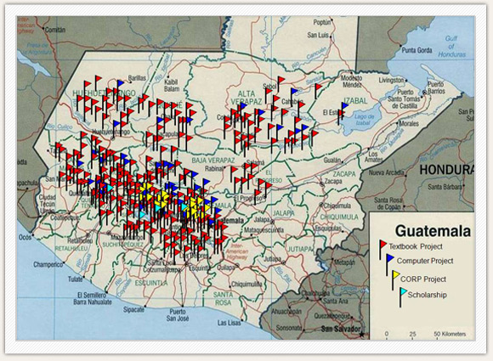

From the Corporate World to the Developing World
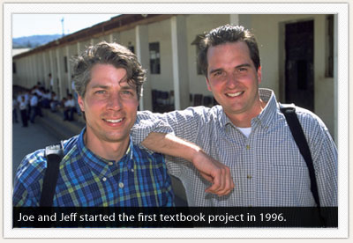
In 1996, brothers Joe and Jeff Berninger left successful, private-sector careers at IBM and Procter & Gamble to address poverty in Guatemala. The Berningers first became interested in Guatemala in the early 1990s during a visit to the country. Inspired by their experiences, Jeff took time off to volunteer in the Guatemalan school system. In his classroom and throughout the school, Jeff noticed that teachers lacked access to the most basic resources, including textbooks, maps, reference materials, and technology. Students spent most of their learning time copying from the chalkboard. They quickly became bored with school, and their lack of motivation led to high dropout rates. Jeff decided to help the school get the resources they needed to improve learning outcomes for the young people of the community.
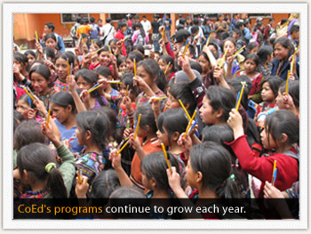

Cooperative for Education Programs
Cooperative for Education provides holistic and sustainable support to the communities we serve through separate, but complementary, programs:
Textbooks
Provides vital books (in the core areas of math, science, social studies, and Spanish) to middle schools in rural Guatemala in order to improve the quality of teaching and learning.
Computer Centers
Gives middle school students in rural Guatemala theopportunity to use technology to solve real-world problems faced by their local communities, while developing the computer skills needed to secure better jobs after graduation.
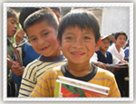Culture of Reading Program
Helps Guatemalan elementary school students becomecompetent and enthusiastic readers by providing books, materials, and training for their teachers in engaging teaching methods.
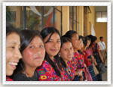Scholarship & Community Give-Back Program
Removes economic barriers to education by giving talented Guatemalan youths academic scholarships and involves them in improving their community through organizedservice projects.
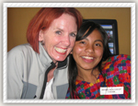Bridges
Connects people in the U.S. with Guatemalan communities that benefit from their support and builds partnerships with other organizations committed to improving the lives of Guatemalans.

