BLOOMBERG PORTFOLIO SET UP
CREATING A PRTU DATA BASES
FOR MANAGED PORTFOLIOS

- From PRTU, export your portfolio to Excel:

- In your Excel file:
  - Delete columns for Security, Mkt price, FX rate, Cost FX, Cost Value (left with ID, Position, Cost Px, and Cost Date)
  - Delete first 7 rows
  - Add a new Column 3 for naming your portfolio (e.g., Mister)
  - Interchange date and Cost Px Columns

- Copy and paste your portfolio the number of times you made a portfolio changes. For each portfolio change, change the date and edit the pasted version to reflect your changes. Also leave one space between each portfolio change. For example:

- Save your Excel file (Mister dog)

- On Bloomberg, go to BBU

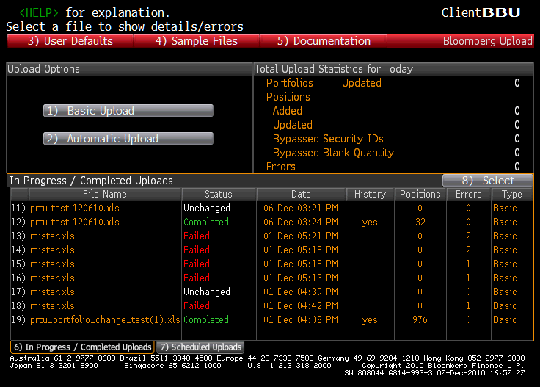

- Click “Basic Upload,” and search for your Excel file, and upload. If the upload is successful, you should see no position errors and a status of “Click to map.”

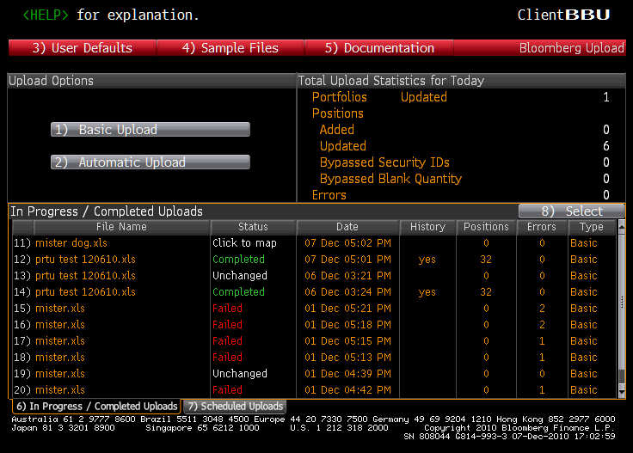

- Click “Click to Map.” Hit Next

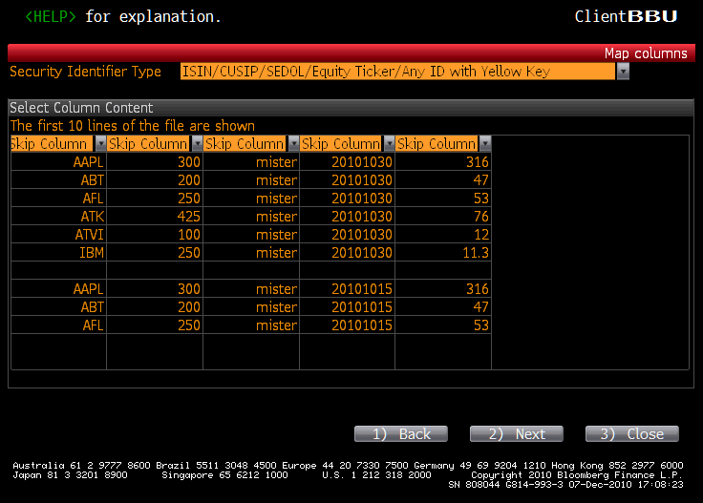

- Use the drop downs to align BBU with your Excel headings:
  - Column1: Security ID
  - Column2: Quantity
  - Column 3: Portfolio Name
  - Column 4: Cost Price

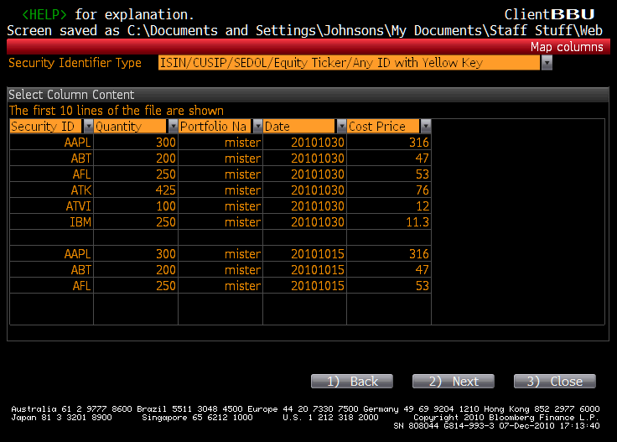

- Check number format. If you did it correctly, then BBU should indicate “Completed” with zero errors.

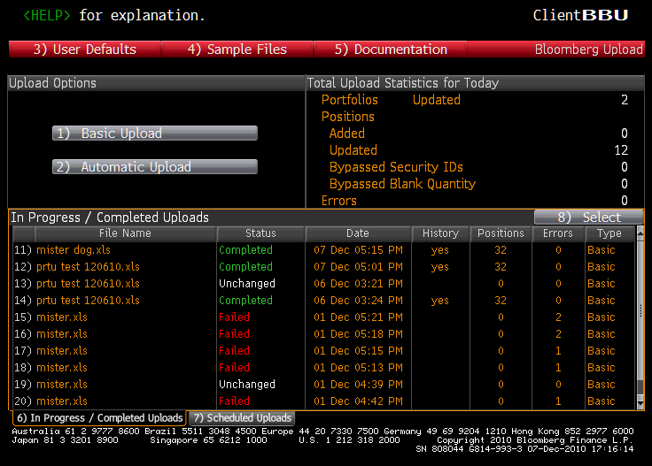

- Go back to PRTU and look for your portfolio (Mister).

- Click PMEN, select HFA, and find your portfolio

