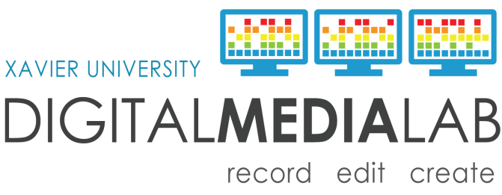
AV Script

Production Title:
Draft Date:
Draft Version:
Training: What is an AV Script?
Audio | Visual
Use this side to write out things you will say, or that your viewer will hear. | Indicate the visual here – slides, actions, etc.  Move to the next row down when the visual changes.
Example: In this presentation you will learn about how to write a script. | Example: Show myself holding up a printed copy of a finished script.

