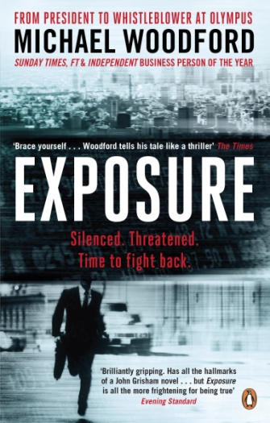

LITERARY REVIEWS OF ‘EXPOSURE’

“A brilliantly gripping book with a great hero at its heart. Has all the hallmarks of a John Grisham novel... but Exposure is all the more frightening for being true.”
Evening Standard
* * * * * *

“Remarkable. Vivid, angry and straight from the heart.”
Mail on Sunday
* * * * * *

“Brace yourself, Woodford tells his tale like a thriller.”
The Times
* * * * * *

“Woodford relates, at Grisham-like pace, how he stumbled upon a $1.7bn fraud that he, unlike his fellow board members, refused to hide. He is one of the few foreign businessmen to have penetrated deep inside a Japanese corporation and to report back unflinchingly.”
Financial Times
* * * * * *

“In a world increasingly dominated by global multinationals, he just felt someone had to speak out.”
Sunday Times
* * * * * *

“When Woodford turned whistleblower, he set off a tumult unlike anything that the cosseted world of Japanese business had seen.”
New York Times

FROM PRESIDENT TO WHISTLEBLOWER AT OLYMPUS

Page 2

“The business book of the year has to be Michael Woodford’s Exposure.”
Evening Standard
* * * * * *

“He’s the most celebrated international whistleblower of recent times. On reaching the top at Olympus, he exposed a $1.5bn fraud. His story is filled with mystery, suspense, and betrayal.”
Management Today
* * * * * *

“Michael Woodford had everything the corporate world could ever offer. Yet when he discovered rampant corruption at the core of one of Japan’s most prestigious companies, he did not hesitate. This is a sensational personal account of a man of great courage and principle who got to the top, and blew the whistle to glorious effect.”
Jon Snow, Channel 4 News
* * * * * *

“A must-read for businesspeople, politicians and would-be movers and shakers.”
Bloomberg
* * * * * *

“Michael Woodford's rapid ascent and downfall for doing the right thing is nicely told in this first-person whodunnit. The kind of integrity and courage that Woodford displayed is unusual. Exposure should be seen as compulsory reading for company directors and MBA students. Woodford stands tall as an example of leadership. Read his book and ask yourself: would you do the same thing - or would you just shut up and go to Davos?.”
Economist
* * * * * *

“Michael Woodford took a considerable risk in exposing wrongdoing. He was a study of boldness in action.”
Lionel Barber, Editor, Financial Times

Page 3

“Michael Woodford could have spent years turning a blind eye to the shady dealings of executives at Olympus. Instead he dove headfirst into allegations of corporate misconduct.”
Time
* * * * * *

“Michael Woodford has proven himself a hero, though he never wanted the battle. He risked everything.”
Clive Stafford Smith, Founder and Director, Reprieve

* * * * * *

"This memoir of one of Japan’s biggest business scandals is for more than corporate governance experts, with its fascinating tale of good versus evil.”
Japan Times

