
All sessions
run from
8:30—11:30 am
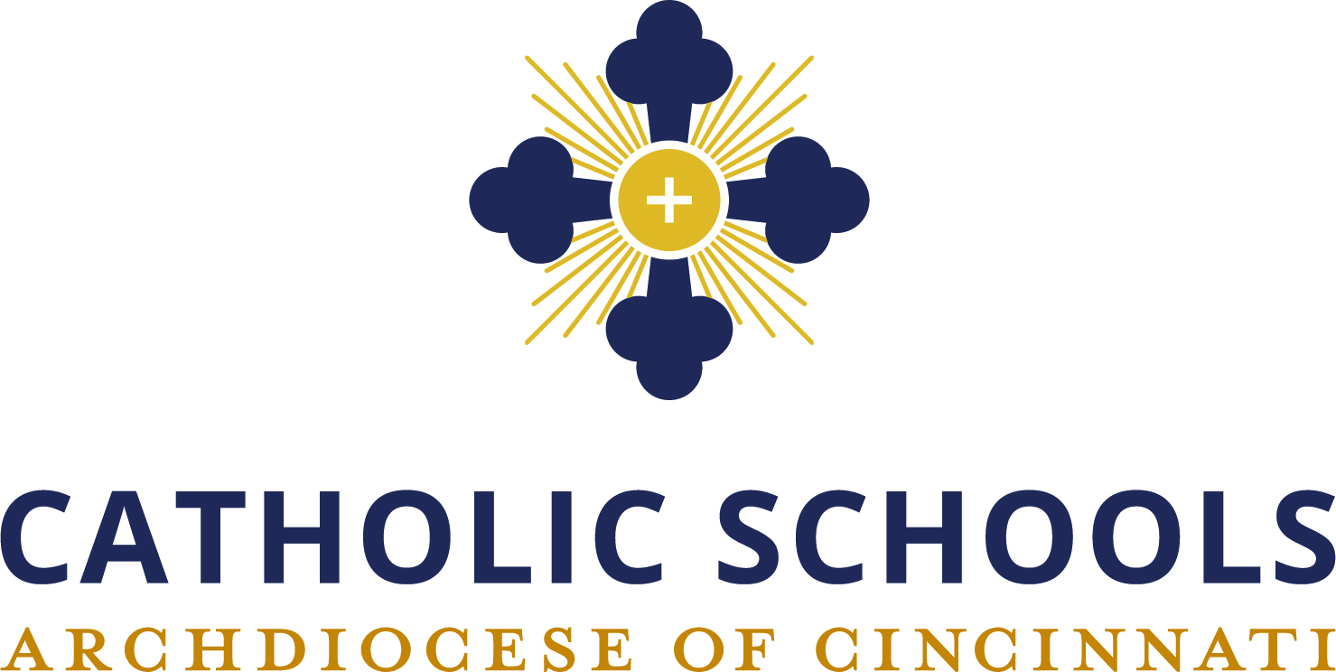
Initiative Goals:
- To develop and strengthen leadership in Catholic Schools
- To improve student learning and retention
- To implement a student-oriented pedagogy
Calendar for 2024-2025
September 13, 2024
October 4, 2024
November 8, 2024
December 13, 2024
January 10, 2025
February 7, 2025
March 14, 2025
April 11, 2025

New principals are required to attend all sessions.
Returning principals are required to attend at least 4 sessions.

Catholic Speaker Series: TBA

INITIATIVE FOR CATHOLIC SCHOOLS
2024-2025
A PROGRAM OF THE XAVIER CENTER FOR CATHOLIC EDUCATION
_____________________________________________________

Introduction
Xavier University, in collaboration with the Archdiocese of Cincinnati Catholic Schools Office, has pioneered an outstanding professional development program for Catholic educators in the Cincinnati/Northern Kentucky area since 2009—The Initiative for Catholic Schools (ICS). The Program is open to Catholic elementary and secondary educators.
Professional Learning Communities
A professional learning community builds a collaborative culture that is focused on student learning and is driven by results. The yearlong series of workshops will concentrate on developing a professional learning community to ensure that all students in your school learn at a high level. Application for participation is open to any Catholic school team in the Cincinnati Archdiocese or Covington Diocese. This class will develop a leadership team to implement the Professional Learning Community program in your school. The team must include the principal.
_____________________________________________________
The Requirements for a Participating School Include
- Participation of the principal and two teacher leaders
- Required monthly Friday workshop attendance 8:30-11:30 am for all participants. It is suggested you reserve the afternoons for individual school team PLC planning
- School’s entire faculty attends the Catholic Speaker Series
- Each participant in the class will be eligible to receive graduate credit hours (at the Catholic School rate) based on attending all sessions and completion of required assignments.

Team Outcomes/Benefits
- Developing and empowering teacher collaborators/leaders
- Shifting from a focus on teaching to a focus on learning
- Providing common planning time/creative scheduling
- Using results-oriented data to drive student learning
- Shared decision making through team leadership
- A renewed passion for teaching

