List of Xavier Majors Activity
Review the List of Majors Xavier offers and:
- Eliminate any majors that you DO NOT have an interest in pursuing.
- Highlight majors that sound interesting and would like more information.
- Of the highlighted majors, star 2-3 that are your top choices.
- Schedule an Exploring Majors appointment and detail your top choices in the notes section.

See a major and do not understand the criteria, career paths or requirements?
Research the major via the search bar on Xavier’s website and page for that major.

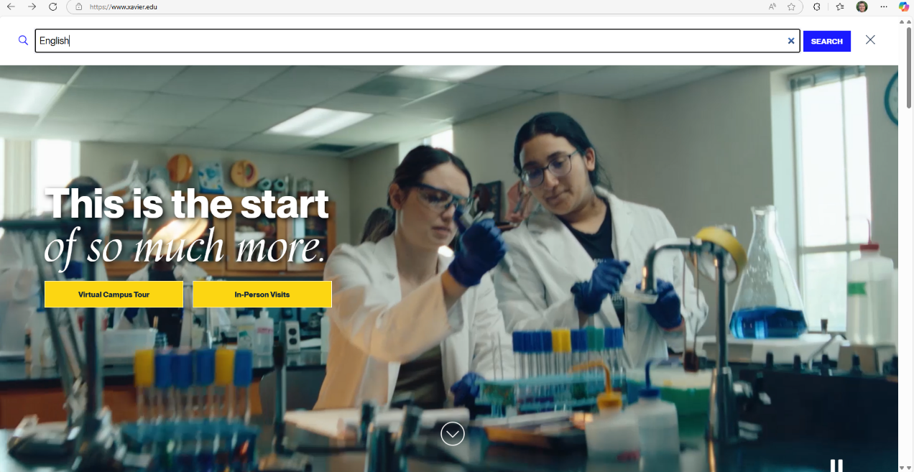

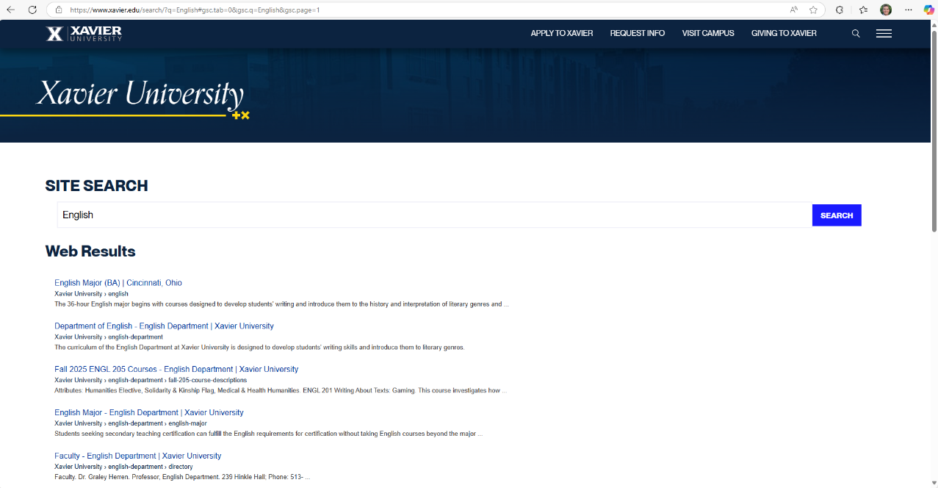

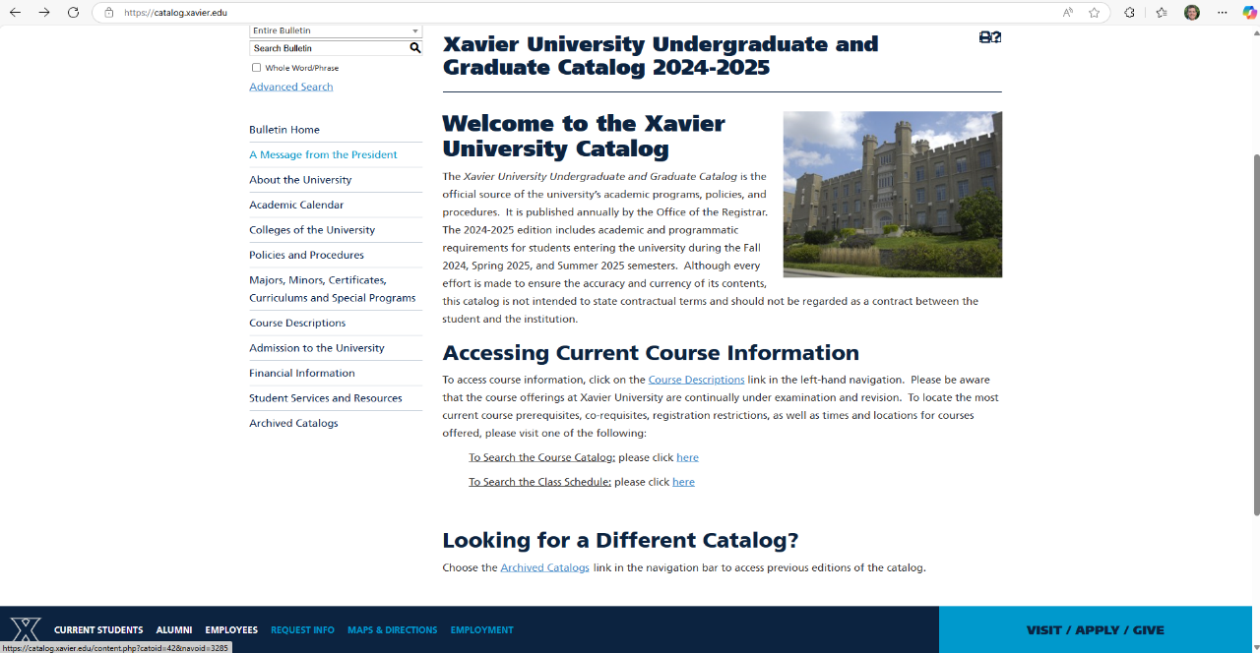
Use the Xavier University Catalog to Search Majors and Minors

Use the “What If” Function in Degree Works to See Course Requirements
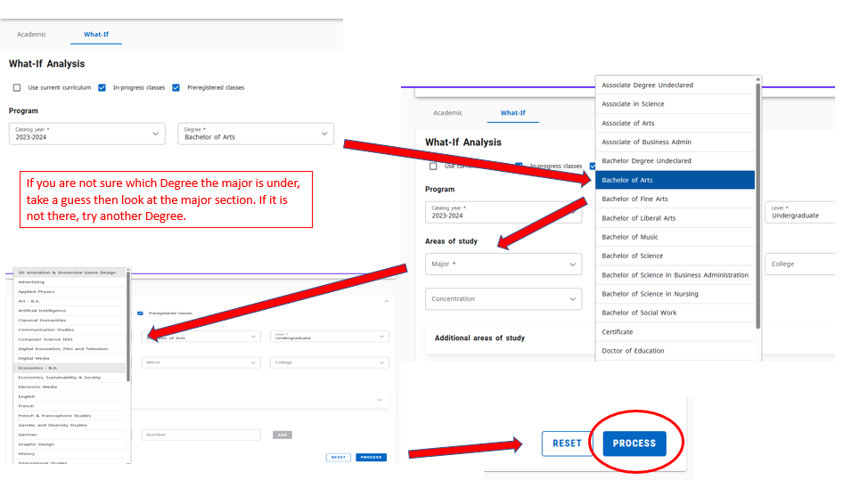

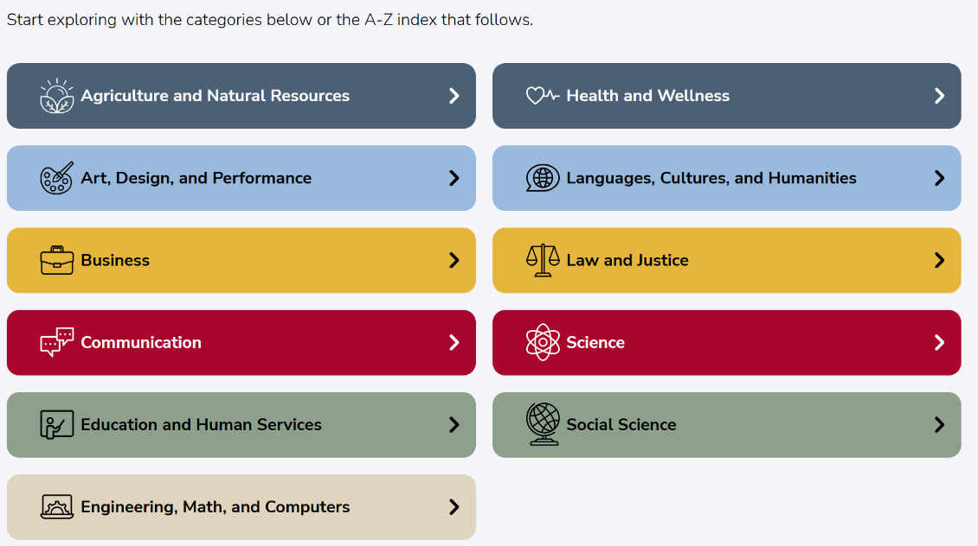
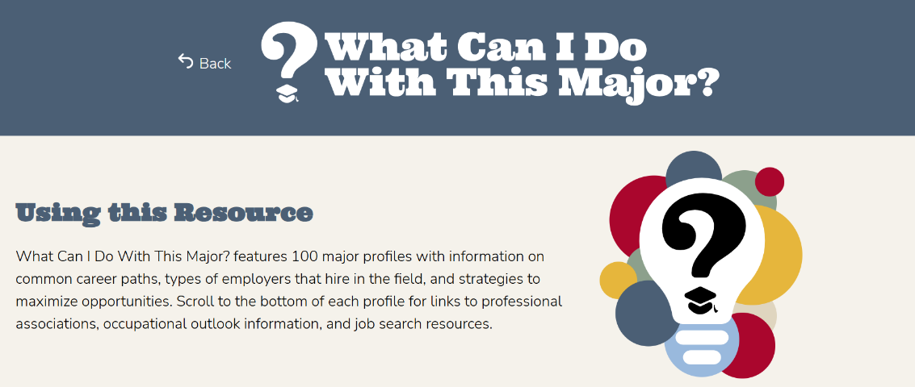
Career Guide: What Can I Do with This Major?

List of Xavier University Majors, Minors, etc.

Bachelor of Arts
- History
- International Studies
- Liberal Arts (APEX only)
- Medical & Health Humanities
- Music
- Musical Theatre
- Organizational Leadership
- Philosophy
- Political Science
- Sociology
- Spanish
- Theatre
- Theology

- 3D Animation & Immersive Game Design
- Art
- Artificial Intelligence
- Classical Humanities
- Communication Studies
- Computer Science
- DIFT
- Economics, Sustainability & Society
- English
- Fine Arts
- French & Francophone Studies
- Gender & Diversity Studies
- Graphic Design

Bachelor of Science
- Exercise Science
- Finance
- Genetics
- Health Administration
- Health Science & Wellness
- International Business
- Life Sciences for Business
- Management
- Marketing
- Mathematics
- Microbiology
- Neuroscience
- Nursing
- Physics
- Psychology
- Social Work
- Speech, Language & Communicative Behavior
- Sport Management
- Sport Marketing
- Theatre Education (P-12)

- Accounting
- Actuarial Science
- Applied Physics
- Applied Physics (Pre-Engineering)
- Biology
- Biochemistry
- Biomedical Science (Pre-Med)
- Biological Sciences for Business
- Biophysics
- Business Analytics & Information Systems
- Chemistry
- Computer Science
- Criminal Justice
- Economics
- Primary Education (P-5)
- Middle Childhood Education (4-9)
- Montessori Education (P-5)
- Special Education (P-12)
- Engineering Physics
- Entrepreneurship & Innovation
- Environmental Science

Honors Programs
- Data Science
- Philosophy, Politics & the Public
- Smith Scholars
- University Scholars

Pre-Professional Programs
- Pre-Dental
- Pre-Law
- Pre-Medicine
- Pre-Pharmacy
- Pre-Veterinary

Minors Programs
- Latin American Studies
- Management for Non-Business
- Music Performance
- Music Studies
- Musical Theatre
- Peace Studies
- Political Communication
- Political Thought
- Population Health
- Public Diplomacy
- Religious Education
- Sales
- Spirituality & Solidarity
- Statistics
- Theatre
- Writing

- Africana Studies
- Applied Mathematics
- Applied Health Sciences
- Arts Administration
- Asian Studies
- Business
- Catholicism & Culture
- Coaching Education
- Corrections
- Deaf Studies
- Environmental Studies
- Education: Principles, Development & Foundations
- Gender & Diversity Studies
- Forensic Science
- Information Systems
- Jewish Studies

