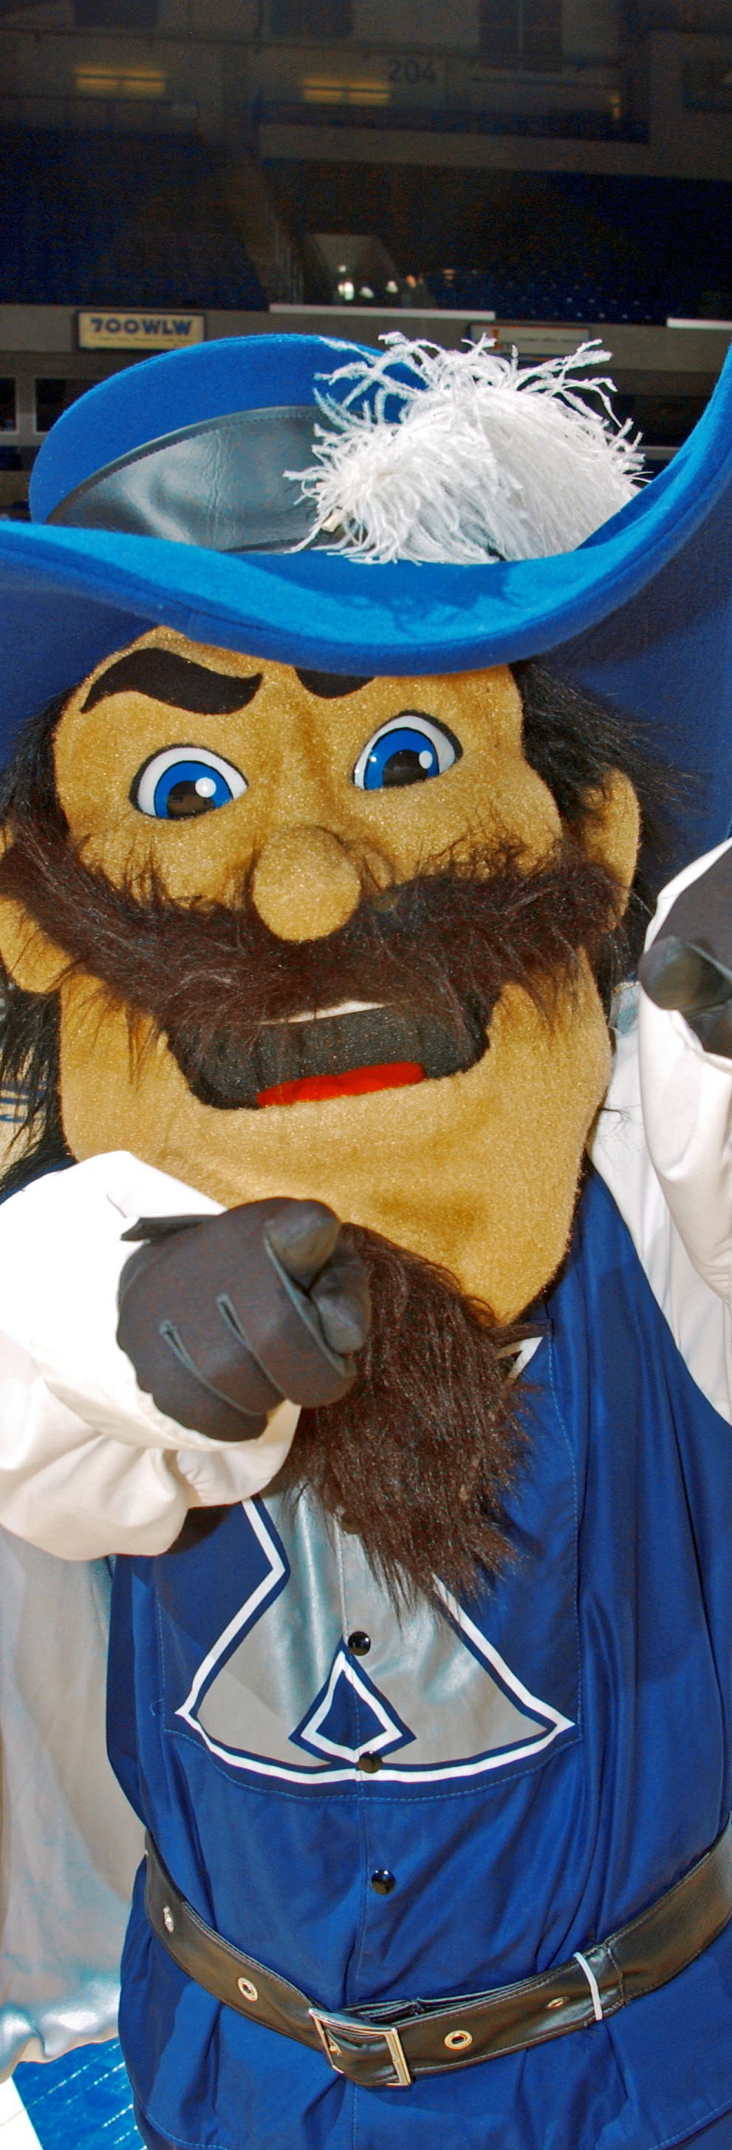

Headline Copy Here
SUBHEAD COPY HERE

Body Copy. Ut doluptatia volo to doluptas quaecaecum facea sequi si tes rectur?
Voluptibus dolupta nissimi, quundit etus ditae voluptati as aliquo expedit vel inveles re ditis aces res etur, sitem re explaccatur mo int, ere non prerovid quis doloria di nisimin et reptae. Obis voluptate et prat.
+ Bullet header content
+ List item one
+ List item two
+ List item three
+ List item four

Learn more at:
xavier.edu/blank
Contact Name can go here
at email address or phone number.

