# Word Document Accessibility

This is a short sample page with brief instructions to guide you in creating an accessible Word document.

## Use Headings

Use the headings in hierarchal order found on the styles list on the home tab; don’t skip heading levels going down.

### Benefits

Using headings adds many benefits to your document:

1. Add structure to your document for accessibility
2. Format all of one style at the same time
3. Move headings around with their content attached
4. Auto-generate a table of contents, with links for headings

## Use Lists

Using the built in list functions allows the items in a list to be “linked” together. Lists can be ordered (numbered, lettered) or unordered (bullets). You also have the option of creating multi-level lists.

## Structure tables

Tables can be very useful tools. Here are a few tips to help you structure them accessibly:

* Use to hold data relationships, not to format
* Keep it simple!
* Don’t split or merge cells
* Don’t have completely blank rows or columns
* Add visual headers in the table design style
* Add header row in the table properties

| If your test is on… | Sign up by 5 PM on… |
| --- | --- |
| Monday | Wednesday (of the previous week) |
| Tuesday | Thursday (of the previous week) |
| Wednesday | Friday (of the previous week) |
| Thursday | Monday |
| Friday | Tuesday |

## Links

Every link should be labeled with meaningful text. This text should not need to rely on surrounding text. If the same text is used to label a link, the link should be the same.

[Read&Write at Xavier University](https://www.xavier.edu/disability-services/readwrite-gold)

## Visuals

No important information should be conveyed only in a visual manner. This may include pictures, graphs, colors, SmartArt, etc.

### Alt Text

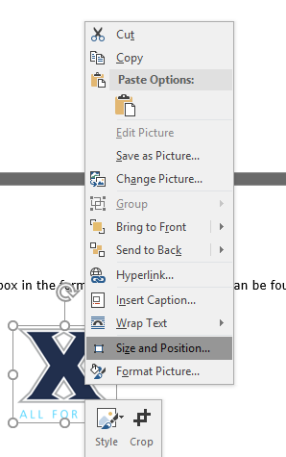Add alt text to the description box found under format picture in the right-click menu.

Alt text should accurately represent the content and function of the image in a succinct manner. It should not be redundant or repetitive of the text surrounding.

As a general rule of thumb, alt text should be no longer than a tweet (140 characters) or two sentences.

### Colors

Make sure that information is not only conveyed using color. A common example of this is required fields or negative numbers. These things should also have some other indicator of the meaning the color holds (i.e. asterisk or negative symbol).